Study report 2008
ePortfolios & Digital Identity
for cooperation & development

Commissioned by the Agency for Development and Cooperation

of the Swiss Confederation – (http://www.deza.admin.ch)
Version 2.0 - May 2009
Table of Contents
Introduction 3
1.1.Summary of Objectives 3
1.2.General Context of the Study 3
1.3.Study Activities 7
2.Findings 9
2.1. E-portfolio Related Practice 9
2.2. Potential areas of use of ePortfolios in the context of cooperation and development 10
2.3. ePortfolio Systems, Content and Support Models 14
2.4. ePortfolio support Models 15
2.5. ePortfolio Synergies 15
3.Qualitative analysis and possible future strategies 16
3.1. Success 16
3.2. Weaknesses 17
3.3. Obstacles 17
3.4. Potentials 17
3.5. Possible future steps 18
4.Conclusion and Strategic Recommendations 18
5.Agencies and Organisations Explored within the Study 19
6.Publications and Presentations Related to ePortfolios 23
7.Events Attended in the Context of the Study 23
8.ePortfolio Centres of Research and Information 24
9.INTERVIEWS 24
The questions 24
COL – COMMONWEALTH OF LEARNING 26
FAO / IMARK INITIATIVE 29
FORUM DES AMIS DU NET – GABON 31
UNI-HAMBURG ePORTFOLIO INITIATIVE 33
KATIMAVIK 35
NOVATION INTERNATIONALE 38
IICD 41
KASA 43
ONG CIPUF 45
UNESCO YOUTH UNIT – DAKAR 46

Introduction

Summary of Objectives
Our society is more and more including lifelong learning programmes and competence based approaches as key tools for human development. On these basis, the general objective of this study is to gather a better understanding of how to make efficient and effective use of digital technologies to support professional development, as well as knowledge management for
- the Swiss Agency for Development and Cooperation (SDC), Capacity Building, Training and Culture section
- governmental organisations and their civil society partners operating in the area of capacity building for international development and cooperation.
More specifically, it aims to
- identify a few significant practices in e-portfolio and digital identity within the context of international development and cooperation
- produce an overview of different e-portfolio processes and aspects that could be pertinent to professional development the context of international development and cooperation
- identify existing and potential synergies in the area of e-portfolios and digital identity programmes

General Context of the Study
Our societies are presently in the throes of a shift from an industrial paradigm in which the individual is perceived as a "consumer" of information and learning to a paradigm in which the individual becomes a "producer" of information. Within the context of this study, we are referring in particular to the following facts:
- individuals are no longer only "navigating" the web, but also actively projecting themselves into the web space, contributing content, exchanging and collaborating; and
- education, learning and training are transitioning to accommodate and encourage self-regulated, self-directed learning and reflective practice that encompasses formal, non-formal and informal learning.
These are concrete changes in line with a new reality of lifelong learning and competence-based approaches.
Within this context, ePortfolios processes are taking a fundamental role. These emerging processes on identity building concern both the public types of ePortfolios relating to digital identity and the private aspects of ePortfolios akin to personal learning environments.
"Organisations that have worked in isolation can be projected into a global space encouraging transnational sharing, networking, collaborating, innovating. The World Wide Web has tremendous potential to give civil society in developing countries a global audience, to help NGOs and local not-for-profits connect to each other."
Tobias Eigen, Director of Kabissa.org

The limits of traditional e-learning and Learning Management Systems (LMS) to truly accommodate the learning needs and challenges of a self-directed learner, explains the rising interest of ePortfolios and personal learning environments.
An ePortfolio can be defined in different ways. For example the Joint Information Systems Committee (JISC) states “Fundamentally an 'ePortfolio' is the product created by learners, a collection of digital artefacts articulating experiences, achievements and learning.” For this study, we summarise an ePortfolio as an on-line environment supporting processes that allow an individual, group or organisation to capture, reflect upon, document and present who they are, what they are learning and their future goals. This may include their strengths, activities, experiences, challenges, goals, competences and values. Hence, ePortfolio processes support individuals and organisations to take charge and manage their virtual identity and develop as lifelong learners, learning organisations or learning regions.
eCulture, the sum of all behaviours in digital environments, includes these two aspects:

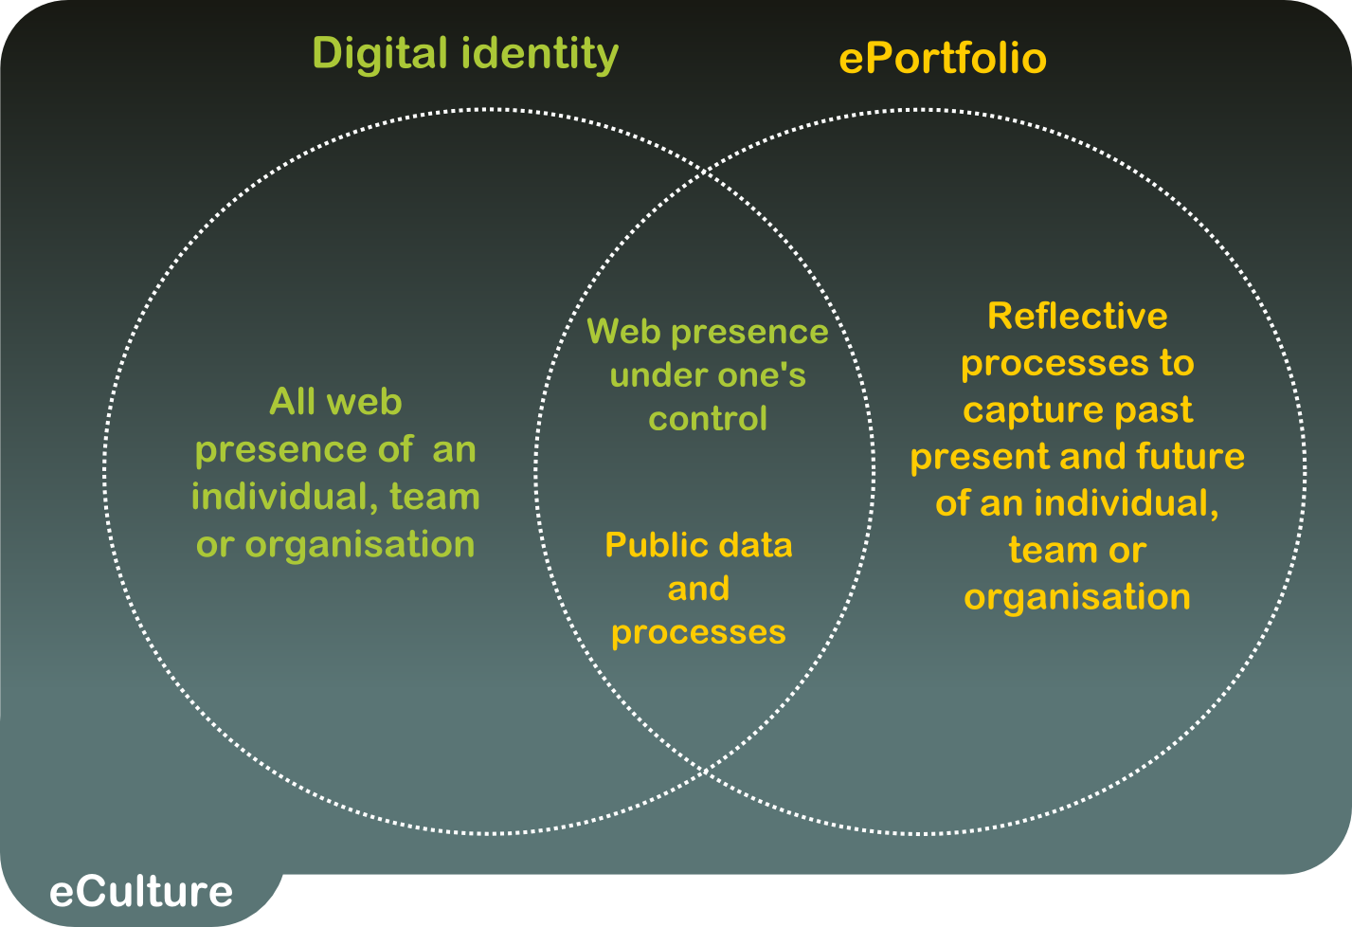
ePortfolios systems, unlike social networks systems (such as Facebook) have as a goal personal or organisational learning and development. Also an ePortfolio is about building and controlling one's on-line identity.

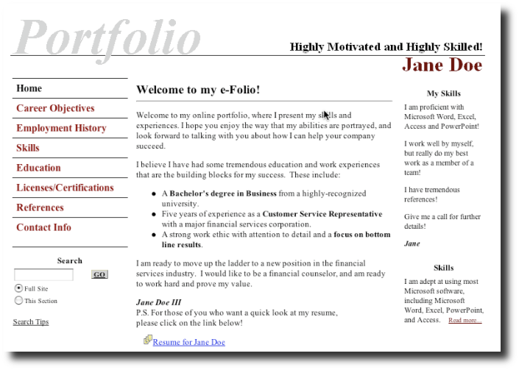

ePortfolios are becoming more and more widespread in academia, both in the north and in educations organisations all over. For example, the Ministry of Education of Tunisia supports ePortfolio "as a proof of competency" and the University of Pretoria is including ePortfolios in its e-education transition.

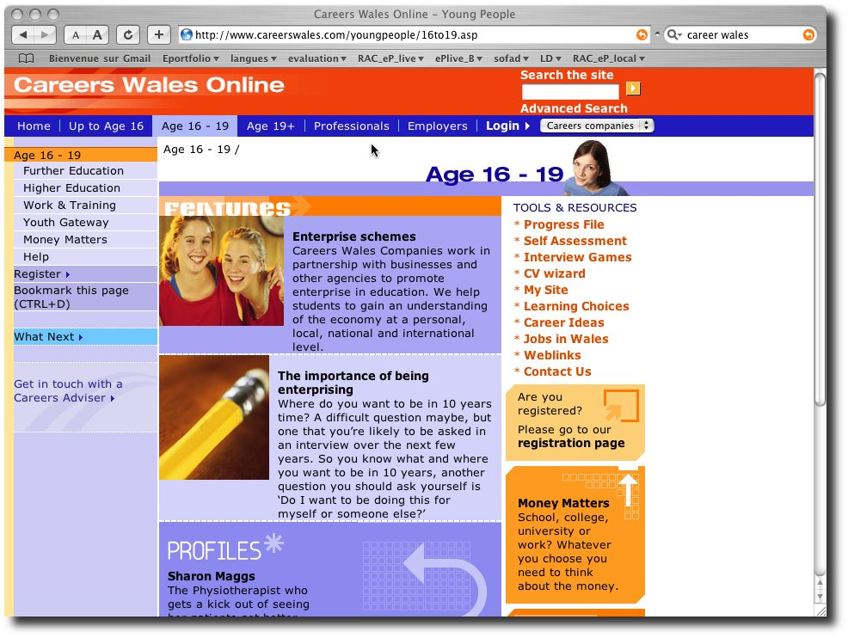
There is a rise in large-scale regional ePortfolio initiatives:
Wales offers an ePortfolio to its 3 million citizens (see image)
Minnesota (USA) has had an ePortfolio initiative operating for over five years with more than 100,000 registered users (now expanding to the state of California) and there are various regional initiatives underway in France and the Netherlands. Europortfolio leads the "ePortfolio for all" campaign in Europe.

While making strong headway in education, in professional development and training, ePortfolios are still a very recent approach. Schmidbauer offers both hope and caution regarding how "ePortfolios might play an important role in future corporate learning strategies". The Dutch Ministry of Defence (MOD), having had a positive pilot experience introducing an ePortfolio to facilitate the development of career skills of the MOD employees and to support Validation of Prior Learning , will be implementing the ePortfolio company-wide (for 60,000 employees) "as the foundation of the Human Resource Development processes". In the UK "professional bodies are increasingly turning to customised ePortfolio systems to enable members to engage in Continuing Pofessional Development. For example, the Institute for Learning (IFL) is introducing the optional use of ePortfolios to record the statutory 30 hours of CPD now required of the 300,000 practitioners in further education in England. The chartered Society of Physiotherapy (CSP) has also piloted an optional ePortfolio system for Continuing Professional Development(CPD). To practise within the UK, physiotherapists registered with the health professions council undertake to keep a record of the reflective and professional learning that underpins their practice" (JISC, 2008).

Study Activities
This study aims to explore current practice of ePortfolios in the context of professional development and knowledge management in the development and co-operation sector, specifically for professional development. The study included three types of activities.

Desk research
Desk research was conducted to explore different agencies and organisations that should be part of the study and to gain a broader understanding of the current state of play of ICT (Information and Communication Technology) uptake by development and cooperation organisations and agencies, as well as the role of ePortfolios and digital identity within that area. See references for details.

Participation at international events
Participants attended three international events to gather a general understanding of the current state of practice and to identify agencies to be researched and contacted within the context of the study.

- 32nd International Public ICANN Meeting
Organised by ICANN (Internet Corporation for Assigned names and Numbers) , Paris, France, June 22-26 2008. This study initiative was informally presented to civil society, governmental and non-governmental delegates who promotes ICT for development

- ePortfolio and Digital Identity, The Human Capital and Social Innovation Technology Summit
Organised by EIfEL, the European Institute for e-Learning, in Maastricht, Netherlands, October 22-24, 2008. At the conference, the study was presented as a "work in progress" as a mean to gain visibility and to facilitate connections to pertinent ePortfolio processes being developed in southern countries. To view the presentation: http://tinyurl.com/5h63oo

- Conférence de Lyon pour la solidarité numérique
Organised by the European Ministry of Foreign Affairs, the Region Rhône-Alpes, the Communauté urbaine de Lyon, World Digital Solidarity Agency and the Global Digital Solidarity Fund, in Lyon, France, November 24th, 2008.

Structured interviews with organisations and agencies
Structured interviews with targeted organisations were conducted to capture and explore ePortfolio and digital identity initiatives representing significant practice. See Appendice I for interview questions.

Findings
In professional development and training in the area of development and cooperation, we did not encounter any full-fledged ePortfolio practices that were both initiated from the south and outside the formal education sector, other than cooperation.net. Most organisations and agencies are working to increase the integration and potential of the web into their activities, but the ePortfolio has not yet been adopted to support learning and training.
However, the research and interviews allowed us to identify
- Southern initiatives “related” to ePortfolio practices
- Five potential areas of use of ePortfolios in the context of cooperation and development
- Some basic information on ePortfolio technology, contents and support models that could be useful for the development and cooperation context
- Some potential synergies for eportolio intiatives

E-portfolio Related Practice
Though not directly ePortfolio initiatives the following types of activities, related to ePortfolio and user profile processes, were identified from the desk research and various conference sessions and contacts.
I - Technologically savvy organisations and learning partnerships such as Inwent, Kabissa, TakingITGlobal, Hivos or GINKS (see references in annex) are integrating the Web 2.0 into their activities, focusing on networking individuals with common interests via succinct member profiles.

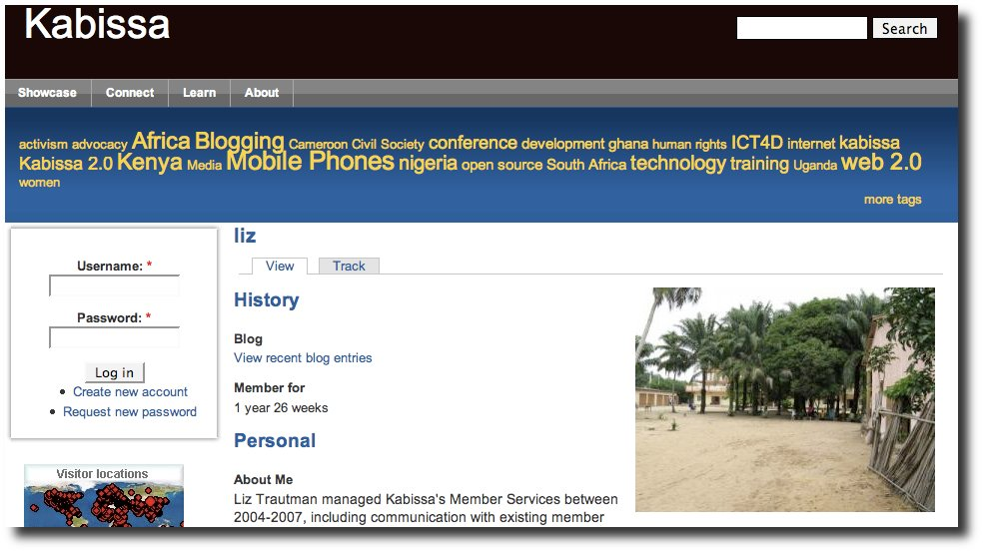
II- Low level technology solutions, appropriate to the realities of the south, such as D-groups, (a starting point for fostering groups and communities in international development) are being adopted that include clunky non-dynamic user profiles as part of their online system.
III - Online courses, such as International Community Development of the Royal Roads College (Canada), are offered to development workers throughout the world, that request students to keep an online presence such as a blog.
IV - Disconnected face-to-face workshops that could potentially be part of ePortfolio practices, such as the sub-regional and national workshops organised by the Knowledge Initiative for Action Aid International front-line practitioners "to support the deepening of front line rights-based practice for change using critical writing as the primary vehicle. Each participant will write a critical reflective story on their work for change. Documenting one's work for change (ppts, comics, photo stories, narratives etc.)."
V -The self-promotion programmes developed by agencies aiming to develop skills of micro-entrepreneurs, through training programmes on accessing strategic information, creating clusters of producers and promoting products in international business networks with new marketing methods, eliminating the middle man (example see interview UNESCO training in Dakar for young leaders in Subsaharian countries).

These novel practices, though interesting and potentially effective, are a far cry from the integrated, long-term and more transformative impact that ePortfolio processes can offer for professional development (example see interview Novation Internationale for micro-entrepreneurs training in ePortfolio development in developing countries).

Potential areas of use of ePortfolios in the context of cooperation and development
Though ePortfolio processes and tools can support a variety of purposes, they truly appear to be a response within in a context of transformation to new and innovative practice. In the context of international development and co-operation, five potential purposes of ePortfolios and digital identity processes were identified. These five categories are based on actual ePortfolio projects researched or ideas for the future as expressed by various interviewees.

Empowering Individuals and Organisations
According to Schmidbauer, "Most existing educational systems in companies and organisations are still grounded in a cognitive approach to learning. That means that mere knowledge aggregation with the aim to achieve qualifications (certificates, diplomas) is still the predominant way of education. But the growing complexity of problems in daily work increases the demand for more self-directed acting and requires competency-based approaches" (2008, p. 2). ePortfolios, on the other hand, revolve around the learner who is the main subject, entering information, thoughts, records, results, etc., related to themselves, their interests, their needs and their competences. The learner is the owner, responsible for managing the contents and the access over a long period of time. In this way, ePortfolios are ideal for empowering individuals and organisations to become self-regulated and self-organised learners with a strong sense of self-efficacy. As Schmidbauer observes, "the powerful self motivation of employees for deeper learning and development is utilized". However, beyond the potential named, Schmidbauer has no initiatives to share (shared in conversation).

With ePortfolios, learning can be personalised rather than forced into a one-size-fits-all model. ePortfolios can support the shift from teacher/trainer-centric learning and professional development to learner-centric processes, supporting the development of creative, innovative, networked individuals who take responsibility for their personal and professional well-being and development.
At the same time, the empowered, under-represented voice of the "south" can take more place in the collective web space. Olivier Kaloudoff and Marie-Jane Berchten, commissioned by UNESCO at the World Youth Forum of United Nation System, (August 2001) share how the challenge of training 400 young United Nations' delegates within a 2 days workshop on ICT was met by concentrating the training on the simple notion “show us who you are” resulting in their online portal and a base of cooperation that continues today.

They recount their experience:
Imagine groups of 20 young African leaders entering into this computer room of the university in Dakar in 2001. Most of them had arrived by bus from the sub-region, after a tremendous travel. We were proposing them to act on the web instead of being consumer of information. They could develop their digital literacy skills, such as how to type on the keyboard, while typing words about their own life.
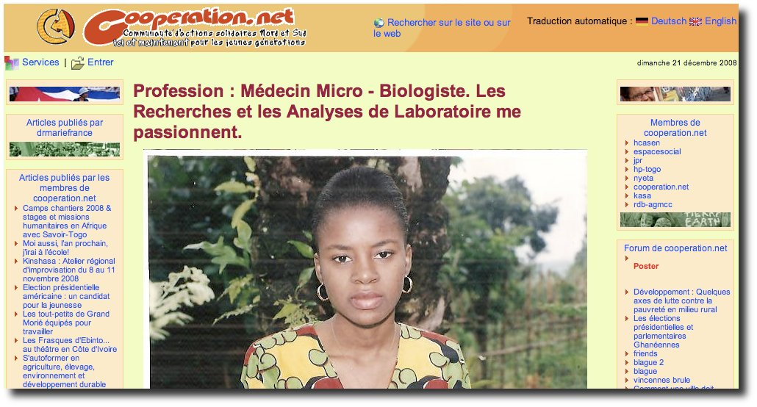
UNESCO Dakar training during Youth Forum – Result of an ePortfolio

Supporting Deep and Complex Learning
ePortfolios help individuals and organisations develop a clearer and more integrated vision of themselves and their learning over a long period of time by connecting fragmented training sessions and by helping individuals look at their learning in relation to their own personal strengths, values and beliefs. Learning is not just about developing technical competence; it is also about developing self- awareness, self-reflection and discernment. Continuing professional development in this way can help individuals gather a global long-term personal perspective on the complex issues they are part of.
The New Era Educational and Charitable Support Initiative (NEEDCSI) explains how individuals need “to discover and develop their inherent gifts, talents and abilities and to help raise ethically responsible, self-disciplined, and creative citizens capable of participation in a positive and sustainable society.” Cooperation work is about competent, confident, responsible, and caring adults.
ePortfolio processes are creative and reflective tools that can be helpful for individuals and also for organisations to get at this deeper level of learning. However, we came across no such examples used in a continuing professional development context.

Expanding Types of Learning
In a world of lifelong learning there is more and more recognition of the potential and importance of non-formal and informal learning. Formal accreditation becomes less relevant with time and even regular training courses for updating skills are not enough. There is a growing need to develop reflective practitioners, professionals who are good non-formal learners, able to capture and connect learning wherever it occurs. ePortfolios are ideal tools to support such learning in an integrated and structured environment.

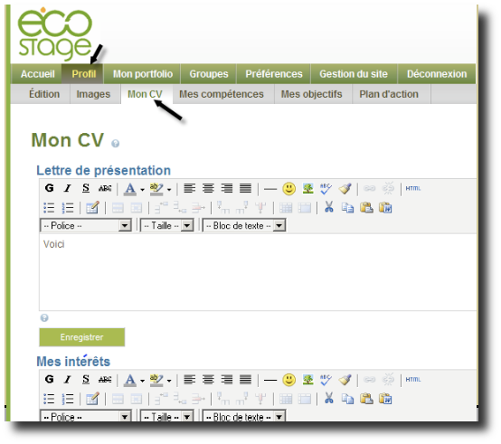
In the case of the development of "eco-citizenship" in Katimavik, there is an agreed-upon framework of competence and each individual, depending on his/her specific interests, intern context, and experience will be developing competences in different ways. Monique Charpentier, eco-internship project manager, explains, "The intern experience IS the learning program". It is the competence framework that helps to commonly express learning that has occurred and the ePortfolio to capture, demonstrate, reflect upon and communicate competence as it develops”. This is an exemplary ePortfolio initiative, however it is presently only being implemented in Québec, Canada though there are discussions for expanding wider.
ecoInternship ePortfolio - cf interview

Professionalisation of a Field of Work
ePortfolio processes offer great potential in helping a field of work to professionalise, or to gain in credibility and self-confidence. In the case of community and development workers and change agents, where roles are neither clearly defined nor recognised by society, common competence profiles and e-portfolio processes can help to bring together and unite a professional field, developing a sense of professional identity, pride and value that is crucial to maintaining committed professionals in their line of work. (Reference Darren Cambridge, 2009, Electronic Portfolios 2.0 http://ncepr.org/darren/publications.html)
This is particularly important given the increased professionalism of development work along with the increased accountability requirements for development activities. Using e-portfolios to critically reflect on the type of professional one is, and would like to be, can be facilitated via a personal online environment in which one may maintain and reflect upon one's work, achievements, thoughts. In this way the e-portfolio process support the development of a long-term and integrated view of one's learning and career and a person's professional identity.
We were unable to locate any such practice, and no such use of ePortfolios and digital identity. However, the potential and need seems to be apparent. For example, Paul West, Director of Knowledge Management and Information Technology at the Commonwealth of Learning (COL), points out that there is a real need to raise the profile and status of teaching, especially across Africa where there is a dire shortage of teachers. He states, "There is a perception amongst teachers that they are at the bottom of the ladder of employment. Teachers seem to be prepared to leave the profession for just about any other kind of employment." By professionalising and increasing the status of the teaching profession, giving it value and respect, there could be a positive effect of teachers motivated to enter and stay in the profession. Though the COL is not actually involved in ePortfolio initiatives it reaching out in that direction (see website, new ePortfolio section).

Intra and Inter Organisational Information Sharing, Collaboration and Communities of Practice
Online ePortfolios can also serve the role of knowledge management or information sharing; they are a place to collect and collate activities, demonstrate competence, and bring together the mass of knowledge that is usually either tacit or dispersed. The benefits of having an evolving knowledge base, at whatever level, are numerous: from induction, to continual improvement, to sharing knowledge development, collaboration, etc.
Though a northern, learning institution project, the online course, "Principles and Tasks of Leadership," offered by the University of Hamburg to students in developing countries across the globe makes use of what they call the “basic” ePortfolio (BeP). Beyene Berhanu, who has used ePortfolios in parallet to formal learning since 2005 with students in Africa and Asia, explains that the ePortfolio serves "to enhance intercultural collaborative learning". This pilot project has demonstrated that by editing and publishing their personal profiles via their ePortfolio, students across more than 15 countries have increased interaction and collaboration.

ePortfolio from the course Principles and Tasks of Leadership

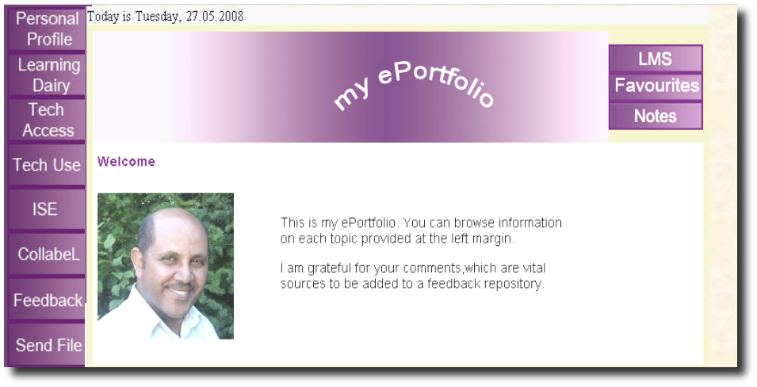
Thanguy Nzue Obame, co-founder of forum des Amis du Net and Coopgabon.net in Franceville, Gabon, Africa, and local independent trainer for national and international organisations such as Agence Universitaire de la Francophonie (AUF) and World Health Organization (WHO) recounts how the portfolio experience contributes to collaboration:
... while profiling freely on a social network dedicated to cooperation and development, I can see the efforts done by other social entrepreneurs worldwide to share the results of their personal and collective development. This is great because it generates a hierarchy of contributors and various thematic communities of practices, like in wikipedia, but this time for fields actors of civil society. It is very motivating for a person living in Gabon or in Congo Kinshasa to discover and share the actions of NGO leaders in Ouagadougou or Bamako without depending on occidental support, thanks to ePortfolio processes. It is also a way for me to see if my local potential NGO partners are seriously involved into social entrepreneurship or not : I look at their personal site, see if it is updated, if content is relevant, etc.

ePortfolio Systems, Content and Support Models

Though the study revealed almost no activity in ePortfolios and digital identity initiatives in the cooperation and development the related initiatives when compared do bring to light some information related to ePortfolio technology, content and support models. Those not directly part of the study, it is helpful to share them here because they could be useful for the context of any future development.

Technical Systems
There is a growing number of technical systems to support ePortfolio processes. These can be organised into three different types of ePortfolio technical solutions (Cégep@distance and SOFAD 2006, p. 39)
- non-dedicated tools such as blogs platforms
- off-the-shelf dedicated ePortfolio systems, both proprietary and free and open-source
- tailor-made ePortfolio systems, i.e. context-specific developments
For example, blogs serve to profile oneself in the public internet realm and can support reflective informal learning processes in either a non-structured or structured way, depending on whether guidelines are present. For example, Kabissa provides online space without stipulating what should be included.
Katimavik, on the other hand, has adopted Mahara, a free and open-source ePortfolio system (which they translated into French for the community of users). Though Mahara offers many ePortfolio features, it lacks the means to integrate a competence framework, so the system was "tweaked" to embed a competence matrix.
Noosfero, part of the ecoPC coalition (including African, European, North & South American partners) works with the www.Zen3.net platform which offers basic e-services for all : ePortfolio free hosting together with social networking tools, professional email, intranet and training tools, without adds, and with possibility to chose different graphic layout and to add independent domain names.
Note: It is not within the scope of this study to conduct a comparative analysis of ePortfolio systems, nor to address issues of mobility, durability and the protection of data or issues of control of permissions.

ePortfolio Contents
Despite the fact that the terms used within ePortfolios change from one culture or context to the next, we do continue to see very similar elements included within ePortfolios. Here is a brief summary of the recurring types of content that can be found in ePortfolios :
- personal profile (including interests, values and beliefs, dreams and goals, personal description, psychometric tests, personality characteristics, preferences etc.)
- work experiences
- learning experiences (depending on the context this might include general life experiences)
- competence/strengths/expertise (again, depending on the context, this might include formal competence matrices, and it might distinguish between technical competence and generic competence and even sometimes between competences the individual is interested in developing or not)
- artefacts of achievement or activity that demonstrate competence
- thoughts and reflections on specific artefacts, specific competences
- tools to communicate to employers, potential employers, clients etc. (such as a curriculum vita or summary of core competences)
- tools to explore career opportunities, develop a learning plan or seek employment or develop a project
- resources and even services that are embedded within the ePortfolio
- an inventory of networks, resources, information feeds that an individual taps into for learning
- an expression of learning, such as a blog, to provide more regular reflections on learning and activities
A key structural element of ePortfolios is competence frameworks or matrices. At one end of the systems spectrum, the user can identify or create their own competence framework. At the other end of the spectrum there may be a fixed and standard competence framework.

ePortfolio support Models
Support is essential to the success and pertinence of an ePortfolio practice. The degree of human support required depends on diverse factors: the context, the ease of use of the ePortfolio owner in ICT, the support embedded within the ePortfolio system, etc. For example, for a person who wants to record generic competences in their ePortfolio, a dedicated page with examples, activities and competence frameworks does not require the same amount of support as a simple blank page. The user needs to understand what is meant be a generic competence, have an appropriate competence framework, and be able to reflect on and demonstrate their competence. These types of tasks are not yet familiar to us and we are truly transitioning to competence based approaches and require support. During this transition period there is even a need to "train the trainer".
In the example of Katimavik, working with young digital natives and a structured ePortfolio, a half day of ePortfolio training with an external expert was deemed sufficient to introduce users to the ePortfolio as a concept and explore its potential. This introduction is then followed up through support from internship coaches. The challenge in this situation is developing the ePortfolio expertise of the coaches, who are also new to the world of ePortfolios.
In the cooperation.net model (developed by Ynternet.org since 1998 with support of SDC, Swiss Agency for Development and Cooporation ), all training tools and material are accessible to all potential trainers as soon as they show their ability to show evaluators or to all internet users the results of their own ePortfolio process. Then the potential trainer receives certification after having given proof of ability to coach others to develop their ePortfolio.

ePortfolio Synergies
There is an enormous potential and need for ePortfolio synergies. We have identified three types:

From Complementary Tools to Essential Tool
As more and more organisations move their activities online, internauts are required to manage an ever-larger and more complex set of accounts and user profiles. It is therefore more and more important to develop an online space that supports the integration of one's fragmented activities, learning, and online presence. Project proposals could require that individuals or organisations include ePortfolios, allowing them to become more and more part of common practice and connecting them to different systems. This step also increases the transparency of organisations and their activities.

Common Knowledge Base
Adopting and integrating an ePortfolio approach to support professional and human development involves many inherent challenges: a shift in professional human development, work culture, technological and accessibility decisions, related policy issues, training and support structures, etc. At the same time, there is no fixed way of setting up and using ePortfolios.
Given this open field, producing quality and robust tools and activities to support ePortfolio and digital identity processes that can be used freely in local languages and local ways can be complex.
Developing an online resource centre specific to human resource development and the context of international development and cooperation could be helpful for all. This resource centre could include such elements as steps to integrate ePortfolios, explanations of how they are structured and supported, lists of policies that have been put in place, technological approaches, certification modules, and so on. Such a resource centre could be ideally set up as an evolving open knowledge base, much like wiki patterns.

ePortfolio Coalition
It is beyond the means of small organisations to undertake these challenges on their own and it is detrimental to the common good for all organisations to try to make headway independently. Instead, different organisations could partner to develop or improve a common technological platform and development process coalition. This coalition would need to be multilingual, multidomain, multigraphical, and fitted with multicontent types.

Qualitative analysis and possible future strategies

Success
The research and interviews revealed a normal and almost inevitable convergence between new ePortfolio processes and the trends impacting e-learning and professional development - that is, a shift toward competence-based approaches and lifelong learning.
Also, "ePortfolio development can make CPD a more natural process for professionals in a number of important ways: links can made to a membership database so that personal information can be incorporated into a CV; ePortfolio development can be used in appraisal; and evidence in undertaking additional responsibilities could lead to accreditation in some circumstances. But the chief gain may lie in enhancing the professionalism of practitioners" (JISC, 2008).
The study helped to clarify an interest in and potential for ePortfolios in professional development. In the international cooperation and development field, we identified five areas (section 2.1. to 2.5) in which ePortfolios could have a positive impact. It seems that when an organisation is seeking to renew or innovate its approach to learning, ePortfolios are an ideal tool to support and evidence novel practice.

Weaknesses
The study identified and interviewed far fewer ePortfolio practices in the area of training in international cooperation and development than it would have liked. It would perhaps have been simpler to reframe the study to explore potential interest and impact of ePortfolios in training in cooperation and development agencies and organisations. Indeed, the interview with the Commonwealth of Learning turned into such a discussion.
As for organisational ePortfolios, in 2009 the domain is so recent that only a few experimental examples could be identified (see section 5); and these are outside the realm of cooperation and development agencies. Given the immense potential in this area, it is an ideal opportunity to reenforce the cooperation between major stakeholders and agencies within existing and future ICT4D coalitions.

Obstacles
The concept and term ePortfolio is not yet part of common usage. Therefore, seeking out ePortfolio initiatives or related initiatives is not easy with this lack of common terminology.

Contacting individuals was not an easy task. Many contacts made where difficult to follow up on since individuals were travelling or unavailable within the time line required.

The interview questions were designed for ePortfolio initiatives and had difficulty to identify related processes or inititiatives.

Potentials
This study has helped to identify potential areas of impact of using ePortfolios for within professional development in the context of development and cooperation work.

Valuing and Leveraging Incidental Learning
In the work world, professionals from afar are often brought together for face to face meetings to work on a particular challenge, project or theme. ePortfolios are an ideal means to capture the significant informal learning that takes place during these events. In this way, the monies spent at the meetings are being used for a double purpose, (1) attaining the planned meeting output, and (2) contributing to the professional development of the meeting participants. This could form an interesting rationale to justify and seek out budgets with stakeholders.
Using ePortfolios to support this type of learning has the added value of providing a long-term, integrated view of all the isolated and fragmented events that are related to one's learning and professional development. Overall, it is a rich and motivating approach to professional development.

Shifting to Competence-based Approaches and Lifelong Learning
There is presently a shift to competence-based approaches and lifelong learning within education, training and learning, both in the north and in the south. Finding actual means and tools to support this paradigm shift is not an easy task, however: ePortfolio processes are naturally in line with these approaches and can serve as the "disruptive technology" that accompanies the organisational change.

Integrated Approach for ICT Competence Development
We are going through a phase of digital literacy towards a phase of digital fluency. There are fewer and fewer courses geared toward computer use for its own sake. The actual experience of developing one's ePortfolio is in itself an excellent means to develop one's facility with computers, within a context that is motivating for the individual while contributing at a broader level to an individual's professional development.

Possible future steps

Innovative Pilots
Now is the time to set up some innovative pilots in the field. These would best be set up as partnerships and should be followed by ePortfolio university research. The field needs leadership and those groups that begin the pilots will be making valuable contributions to this leadership role.

ePortfolio Tools for All
Many organisations in the north are jumping on the ePortfolio bandwagon. While the same advantages are also true for the south, however, the south does not have the luxury of reflecting on and developing this area on an organisational basis. Ideally there needs to be a concerted effort. Developing and implementing tools that can be used freely and are sensitive to local languages and traditions would be helpful. For example, on an individual level, processes of how to identify and demonstrate competence, how to develop a personal learning plan. Also on an organisational level, how to make an inventory of organisational competence, how to begin developing a participatory knowledge base, develop collaboration and transparency online.

Online Collaborative Knowledge Base
Develop an online open and dynamic syndication tool to serve as a knowledge base and resource center to support, encourage and share information, pilot projects and best practices in this new area of ePortfolios to support professional and human development. The space could be tailored to the specific area of international cooperation and development; yet its pertinence extends to the general sector of human resource development, whatever the field of practice.

ePortfolio processes to facilitate transition from training to human development
Governments and their related partners can promote the adoption of ePortfolio capacity building processes to facilitate transition from a traditional training model to a learning or human development model. The study did not come up with many examples of such intiatives.

Conclusion and Strategic Recommendations

The example from Katimavik (Canada) and UNESCO (Dakar UN Youth forum, with Cooperation.net network) demonstrates well how ePortfolios could be used in the context of cooperation. However, thus far these types of experiences are limited to the north. The study identified only a single ePortfolio initiative directly related to cooperation and development, that of cooperation.net
However, we can see that there are related initiatives such as summary profiling (for example, D-groups) or reflective practice activities in face to face training workshops – that could eventually evolve into ePortfolio initiatives. Indeed, some organisations openly express interest in moving in that direction, sensing the potential (for example the Commonwealth of Learning).
The research and interview process did help to identify five potential areas of use and impact of ePortfolios in cooperation and development:
- empowering individuals and organisations;
- supporting deep and complex learning;
- expanding types of learning (work place learning, non-formal learning);
- contributing to the professionalisation of a field of work (for example teaching); and
- intra and inter-organisational information sharing, collaboration and Communities of Practice.

The study allowed to very succinctly identify types of ePortfolio systems, how the content of ePortfolios is often similar, the key role of competency frameworks and the possibility of various ePortfolio support models.

Also a few ePortfolio synergies came to light from the study:
- beginning to embed ePortfolio links in organisational processes (such as project proposals);
- development of a common knowledge base on emerging practice; and
- an ePortfolio coalition for a collective approach to software development.

Though the potential around ePortfolio and the interest in moving in that direction seems evident the weakness of the study was that very few direct examples of significant practice were identified. The obstacles in the study stem from the lack of common usage of the term “ePortfolio” which makes it difficult to identify direct or related practice. The opportunities that emerged from the study relate to challenges organisations are dealing with today, be they valuing and leveraging incidental learning, shifting to competence-based approaches, making the transition to lifelong learning or developing an integrated approach for ICT competence development
Future innovative pilots, ePortfolio tools for all, on-line collaborative knowledge base and ePortfolio processes to facilitate transition from training to human development are all possible future steps that could be taken that would help to move forward in the direction of ePortfolios. It is what is taking place in the North and in academia. In the context of cooperation and development have a potential to support changes and challenges occurring in the human development area, but the area remains, for now, uncharted territory.

Agencies and Organisations Explored within the Study

Methodology and preliminary comment on agencies and organisations explored :

1. Some experiences were studied with interview, some others with on-line research, informal contacts, analyze of publications and of existing guides, results...

2. Most of the major ePortfolio initiatives identified and studied before and during the Maastricht eP & digital Identity conference (October 22-24 2008, Netherlands, major event on this topic, gathering over 300 ePortfolio experts from 4 continents) were developed by Universities of education governmental agencies which have no direct implication in North/South cooperation. These most inspiring experiences are not emerging from cooperation and development agencies, but from educational governmental institutions.

3. Many organizations have developed ePortfolio processes without naming it that way.
4. When making the interviews, 5 of the 10 organizations interviews announced that they had no real ePortfolio experience to share nor information available.

Action Aid International – The knowledge Initiative
www.actionaid.org
An international anti-poverty agency based in Johannesburg, South Africa, helping 13 million of the world's poorest individuals in 42 countries. The Knowledge Initiative is a space within Action Aid which allows it to be visionary, like an internal think tank. KI aims to deepen existing organisational knowledge and package it into an accessible format for the organisation and beyond. KI's overall aim is to challenge Action Aid to work better within its rights approach.

Ghana Information and Knowledge Sharing Network - GINKS
www.ginks.org
Promoting ICT as a tool for development.
Sharing activities and competence of the members of the collective PRO-FEMMES in accordance with its mission of dissemination and capacity building in communication, permitting exchanges via internet with other women and organisations in the world.

HIVOS Media information and Communication programme - MIC
www.hivos.nl
Aims to empower citizens in development countries and the organisations that support them – to express their voices and make them heard.
HIVOS community: www.hivos.nl/eng/community/directory

Dgroups: Development Through Dialogue
www.dgroups.org/

Fostering groups and communities in international development, a partnership catering to both individuals and organisations by offering tools and services that bring people together: a team, a group, a network, a partnership, a community. A simple, non-commercial environment respectful of privacy and targeted at low band with users in the South. Over 2,500 groups, and 100,000 members.

Commonwealth of Learning (with interview)
www.col.org

An intergovernmental organisation of the Commonwealth countries dedicated to promoting and delivering distance education and open learning. Its mandate is to be in the vanguard of technological change in education and training. Projects explored within the interview process for potential added value via ePortfolios: Virtual University for the Small States of the Commonwealth (VUSSC): http://www.col.org/colweb/site/pid/100
and Open Schools initiative
http://www.col.org/colweb/site/pid/5289

FAO Information Management Resource Kit Initiative – IMARK (with interview)
http://www.fao.org/

IMARK is a partnership-based e-learning initiative to support training individuals, institutional delegate and networks world-wide in the effective management of agricultural information. IMARK consists of a suite of distance learning resources, tools and communities on information management.

Forum des amis du Net Gabon – FAN (with interview)
http://www.coopgabon.net/fan

This NGO, developing project by various agencies, trains on webpublishing for youth. It takes part in various periodic events and conferences, nationally and internationally, to empower youth exchange of information and cooperation through the Internet.
Over 300 ePortfolio were developped by this NGO with support of Francophonie and SDC.
UNI-HAMBURG ePORTFOLIO RESEARCH INITIATIVE (with interview)
http://minilien.com/?1us2aqM8rB
http://www.oncampus.pl/index.php?id=1144&L=1

Association to support e-learning in developing countries, starting with use of ePortfolio to foster mutual Intercultural Collaborative Online Learning between students and actors of civil society, with support of governements.
International Institute for Communication and Development IICD - (with interview)
www.iicd.org/
A non-profit foundation that specialises in information and communication technology (ICT) as a tool for development. IICD creates practical and sustainable solutions using both modern media (such as computers, Internet, email and multimedia) and traditional media (such as radio and television) to connect people and enable them to benefit from ICT, thereby contributing to the Millennium Development Goals.

INwent Capacity Building International
www.inwent.org/
A non-profit organisation with worldwide operations dedicated to human resource development, advanced training and dialogue.

Katimavik - Eco-intership Program (with interview)
www.katimavik.org
The largest Canadian volunteer service organization that aims to empower youth and young adults to make a significant contribution to local communities and participate in nation-building while fostering their personal and professional development through a challenging youth-volunteer, leadership and service-learning program.

Kabissa – A network of African civil society organisations
www.kabissa.org/
Seeks to strengthen the capacity of African non-profits to build civil society and democracy in Africa
contact via ICT resources (such as Time To Get Online) and Social Networking for African Organizations

KASA Komitas Action Suisse-Arménie (with interview)
www.cooperation.net/kasa

Promoting solidarity, sharing competences and sustainable development in Armenia.
Has developped an ePortfolio strategy together with various national and international institutions, to train civil society and other bodies on ePortfolio and digital Identity processes.

NOVATION INTERNATIONALE (with interview)
www.cooperationtogo.net/novation

Promoting education processes aiming in changemaking within civil society. Has developed an initiative on training and coaching young Internet trainers, helping them generate incomes and federate themselves internationally to empower ePortfolio development. Hundreds of ePortfolio (individuals and groups) developped under their authority.

Mount Royal College, Canada
http://conted.mtroyal.ca/community/
International Community Development Certificate, offered online, is designed to prepare employees and volunteers of development agencies to understand global issues and work in developing communities around the world. Part of the program includes becoming “an advocate for change in helping people and communities around the world to reach their potential”.

New Era Educational and Charitable Support Initiative (NEEDCSI)
www.needcsi.org/
An non-governmental, non-religious, non-political, non-ethnic, non-profit and charitable educational support organization dedicated to supporting the educational goals and aspirations of the less privileged Nigerian children.

Swiss Agency for Development and Cooperation
www.ddc.admin.ch/
Switzerland’s international cooperation agency within the Federal Department of Foreign Affairs (FDFA). In operating with other federal offices concerned, SDC is responsible for the overall coordination of development activities and cooperation with Eastern Europe, as well as for humanitarian aid.

United Nations Institute for Training and Research
www.unitar.org/
UNITAR's mission is to deliver innovative training and conduct research on knowledge systems to develop the capacity of beneficiaries.

Youth Employment Systems (YES)
http://www.yesweb.org/
The YES Campaign was launched by 1600 delegates from 120 countries at the Alexandria Youth Employment Summit, in Egypt on September 11, 2002. The campaign has three goals: develop capacity of youth to lead in-country youth employment initiatives, promote youth employment to address key development challenges and build in-country coalitions to develop national strategies addresssing youth unemployment.

Ynternet.org
http://www.ynternet.org/
Foundation for research and training in eCulture, taking part in various ePortfolio multilateral projects from European Union and managing ICT for Development programmes in areas such as North/South Cooperation, Youth empowerment, Adult Lifelong Learning and training of trainers .

Publications and Presentations Related to ePortfolios
These
Beyene, B (2008) Model for e-Portfolio-based Feedback from Intercultural Collaborative eLearning in Developing Countries, (paper forthcoming) http://events.eife-l.org/ep2008/conference/programme-1

Cégep@distance and SOFAD (2006) Le portfolio numérique : un atout pour le citoyen apprenant
http://sofad.qc.ca/pdf/portfolio_numerique.pdf
Cooperation.net programmes &network for NGO solidarity, the Cooperation methodology for ePortfolio development http://www.ynternet.org/ynternet.org/info/110992
Hink, M. (Logica), Riedstra, L.(Ministery of Defence) (2008) Introducing an ePortfolio to stimulate career skills. The company wide introduction of an ePortfolio at the Dutch Ministry of Defence, (paper forthcoming) http://events.eife-l.org/ep2008/conference/programme-1

IMS (2004) ePortfolio Brochure
www.imsglobal.org/ep/ePortfoliobrochure.pdf

JISC (2008) Effective Practice with e-Portfolios Supporting 21st Century Learning 2008
www.jisc.ac.uk/effectivepracticeePortfolios

République Tunisienne, Ministère de l'Éducation et de la Formation (2004, updated 2005) Projet d'amélioration de la qualité du système éducatif Tunisien (PAQSET), consultation relative à la formation des formateurs professionnels : Dossier de suivi bilan des participants

Schmidbauer, A. (2008) e-Portfolios at the Workplace: A Link between Individual and Organisational Learning

Sterling, S. (2003) Article in La Revue Durable, N°8, CERIN Ed., Fribourg, CH
http://www.nachhaltigkeit.at/monthly/2004-02/pdf/sterling_artikel.pdf

Events Attended in the Context of the Study

32nd International Public ICANN Meeting
par.icann.org/

Conférence de Lyon pour la solidarité numérique
http://www.digitalsolidarity2008.org/
ePortfolio and Digital Identity http://events.eife-l.org/ep2008/

ePortfolio Centres of Research and Information
This is what
Resources center to create your own ePortfolio
www.iportfolio.fr

EIfEL (European Institute for E-Learning)
www.eife-l.org/

IMS Global Learning Consortium
www.imsglobal.org/ep/

International Coalition for Electronic Portfolio Research
www.ncepr.org/

Joint Information Systems Committee (JISC)
www.jisc.ac.uk/whatwedo/themes/elearning/ePortfolios.aspx

The Centre for International ePortfolio Development
www.nottingham.ac.uk/ePortfolio/

Ynternet.org Foundation, ePortfolio resource centre for trainers of trainers
www.ynternet.org/ePortfolio

INTERVIEWS
The interviews have been realized in english or French, depending on the language of the person interviewed.

The questions

 | Brève description de votre organisation | Brief description of your organisation
1 | Délégué d’Ynternet.org qui a réalisé l'interview | Ynternet.org delegate who realized the interview
2 | Personne de contact et coordonnées complètes. | Contact person & full datas.
3 | Date-s de réalisation de l'interview. | Day-s the interview was/were realized
4 | Description de l'organisation | Description of the organisation
 | Description du produit de formation | Description of the training product
5 | Le produit de formation.  5a) Nom du produit de formation ou nom du projet/programme/initiative dans lequel la formation a été donnée (si le produit n'a pas de nom)  5b) Description générale du contenu du produit de formation (contenu du cours) | The training product.  5a) Name of the training product or, if product has no name, name of the project/programme/initiative in which the training has been given  5b) General description of the content of the training product (content of the course).
6 | Contexte général : Quel était le contexte de développement de l’initiative / programme de formation ? | Context (general description) : What was the context of development of the training initiative / program?
7 | Objectifs du projet : quels sont les défis que ce projet/programme se propose de relever ? | Objectives of the project : what challenge is the project/ program adressing ?
8 | Public visé : qui sont les bénéficiaires ? | Target public : who does it serve ?
 | Caractéristiques du produit de formation | Features/caracteristics of the training product
9 | Combien des personnes ont participé ? | How many people have participed ?
10 | 10a) Depuis quand ce projet existe-t-il?  10b) Durée du projet ?  10c) Durée de la formation proposée (durée du cours) | 10a) How long has it existed ?  10b) Duration of the project ?  10c) Duration of the training (duration of the course)
11 | Durabilité ?  Est-ce que le projet/programme/initiative est en phase pilote ? Ou largement déployé? Ou bien établi ? | Sustainability ?  Is the project/programe/initiative in a pilot phase ? Or widely spread practice/project ? Or well established ?
12 | Frais de participation aux cours ? | Fee for participants to the courses ?
13 | Coûts du projet ? | Global costs of the project?
14 | Environnement technique.  a) Logiciels utilisés ?  b) Licences : sous quelle licence sont les logiciels utilisés et les contenus des programmes pédagogiques ? Licences libres (comme les CC, la GFDL) ou tous droits réservés ? | Technical environment  14a) Softwares used.  14b) Licensing : under which licence are the softwares used and the training contents ? Free licences (such as CC, GFDL) or all right reserved ?
 | Gestion de la formation | Management of the training
15 | Ressources humaines engagées : formateurs, accompagnateurs, autres spécialistes à signaler ? | Human resources involved : Trainers, coaches, other specialists that should be named ?
16 | Quel a été le rôle / la place du responsable de projet/programme ? | Role of the programme managers in this project/programme / practice?
17 | Défis actuels du projet/programme? | Current challenges of the project/programme ?
18 | Comment envisagez-vous de l'améliorer à l'avenir ? | How do you envisage improving it the future?
 | Références | References
19 | Est-ce que les cours sont en ligne ? Si oui, à quelle-s URL ? | Is it online ?  If yes, at which URL-s ?
20 | Avez – vous des articles ou publications qui peuvent être référencées ? | Do you have any articles or publications that can be referenced ?
21 | Avez – vous des références et contacts pour d'autres initiatives de ce type ? | Do you have referrals for other such initiatives ?
22 | Souhaitez – vous ajouter des informations sur les moyens utilisés et le projet lui-même ? | Do you wish to add information about tools used and the project itself?

COL – COMMONWEALTH OF LEARNING

PART A. Brief description of your organisation
PART A. Brève description de votre organisation
1 | Samantha Slade
2 | Mr. Paul G. West  Director, Knowledge Management & Information Technology  Commonwealth of Learning  1055 West Hastings Street, Suite 1200  Vancouver, BC V6E 2E9  CANADA  Tel: +1 604 775 8236  Fax: +1 604 775 8210 E-mail: pwest@col.org
3 | November 7th, 2008
4 | The Commonwealth of Learning (COL) is an intergovernmental organisation created by Commonwealth Heads of Government to encourage the development and sharing of open learning/distance education knowledge, resources and technologies. COL is helping developing nations improve access to quality education and training.

PART B. Description of the ePortfolio training initiative
PART B. Description de l’initiative ePortfolio
5 | COL is working with educators in six countries - Botswana, India, Lesotho, Namibia, Seychelles and Trinidad & Tobago  It aims in developing and sharing open educational resources (OERs) for secondary education, the professional development of teachers in the effective use of technology in classrooms and creating learner support material for teachers.  It's just getting started in 6 countries. Teams of teachers in each of those countries  expand out to other teachers to improve their teaching practices
6 | Mandated to be in the vanguard of technological change in education and training, COL and its international network of partner organisations have helped the Commonwealth's 53 member nations and their citizens realise widespread access to quality, current education and training for over fifteen years.  COL helps developing Commonwealth countries to increase access to learning using distance education and appropriate technologies. Its work is grouped into three sectors of activity: education, learning for livelihoods and human environment.
7 | Open Schools initiative(s)  As primary school enrolments grow due to successful efforts to meet the United Nations Millennium Development Goal of Universal Primary Education, many nations are unable to accommodate the corresponding increase in potential secondary school students. Open Schooling is increasingly recognised as a viable solution to the lack of qualified teachers and conventional schools in the developing world.  The Commonwealth of Learning helps governments and institutions to expand the scope, scale and quality of learning by using new approaches. COL promotes policies and systems to make innovation sustainable and works with international partners to build models, create materials, enhance organisational capacity and nurture networks that facilitate learning in support of development goals.  Access to learning is the key to development.
8 | Open school, as expansion of existing school base, in those they are 200 000 kids which don't see the inside of a school - for those who don't get to a school - a parent could give materials to their children - fairly illiterated parents - aimed at non-formal school - if is useful in regular schools as well - that is a bonus.

PART C. Features/caracteristics of the ePortfolio initiative
PART C. Caractéristiques de l’initiative ePortfolio
9 | 6 countries - and then each one will work with a team of people - lead teachers and then expand from there
10 | N/A
11 | Tangibile goal is courses for schools - by- product is professional development of teachers - capicitating people involved  Funded to the end of production of the materials - need people to be "sharing" (atleast online) .
12 | N/A
13 | N/A
14 | 14a) no ep platform - seeking one (not actively)  14b) creative commons

PART D. Management of the training
PART D. Gestion de la formation
15 | 5 trainers of trainers in each countries
16 | My colleague - francis ferrera - not directly involved but involved with some of the training - side- line support
17 | Challenges specificic to the develop of the course content:  - the actual goals in both these projects is systemic change within countries and this is long and challenging.  Challenging context: technically challenges of acces to equipment and bandwidth, but also issues of time.  Underlying, is another challenge and that is the fact that the teaching profession is undervalued in many countries - and accordingly teachers and lecturers are underpaid. The general teacher shortage in these countries, and low status according to the professional field of teaching. Teachers truly perceive themselves as at the bottom of the employment ladder and are ready to move on to any other type of work. If it was possible to capture some of this rich learning that takes place.
18 | Stronger network of institutions that have capacity to offer courses online to international audiences - (usually send people abroad to study) want to go to small states to study If it was possible to capture some of this rich learning that takes place  ePortfolios have a potential for these types of projects in the future to capture the diverse learning that occurs while the course productions go on: for example, ICT skills, intercultural capacities, team work, leadership, etc. At the same time that "project participants" are producing the deliverables they are learning, and this learning could be captured and valued and become part of a continuing professional development process.  Given that formal courses have a limited life span for their usefulness it is important to build in continual learning process. The informal learning that takes places during these types of projects needs to be captured and valued - even recognised.  Firstly, this could be with lecturers and teachers and also for IT staff who work in a field that requires an intense and regular level of lifelong learning. Possibly management could also benefit from such an approach, but in general they already have both a sense of professionalism and are taken care of.  note: in the Open School project, in early 2009 is training of teams of teachers - if there was a simple system of recording their learning with an ePortfolio system, it would be interesting to try it

PART E. References
PART E. Références
19 | No
20 | http://www.col.org/colweb/site/cache/offonce/pid/5099
21 | None
22 | The need for an ePortfolio system is specifcally one with which non technical users could work offline and online (like thinkfree.com) with templates that help make the tasks more simple and tangible. Also, the actual solution would need to be sustainable, that is either with advertisements etc. because in the case of developing countries the users are not in a position to be paying for the service.  The conditions expected are :  Technically simple - yet can work - capture stuff offline - and then put it online - templates - interesting use of IT - learning and training - innovative practice that will eventually come to them - this isn't something -  Sustainability needs to come from something like advertising computer navigator's certificate, which is a free alternative to ECDL (ECDL is too expensive)  COL were requested to come up with some alternatives, this is why we set out curriculum outline.

FAO / IMARK INITIATIVE

PART A. Brief description of your organisation
PART A. Brève description de votre organisation
1 | Théo Bondolfi
2 | Charles Andrew Nadeau Andrew.Nadeau@fao.org  Cristina Peracchi Cristina.Petracchi@fao.org  FAO – Roma - Capacity Building and Outreach Branch  Knowledge Exchange and Capacity Building Division  ++39 06 5705 3876 www.fao.org www.imarkgroup.org
3 | 18 juillet 2008
4 | The Information Management Resource Kit (IMARK) is a FAO initiative from the Knowledge Exchange and Capacity Building Division (KCE).  IMARK is a partnership-based e-learning initiative to support training individuals, institutional delegate and networks world-wide in the effective management of agricultural information. IMARK consists of a suite of distance learning resources, tools and communities on information management.

PART B. Description of the ePortfolio training initiative
PART B. Description de l’initiative ePortfolio
5 | Not available (N/A)
6 | Not available (N/A)
7 | Not available (N/A)
8 | Not available (N/A)

PART C. Features/caracteristics of the ePortfolio initiative
PART C. Caractéristiques de l’initiative ePortfolio
9 | Not available (N/A)
10 | Not available (N/A)
11 | Not available (N/A)
12 | Not available (N/A)
13 | Not available (N/A)
14 | Not available (N/A)

PART D. Management of the training
PART D. Gestion de la formation
15 | Not available (N/A)
16 | Not available (N/A)
17 | Not available (N/A)
18 | Not available (N/A)

PART E. References
PART E. Références
19 | Not available (N/A)
20 | Not available (N/A)
21 | Not available (N/A)
22 | IMARK is interested in developing ePortfolio resources

FORUM DES AMIS DU NET – GABON

PART A. Brief description of your organisation
PART A. Brève description de votre organisation
1 | Théo Bondolfi
2 | Thanguy Nzue Obame  www.coopgabon.net/thanguy  thanguy@coopgabon.net  ONG Forum des Amis du Net  www.coopgabon.net/fan
3 | 21.10.08
4 | FAN (Forum des Amis du Net) forme les personnes qui le désirent à la création de contenu internet, à la protection de l'environnement à travers l'usage des technologies de l'information et de la communication. FAN favorise l'échange entre jeunes de tous les horizons du Nord comme du Sud. FAN organise ou participe à de nombreuses manifestations gabonaises ou internationales sur le thème de l'internet tels que les netdays, le CIPUF,..

PART B. Description of the ePortfolio training initiative
PART B. Description de l’initiative ePortfolio
5 | Accompagnement à la réalisation de site pour se profiler sur le web.
6 | FAN a réuni de nombreux leaders associatif et jeunesse au Gabon pour développer des programmes de formation à l'usage d'internet dans le but de favoriser la citoyenneté et l'appui au ONG locale.
7 | Développer et animer une communauté virtuelle regroupant les leaders “entrepreneurs sociaux” du Gabon et les relier avec le monde pour qu'ils puissent mieux bénéficier d'opportunités de coopération et de développement personnel et collectif.
8 | Les jeunes passionnés d'internet qui souhaitent en faire une activité tant sociale qu'économique.

PART C. Features/caracteristics of the ePortfolio initiative
PART C. Caractéristiques de l’initiative ePortfolio
9 | 317 bénéficiaires sur 5 ans ont réalisé un e-portfolio complet avec validation. Liste complète disponible sur: http://www.coopgabon.net/cms/id/list/com.html
10 | 10.a) 2003  10.b) En cours  10.c) de 1 à 12 mois selon les compétences et les expériences déjà réalisées par les “aspirants médiateurs”.
11 | Bien établi
12 | Les frais de participation au cours sont payer par les bénéficiaires au cas par cas, soit avec des fonds de partenaires tiers, soit directement de leur poche, à des tarifs modestes mais qui permettent néanmoins aux formateurs de gagner leur vie.
13 | Via la DDC, plusieurs formateurs et volontaires ont formé les formateurs “incubateurs” de FAN pour le développement d'une communauté virtuelle. Le coût du projet n'est pas fixe puisque ce sont les bénéficiaires qui paie directement les animateurs, surnommés médiateurs internet, au cas par cas.  Financement: Agence universitaire de la francophonie et Direction suisse de la Coopération et du Développement
14 | 14a) Plate-forme web d'hébergement d'e-portfolio www.coopgabon.net  14b) logiciel libre

PART D. Management of the training
PART D. Gestion de la formation
15 | Des incubateurs de micro-entreprise de formation internet, des formateurs “micro-entrepreneurs”, des volontaires internationaux pour accompagner le lancement de cette structure autonome et autogérée de prestations de service de formation internet
16 | Accompagnement sur place et à distance
17 | Assurer la pérennité du programme avec des personnes véritablement capables de générer des revenus en vendant de l'accompagnement à l'usage de cet outil.
18 | En diversifiant les producteurs de contenu, ce que nous nous réjouissons de faire dès que la nouvelle plate-forme pour coopgabon.net sera fonctionelle, ce qui est prévu pour dans quelque mois.

PART D. Management of the training
PART D. Gestion de la formation
19 | Oui  www.coopgabon.net
20 | Oui  c.f www.coopgabon.net, nombreuses informations ressources
21 | Oui  takingitglobal.org / idealist.org
22 | ... while profiling freely on a social network dedicated to cooperation and development, I can see the efforts done by other social entrepreneurs worldwide to share the results of their personal and collective development. This is great because it generates a hierarchy of contributors and various thematic communities of practices, like in wikipedia, but this time for fields actors of civil society. It is very motivating for a person living in Gabon or in Congo Kinshasa to discover and share the actions of NGO leaders in Ouagadougou or Bamako without depending on occidental support, thanks to ePortfolio processes. It is also a way for me to see if my local potential NGO partners are seriously involved into social entrepreneurship or not : I look at their personal site, see if it is updated, if content is relevant, etc.

UNI-HAMBURG ePORTFOLIO INITIATIVE

PART A. Brief description of your organisation
PART A. Brève description de votre organisation
1 | Théo Bondolfi
2 | Beyene Berhanu  beyene@informatik.uni-hamburg.de  040 / 42883-2545 or Mobile  +49-172-5256-138
3 | October 23rd
4 | Hamburg University, computer science dép.  Association to support e-learning e-healthcare in developing countries

PART B. Description of the ePortfolio training initiative
PART B. Description de l’initiative ePortfolio
5 | - Action research methodology  Participants from 8 african countries were recruited  - Intercultural dialogue between students and lifelong learners in different countries. Students from very different sections : managers, doctorants...  The training also included management courses and leadership training.  - 4 different courses in 4 cycle :  Fundamental of computer sciences (bachelor)  Computer networking (bachelor)  Management courses
6 | North/south inter-academic cooperation
7 | How is e-learning in different countries, then we start to investigate 3 factors : technology, society and organization.
8 | Students

PART C. Features/caracteristics of the ePortfolio initiative
PART C. Caractéristiques de l’initiative ePortfolio
9 | 4 cycles, total 140 participants
10 | Started in 2005, more then 2 years of pilots
11 | Pilot project is now terminated, results show that e-proftolio is important to develop, because otherways  With a stranger, you communicate less then with a person you know.  Therefore we asked students to introduce themselves to their peers. We started to discover that if we use e-portfolio, they can collect information about themselves and about the topics they want to learn.  This is why intercultural collaborative programme started to include participant in Asia (pakistan, saudi arabia and Nepal)  Europe (Germany, Sweden and UK) and Africa
12
13 | Ministry of Education in Ethiopia was informed and appreciated the project, but Students took part free of fee with support of the regular funds of university courses.  For travel costs, we shared the costs
14 | 14a) Students were free to chose the tools and webplatform, the aim was to make very simple technically  14b) No position because no specific tools chosen

PART D. Management of the training
PART D. Gestion de la formation
15 | Professors of university
16 | The empower culture dialogue.  The role was to observe how the participants communicate and interact and how they build a group and solve specific problem on management courses with distance learning. The use of e-portfolio was to to know each other better in order to cooperate better in the problem resolution.
17 | We look for new funds to continue and enlarge the experiment
18 | We are now studying how to continue, many people are applying, but the disadvantage it projects have a start and an end. We are looking for institutional partners to continue.

PART E. References
PART E. Références
19 | No, because it's a research project  but it is planned to put on y webpage, but we have the presentation of the results
20 | Publication « model for ePortfolio-based feedback from intercultural collaborative eLearning in Developing Counries » Beyene, Berhanu, University of Hamburg, Germany , published at ePortfolio & Digital Identity 2008, reference  http://www.eife-l.org/publications/eportfolio/proceedings2/ep2008/presentations/eP2008_abstracts.pdf
21 | No referrals for other such initiative in the framework of developing countries with support of governemental agencies. But various projects exists in universities.
22 | It was a qualitative study and the students used prototype e-portfolios and then not all were agreed to use e-portfolio because, although they appreciated it. Problems appeared such as :  - time consuming to produce an e-portfolio  - difficulty to find a easy to use e-portfolio platform

KATIMAVIK

PART A. Brief description of your organisation
PART A. Brève description de votre organisation
1 | Samantha Slade
2 | Monique Charpentier  Directrice, Projet environnement  Katimavik Services Jeunesse  514-868-0898 (2222)
3 | Nov. 20th 2008
4 | Katimavik, depuis 1977, est un organisme de service volontaire canadien de grande envergure qui permet aux jeunes adultes de contribuer de façon importante à des collectivités locales et de participer au développement du pays tout en poursuivant leur avancement personnel et professionnel grâce à un programme stimulant de volontariat pour la jeunesse axé sur le leadership et l’apprentissage.  Katimavik, since 1977, is the largest Canadian volunteer service organization that aims to empower youth and young adults to make a significant contribution to local communities and participate in nation-building while fostering their personal and professional development through a challenging youth-volunteer, leadership and service-learning program.

PART B. Description of the ePortfolio training initiative
PART B. Description de l’initiative ePortfolio
5 | Katimavik places participants in different regions of Québec within public, parapublic and non-profit organizations whose mission focuses on the environment and sustainable development. The interns are placed, based on their interests, competence and goals for one or two three-month sessions .  Internships consist of volunteer service carried out in a group living environment. All costs are covered. An atmosphere of pedagogical support and cooperation is maintained both in person and online. Part of this support is an ePortfolio. There is training offered to the program participants on using the ePortfolio and there is training for the trainers on the ePortfolio processes and tool.
6 | Katimavik arrived at a new phase in its history which required exploration of a new type of program that could be developed. Within this exploration a concept was born to design and implement a program responding to a different client base, young adults (18-30) and with a more focused objective, that of eco-citizenship. Everything needed to be thought out from scratch; the pedagogy, policies, procedures, tools etc. and it was understood that this new program would represent a certain amount of innovation in comparison with the regular program. An outside resource was hired to manage the program development and pilot. The shift in this new program is also the fact that it intended to bring in the technological world into the volunteer service program and also a more formal vocabulary and categories of learning (related to ecocitizenship) into an informal world of volunteer service. Hence an eportfolio, equipped with a competence framework is one of the key tools of the program.  Note: Katimavik's regular program has always been pan canadian interprovincial collaboration but in the case the project for the moment is only operating out of Québec, where an outside instance, the Secrétariat de la jeunnesse is providing funding.
7 | Program  - foster the personal and professional development of college graduates and university students by offering them an eco-citizenship learning and volunteer service program where they can practice their skills through internships in which they contribute actively towards solving environmental challenges that Québec faces.  More specifically:  - Participate actively in solving environmental problems in different regions of Quebec  - Practice and apply the principles of eco-citizenship, volunteer service and a sustainable lifestyle that are at the heart of Katimavik  - Gain valuable experience to increase their employability potential
8 | College graduates and university students, between the ages of 18 and 30 who have completed or are pursuing studies in science, environment or related fields and who have a strong, demonstrable interest in the environment.  Note: that the ePortfolio training has targeted both the participants and the trainers.

PART C. Features/caracteristics of the ePortfolio initiative
PART C. Caractéristiques de l’initiative ePortfolio
9 | By end of 2009, 80 - 100 interns  (presently 20)
10 | 16 months  The project was officially launched in April 2008 and will continue until end of 2009, with hopes to extend it.
11 | Even though this is a pilot project, it has been carried out with a vision of sustainability. The outside resource will ensure that all the necessary tools, policies, processes etc. to allow the program (and the ePortfolio). Mid term and end of project evaluations will recommend uptake of this program as a regular Katimavik program.
12 | The program is free – and all expenses are covered for the interns. At the end of the internship interns receive either the laptop they have been working with during the internship or gift certificates (of 300 $)
13 | not available
14 | 14a) Mahara (version française)  14b) Software is free and open licence  The training materials are presently not available for the public.

PART D. Management of the training
PART D. Gestion de la formation
15 | Program director, program animators/coaches and external support for developing the competence framework, the ePortfolio tool and for the ePortfolio training.
16 | Within the program, the interns are provided regular support via the coaches who are physically in the same region as the interns. Coaches are faced with the challenge of assisting the interns with their ePortfolio and therefore require training as this is an entirely new skill set. Training is presently ½ day face to face with an external consultant expert in ePortoflios
17 | - Change management within Katimavik: This new program represents a change in practice and the integration of digital tools (namely ePortfolios) and practice into the organisation. This requires an adjustment period and support to make the shift from a paper based approach for managing programs to a digital based approach.  - The deadline was very tight; it is important to take the time to develop a new program, new tools, new policy and new training.  - The successful use of ePortfolios is very much dependant on many factors that all need to be taken into account, specifically portfolio reflexion support tools. These need to be developed for the project and more training provided to the coaches.
18 | The ePortfolio training program needs to be better equipped – guides, process etc. for the ePortfolios to truly support reflective practice and sense of community within the interns.

PART E. References
PART E. Références
19 | http://www.ecointernship.qc.ca/  http://www.ecostage.qc.ca
20 | Web site: in French http://www.ecostage.qc.ca and in English http://www.ecointernship.qc.ca/  Powerpoint summary of project in French (sam can send it)
21 | no
22 | no

NOVATION INTERNATIONALE

PART A. Brief description of your organisation
PART A. Brève description de votre organisation
1 | Marie-Jane Berchten
2 | ONG Novation  Andre Kangni AFANOU  S/c Roger Foli AFANOU BP 120 Lomé TOGO  andre@cooperationtogo.net  www.cooperationtogo.net/novation  www.cooperationtogo.net/andre  Télephone : + 228 902 10 38
3 | 15.09.08
4 | Novation est une ONG qui travaille avec les agences gouvernementales internationales et la société civile pour favoriser l'éducation des jeunes.  Le focus est le renforcement des capacités de nos membres qui à leur tour, s'impliquent le transfert de leurs connaissances aux divers groupes cibles avec lesquels nous travaillons.  La voie privilégiée est l'utilisation des NTIC. Novation mène des actions dans le cadre de ses différents programmes, notamment par l'animation de sites web sur divers thèmes : Santé/Sida, culture de la Paix, jeunes filles et statut social, sauvegarder les ressources de la planète, Campagne Globale pour les droits des enfants, Nouvelles technologies de l'Information et de la communication (NTIC) pour tous.

PART B. Description of the ePortfolio training initiative
PART B. Description de l’initiative ePortfolio
5 | Formation de formateurs  apprendre à former au développement d'un site web pour se promouvoir  Les apprenants doivent pouvoir justifier avoir accompagné au moins 10 jeunes socialement engagés (délégués d’ONG) à l’utilisation de l’Internet et à la création d’un profil (site de présentation) dans une communauté virtuelle.  Les participants ont documenté les méthodes de réalisation de leurs prestations (création de site profil, rédaction, formation bureautique, formation email…).
6 | Un séminaire pour fortifier un réseau de jeunes micro-entrepreneurs Internet Solidaires, réunissant des jeunes professionnels de 6 pays d'Afrique et 2 pays d'Europe.
7 | La fortification d’un réseau ouvert et non limitatif ;  L’émergence de nouveaux réseaux de production de contenus venant de jeunes africains eux-mêmes, permettant de faire ressortir la diversité culturelle de ceux qui les réalisent;  Souder - Consolider une équipe de jeunes francophones qui travaillent ensemble via le net, et qui ont du succès dans leurs opérations multilatérales;  Harmoniser les pratiques de formations et de prestations de chacun des groupes afin d’avoir un référentiel commun dans les supports de cours ( Découverte, Bureautique, Internet, opérateurs, Médiateurs…) et les tarifications (création de sites web, Hot Line, nom de domaine …) ;  Identifier et installer les modalités de certification mutuelle de formateur que les jeunes francophones peuvent réaliser, afin de fortifier le réseau des formateurs Internet francophones ;
8 | Le projet s'adresse à de jeunes francophones engagés socialement (actions volontaires dans des ONG) et compétents en usage NTIC, souhaitant générer des revenus en restant socialement engagé

PART C. Features/caracteristics of the ePortfolio initiative
PART C. Caractéristiques de l’initiative ePortfolio
9 | 30 bénéficiaires de la formation directe, dont 10 sont parvenu à la certification (médiateur ou incubateur de médiateurs)  Grâce à eux, 327 personnes ont réalisé un site qu'on peut nommer "eportfolio"  liste ici : http://www.cooperationtogo.net/cms/id/list/com.html?order=revised
10 | 10.a) 2003  10.b) En cours  10.c) flexible, autoformation avec coaching de 1 à 12 mois.
11 | Bien établi
12 | Somme symbolique  Les participants paient une somme symbolique pour bénéficier de la formation.  Ensuite ils peuvent facturer leurs prestations de formateurs/coach auprès de leurs « clients », en augmentant leurs tarifs progressivement, selon leurs résultats et leur réputation acquise.
13 | 30'000 € pour la formation pour 30 agents multiplicateurs  Financement: Programme Mobilité Jeunesse de l'Agence Intergouvernementale de la Francophonie, incluant divers partenaires ayant bénéficié de fonds d'agences gouvernements du Nord pour développer les outils mis à disposition des formateurs et de leur publics/clients
14 | 14a) Plate-forme web d'hébergement d'e-portfolio www.cooperationtogo.net  14b) logiciel libre

PART D. Management of the training
PART D. Gestion de la formation
15 | Formateurs, formateurs de formateurs, informaticiens, gestionnaires de projets, managers de PME, créateurs multimédias, experts web
16 | Coordinateur du programme
17 | La pérennisation de la génération de revenus pour certains participants méritants, leur permettant de mieux rester socialement engagés tout en construisant une vie professionnelle solide
18 | Formation continue

PART E. References
PART E. Références
19 | Oui  http://www.cooperation.net/cooperation.net/info/106467  +  http://www.cooperation.net/info/106467/file/6557/PMJ-Novation-2003V2.pdf  +  http://www.cooperationtogo.net/info/111191.html
20 | Oui  c.f http://www.cooperationtogo.net/info/111191.html
21 | Oui  Le CIPUF, mais il ne traite pas exactement d'ePortfolio, il traite plutôt de formation de journalistes pour blogs
22 | Diverses méthodes de développements de sites web de promotion (site profil, ePortfolio) peuvent être confrontées et harmonisées dans le cadre du réseau « Jeunes micro-entrepreneurs solidaires ».

IICD

PART A. Brief description of your organisation
PART A. Brève description de votre organisation
1 | Théo Bondolfi
2 | FLaureys@iicd.org  Officer Partnerships  International Institute for Communication and Development (IICD)  P.O. Box 11586  2502 AN The Hague  The Netherlands  Visitors address: Raamweg 5  2596 HL The Hague Phone general: +31 (0)70 311 73 11  Phone direct: +31 (0)70 311 73 24  Mobile: +31(0)6 171 65 361  Fax: +31 (0)70 311 73 22  Website: www.iicd.org  People - ICT – Development
3 | Nov 27th
4 | IICD is providing ICT access and use for people developing. With governemental support from the Netherlands and various other Cooperation and Development agencies, IICD is currently (2008) supporting over 130 ICT projects in the five sectors of Education, Governance, Health, Livelihoods and Environment.

PART B. Description of the ePortfolio training initiative
PART B. Description de l’initiative ePortfolio
5 | Not available (N/A)
6 | Not available (N/A)
7 | Not available (N/A)
8 | Not available (N/A)

PART C. Features/caracteristics of the ePortfolio initiative
PART C. Caractéristiques de l’initiative ePortfolio
9 | Not available (N/A)
10 | Not available (N/A)
11 | Not available (N/A)
12 | Not available (N/A)
13 | Not available (N/A)
14 | Not available (N/A)

PART D. Management of the training
PART D. Gestion de la formation
15 | Not available (N/A)
16 | Not available (N/A)
17 | Not available (N/A)
18 | Not available (N/A)

PART E. References
PART E. Références
19 | Not available (N/A)
20 | Not available (N/A)
21 | Not available (N/A)
22 | IICD is interested in developing such initiative.

KASA

PART A. Brief description of your organisation
PART A. Brève description de votre organisation
1 | Errico Lupi  Consultant/ formateur NTIC  eglupi@cooperation.net  http://www.cooperation.net/eglupi
2 | KASA NGO Armenia  Responsable du projet : Mlle Anahit Minassian (anahit.minassian@cooperation.net)
3 | Nov 27th 2008
4 | Créée pour reconstruire l'Arménie après le tremblement de terre de 1991, cette ONG est l'organisation Suisse qui a le plus soutenu l'Arménie selon les rapports 2005, 2006 et 2007 du Département Fédéral suisse des Affaires Etrangères. KASA a créé un réseau de centres Internet Communautaires (CIC) fournissant des programmes de formation à la citoyenneté et à Internet aux populations locales, avec l'aide directe et indirecte de plusieurs fonds gouvernementaux et de programmes académiques.

PART B. Description of the ePortfolio training initiative
PART B. Description de l’initiative ePortfolio
5 | Formation à l’utilisation de l’e-portfolio comme instrument d’insertion professionnelle et sociale.  Diffusion en Arménie de cet instrument, pour le moment pratiquement inconnu. Traduction en arménien d’une interface de création et d’hébergement d’e-portfolio (zen3) et création d’une structure de e-learning en arménien, comprenant entre autre une formation e-portfolio.  Responsable du projet : Mlle Anahit Minassian (anahit.minassian@cooperation.net)
6 | - Absence de structures de formation à distance en Arménien  - Gros problèmes d’insertion/réinsertion professionnelle (chômage à 40%)  - Accès aux instruments informatiques et leur maîtrise très limités
7 | - Former le plus grand nombre possible de personnes à l’utilisation de l’e-portfolio  - Faire connaître cet instrument largement en Arménie.
8 | Sera destiné à tous types de population (jeunes et adultes) pouvant tirer profit de la démarche e-portfolio.

PART C. Features/caracteristics of the ePortfolio initiative
PART C. Caractéristiques de l’initiative ePortfolio
9
10 | A démarré au mois d’avril 2008  Première phase: 16 mois
11 | Le projet a démarré en 2008. La première phase devrait se terminer en septembre 2009, avec la pleine opérativité de la plateforme de formation à distance et la mise en ligne de la formation e-portfolio.
12 | Somme symbolique ou gratuit
13 | Au total : 40’756€
14 | 14a) Moodle, zen3  14b) -

PART D. Management of the training
PART D. Gestion de la formation
15 | Actuellement, un coordinateur, un consultant, la responsable du projet et une équipe d’une dizaine de traducteurs
16 | Le rôle d’Anahit est de structurer, superviser et rendre opérationnelle la structure de formation e-portfolio, aussi bien en présentiel qu’en ligne.
17 | Dans un pays où le problème d'emploi est très grand (chômage autour de 40%), l’utilisation de cet outil d’insertion/réinsertion professionnelle et sociale et son extension progressive à un nombre toujours plus grand de personnes, en particulier par la formation à distance, est notre perspective pour le futur.
18 | Traduire tous les supports de cours en Arménien

PART E. References
PART E. Références
19 | Non, pas encore
20 | Pas encore de publications
21 | Non
22 | Ce projet est en cours de réalisation en collaboration avec:  - Université d’Etat, Erevan  - Université Américaine, Erevan  - Université Européenne, Erevan  - Université Française, Erevan  L’ensemble du projet CoVi (plateforme de e-learning en arménien) comprendra, en plus de la formation e-portfolio, une formation e-médiateur, une formation d’enseignants d’informatique (en collaboration avec l’Institut national de l’Education, Ministère Arménien de l’Instruction) et une formation de travailleurs sociaux (en collaboration avec le Service Social International, Genève).

ONG CIPUF

PART A. Brief description of your organisation
PART A. Brève description de votre organisation
1 | Brice Korabié
2 | SOMÉ Juvénal, journaliste  BP 3381 Ouagadougou 01  Téléphone: +226 78807499  Email : juvenalbf@yahoo.fr  SAWADOGO Seydou, économiste  BP 650 Ouagadougou 01 Burkina Faso  Télephone: +226 76676602  Email: ssawadogo2000@yahoo.fr  www.cipuf.org
3 | 28 octobre 2008
4 | Le Carrefour international de la Presse universitaire francophone (CIPUF) est une organisation internationale présente sur les 5 continents qui regroupe les médias universitaires de toute la Francophonie. Initié par des journalistes canadiens et africains sur financement du Fonds Francophone des inforoutes, le CIPUF est présent en 2008 dans 20 pays et regroupe plus d'une cinquantaine de médias, essentiellement produits par des jeunes. CIPUF organise des formations à l'usage d'Internet et des blogs pour les jeunes journalistes.

PART B. Description of the ePortfolio training initiative
PART B. Description de l’initiative ePortfolio
5 | Aucune initiative dédiée à la valorisation de la personne, mise à part dans le réseau Cooperation.net, dont plusieurs membres (parmi lesquels Coopfaso) font partie.
6 | Not available (N/A)
7 | Not available (N/A)
8 | Not available (N/A)

PART C. Features/caracteristics of the ePortfolio initiative
PART C. Caractéristiques de l’initiative ePortfolio
9 | 104 personnes au Burkina Faso ont réalisé un site profil, mais sans lien direct avec le CIPUF comme entité. Ils l'ont fait avec des journalistes/formateurs qui sont membres du réseau CIPUF. Liste des 104 ePortfolio est ici : http://www.coopfaso.net/cms/id/list/com.html
10 | Not available (N/A)
11 | Not available (N/A)
12 | Not available (N/A)
13 | Not available (N/A)
14 | Not available (N/A)

PART D. Management of the training
PART D. Gestion de la formation
15 | Not available (N/A)
16 | Not available (N/A)
17 | Not available (N/A)
18 | Not available (N/A)

PART E. References
PART E. Références
19 | Not available (N/A)
20 | Not available (N/A)
21 | Not available (N/A)
22 | Not available (N/A)

UNESCO YOUTH UNIT – DAKAR

PART A. Brief description of your organisation
PART A. Brève description de votre organisation
1 | Théo Bondolfi
2 | Maria Helena, Enrique Studer, coordinateur youth unit à l'Unesco à Paris + Olivier Kaloudof (kalou@kalou.net) et Marie-Jane Berchten (mjb@ynternet.org), chargé de programme
3 | 15 octobre 2009
4 | UNESCO unité jeunesse

PART B. Description of the ePortfolio training initiative
PART B. Description de l’initiative ePortfolio
5 | Initiation au développement de l'identité virtuelle.
6 | Forum mondial de la jeunesse du système des Nations Unies, Dakar août 2001. 200 délégués ont été invités par le système des Nations Unies pour débattre et définir des recommandations pour la politique de la jeunesse. Un centre informatique connecté à internet a été installé pour leur permettre de consulter leur e-mail et de développer leur compétence pour bien coopérer en réseau. De plus, 200 jeunes de la sous-région d'Afrique de l'Ouest sont venus en bus et ont bénéficié d'une formation supplémentaire dans les locaux de l'agence universitaires de la francophonie
7 | Initier au développement de l'identité virtuelle dans un contexte de web 2.0 balbutiant bien que déjà existant
8 | Les jeunes délégués des organisations membres des Nations Unies ainsi que les jeunes leaders associatifs de la sous-région de l'Afrique de l'Ouest.

PART C. Features/caracteristics of the ePortfolio initiative
PART C. Caractéristiques de l’initiative ePortfolio
9 | 400 jeunes de 18 à 30 ans
10 | 10.a) 1999 (sous l'étiquette reseaucoopération.net)  10.b) La formation a duré 10 jours intenses  10.c) 2 à 4h, plus suivi en ligne.
11 | Bien établi, car depuis 2001, les jeunes ainsi formés continuent à coopérer via l'outil mis à disposition et à développer leur e-portfolio année après année, avec des mises-à-jour pour certains et un lien régulier pour certains autres.
12 | gratuit
13 | 16'000.- dollars pour 400 personnes formées sur 2 à 4 heures + 840'000.- CHF pour concevoir et déployer les cours et la plate-forme d'hébergement e-portfolio sur 5 ans (1998-2003). Financement: UNESCO, Direction suisse de la coopération et Agence intergouvernementale de la francophonie
14 | 14a) 100 % logiciel libre  14b) logiciel libre

PART D. Management of the training
PART D. Gestion de la formation
15 | Formateurs de formateurs et formateurs.  Les Formateurs de formateurs ont été formés préalablement de 1999 à 2002 dans le cadre du réseau sénégalais qui était l'hôte de la manifestation. Les formateurs ont été formés par les formateurs de formateurs durant les 10 jours précédents la cession de formation.
16 | Les responsables de projet ont principalement vérifié que les aspirants formateurs et les aspirants formateurs de formateurs donnaient la preuve qu'ils avaient déjà réussi à accompagner la réalisation de 5 e-portfolio avant d'être intronisé formateurs.
17 | Assurer le lien entre les utilisateurs d'e-portfolio
18 | Hotline d'appui au développement d'e-portfolio.

PART E. References
PART E. Références
19 | Oui  http://www.ynternet.ch/cdrom/cours/initiation-cooperation-net-v2.pdf  et autre supports de cours sur http://www.ynternet.ch/cdrom/documentation.htm  Résultats sur sur http://www.cooperation.net/cms/id/list/com.html  (1441 ePortfolios réalisés et validés)
20 | Oui  http://www.ynternet.org/ynternet.org/info/105573
21 | Oui  takingitglobal.org et jeunesse.francophonie.org
22 | Imaginez des groupes de 20 africains entrant dans cette salle informatique de l'université de Dakar en 2001. La plupart d'entre eux étaient arrivés en bus de la sous-région, après un voyage épuisant. Nous leur proposions d'agir sur le web au lieu de rester simple consommateurs d'informations. Ils ont pu développer leur compétences informatique, comme l'apprentissage du clavier, tout en rédigeant et publiant des phrases présentant leur vie.

© Copyright Swiss Agency for Development and Cooperation 2008-2009.
Author : Samantha Slade, ePortfolio at http://samanthaslade.ca/
under supervision of Théo Bondolfi, ePortfolio at http://www.ynternet.org/move
Contributors and reviewers:

- Brice Korabié, Burkina Faso, ePortfolio at http://www.coopfaso.net/bricek
- Eric Lupi, Switzerland and Armenia, ePortfolio at http://www.cooperation.net/eglupi
- Ynternet.org team in Switzerland, France, Africa and Brasil

Source of the picture on page 1 : courtesy of Serge Ravet, EIFE-L.org

