Innovation, and Data Analytics
Posted on August 4, 2015
Data analytics announcement – 3/08/15
The Hon Victor Dominello MP, Minister for Innovation and Better Regulation
UTS Data Arena
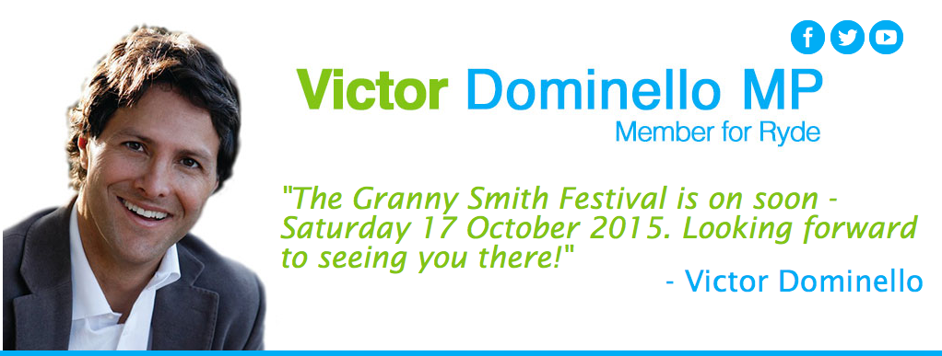
Acknowledgement of dignitaries and acknowledgement of Country.
A special thanks to UTS for hosting – the Data Arena is an incredible facility which I will talk more about later.
As you are all aware, I’m here tonight to make an announcement about the direction of NSW in relation to innovation, and data analytics.
But before I do so, I want to tell you about who I am, and why I’m passionate about innovation and data, and how we got to this point tonight.
I’m not a scientist, technician, engineer or mathematician; I’m a 48 year old former lawyer and now politician.
In 2002, before I entered the world of politics, I was at a personal crossroad. My father had passed away and I wanted to find out the meaning of life.
I thought of no better place than India – where life and death collide in a chaotic yet beautiful way.
When I was in India 13 Years ago, I saw and did some amazing things
I saw the Taj Mahal, I stood on a cliff overlooking the blue city of Jaipur,
I played cricket with kids in Orchha, I tried to buy a camel in the Pushka markets
…and I saw kids get excited simply because I had an old SLR camera and I was able to take photos of them (even though they couldn’t see the photos I was taking at the time).
I also saw things that troubled me deeply and challenged my view of the world and how unfair it is.
[image of Minister speaking with farmers in rural India]
I had the opportunity to go back to India in 2013. I went back to visit the slums in Dharavi and I got to listen to the concerns of poor farmers in remote communities. Needless to say, some of the conditions that these people were living in were still very confronting.
However on this trip back to India, I did notice a change. I want you to have a look at one of the farmers sitting down opposite me crossed legged.
That poor farmer had a mobile phone, in fact most people had a mobile phone… even the kids in the Dharavi slums.
The great thing about this, is that through advancements in technology, even the poorest of the poor have access to a world of opportunities and information in a way never before possible.
These people are now connected to the Information age. And information is power.
As Francis Maude said – “Open data can be a raw material for economic growth – just like iron and coal were to the industrial revolution”
We have left the industrial age.
We are now in the information age and data is the fuel.
On the 2nd of April this year I got a call from Mike Baird asking me to be the first Minister for Innovation in NSW.
My job – to digitise the NSW government and encourage collaboration with the private sector to drive better outcomes for the people of NSW.
Innovation in government? Sounded like mission impossible to me.
The first thing I did in my new role was survey the landscape. It’s clear that NSW is the number one state in Australia.
We have robust performances in all our “major” sectors including construction, mining, education, tourism, agriculture and of course banking and finance.
Underneath the headline stories of our economic success, also sits our thriving digital economy – which I know is something that you are all acutely aware of.
In order for the digital economy to flourish, we need meaningful collaboration between government and industry.
I commend my Cabinet colleagues, for work already underway to boost the technology sector, including the work of my colleague Anthony Roberts with Knowledge Hubs, and initiatives to work with industry to improve productivity.
The Premier has also made a personal commitment to engaging with the digital ecosystem through the Premier’s Innovation Initiative and of course the creation of a dedicated Innovation portfolio that he has charged me with.
And we’ve got Digital Plus, the most recent iteration of the ICT Strategy.
That reform program kicked off in 2012 and has delivered significant achievements in the last 3 years including:
Supporting better customer services through ServiceNSW, being strongly led by my colleague Dominic Perrottet;
We’ve got a world leading data centre in GovDC;
A dedicated focus on Open Data and the principles of Open Government;
And reforms to procurement processes to make it easier to do business with government.
And while we’re on this topic, as we have in previous years, we’ll be seeking your input to the next phase of the ICT strategy to be announced later this year…
…An open call for your ideas on key themes for the next iteration, will go live tonight on the government’s Have Your Say website, which I encourage you to participate in.
We also have a Digital Council established under the leadership of Mike Pratt, the Customer Service Commissioner, to bring business leaders from across government together to reimagine the delivery of public services.
…And over the next few months the Digital Council will be looking to work with industry to achieve this goal.
There is valuable data analytics work being undertaken by individual agencies.
In Health we have Centre for Health Record Linkage (CHeReL)
In Education we have the Centre for Education Statistics and Evaluation (CESE)
In Crime, we have the Bureau of Crime, Statistics and Research. (BOCSAR)
… to name just a few.
The biggest challenge is that governments have a 20th century approach to the use and sharing of data.
Data is held in agency silos and there are over 140 agencies in the NSW Government alone.
The slow and heavy handbrake of bureaucracy means that whole of government data sharing and analytics is stifled.
We all know about Henry Ford and his famous quote last century regarding mass production and a one size fits all approach.
[slide: "Any customer can have a car painted any color that he wants so long as it is black" – Henry Ford]
But government can’t afford to think this way. As a Government we need to become more customer-centric in the 21st century. And this means we must be agile, faster, smarter in the way we operate.
We need to harness our data assets to deliver better tailored services. In doing so, we need to collaborate with the private sector to bring new thinking and new ideas to government.
Through my initial discussions with both the public and private sector – including many of you here tonight, key themes became apparent in terms of what needed to be done.
I realized that in order to harness our data assets, we needed a centralised agency, with the capacity to aggregate and analyze whole of government data (including from SOCs and local councils).
The goal? To gain greater insights and tackle the complex challenges our society faces.
Tonight, for the first time, I’m proud to publicly announce that the NSW Government will establish a whole of government data analytics centre, the first of its kind in Australia.
Affectionately known as the “DAC” (at least for now), the data analytics centre will be tasked with the following responsibilities:
collecting and analyzing of whole of government data in relation to approved projects;
Coordinating consistency of definitions and data standards across NSW Government agencies;
It will establish and maintain a register of data assets in government; and provide advice to government on the greater publication of open data;
It will also provide advice on how data can inform the digitisation of the NSW Government and how the NSW Government can support the digital ecosystem;
Importantly, it will investigate and establish processes and methodologies to enable the protection of personal information; and
advise the NSW Government on best practice analytic processes and data/information security.
Not only will this significantly facilitate and expedite data linkages within government, it will also, in time, provide a central point – a one stop shop – for those seeking access to data and analytics in NSW.
With all of these functions centralised in one place, not only will it be the first of its kind in Australia, to the best of our knowledge, it will also be the first of its kind in the world.
It will be an environment where researchers, start ups, companies and the NGO sector can work directly with experts from government.
The DAC will be able to interface with the NSW digital ecosystem in a significant way to gain insights and reduce some of the great public challenges that we have such as, in the areas of crime prevention, childhood obesity, pollution, sustainable urban planning etc.
Governments right around the world spend enormous resources in trying to solve these challenges in a piece meal way. What the DAC will provide is an ability for industry and researchers to interface with Government in a one stop shop environment to solve some of these complex issues.
The possibilities are endless.
The DAC will be located initially within Department of Finance, Services and Innovation.
And I’d just like to take a moment to thank the Department team led by William Murphy for their herculean efforts in bringing this project together with the priority it deserves.
To ensure that the DAC fulfils on its promise, we recognised that it was important to get critical stakeholders involved in the design phase.
For this purpose, we have assembled a Steering Committee which includes:
Mike Pratt, the NSW Customer Service Commissioner – at the end of the day this is all about improving the services we provide to the citizens of NSW
Professor Mary O’Kane – NSW Chief Scientist and Engineer, and a passionate advocate of the power of data to do things differently
Liz Tydd, the NSW Information Commissioner – who’s brief already extends to making NSW data open and available for use by the community, and
Dr Elizabeth Coombs, the NSW Privacy Commissioner.
Dr Coombs’ role here is, of course, essential.
Dr Coombs involvement will ensure that the development of the DAC has privacy as one of its core design principles.
While we all recognise the value in joining-up data, and bringing people together to develop new insights…
The need to protect the privacy of individuals and the security of their information is absolutely non-negotiable.
In fact, the DAC will strengthen privacy in NSW by making it a key element of this initiative.
We are blessed in Sydney to be the beating heart of Australia’s digital ecosystem.
This incredible facility here at UTS (Data Arena) is just a part of the world-class education and research infrastructure that is located in NSW.
Those who have seen it will know what I’m talking about – and for those who haven’t, I encourage you to have a look later tonight.
Bringing data sets together in 3D, in real time taps into that basic human skill, developed over millennia, to make visual sense of the world and see things we didn’t expect to see. In fact, if you want to see, tomorrow today – step inside the data arena now.
With the number of world class research and educational facilities here in NSW looking at data analytics, I believe we owe it to the people of NSW to bring this vibrancy and innovation into the delivery of public services.
And in turn, I hope that working with government can be a catalyst for new and exciting developments to take the technological capability of NSW to the world.
With the DAC, we now have an even stronger vision for NSW.
Over two-thirds of Australia’s start up community makes its home right here in Sydney, including:
Incubators and accelerators like Fishburners, Blue Chilli, Stone&Chalk, Pollenizer, ATP Innovations, and Lakeba, to name just a few.
We also have some of the most well known digital businesses around including GoCatch, Freelancer, Shoes of Prey, and GoGet.
Sydney-based Atlassian and SocietyOne were once start ups here but are now mature successful international tech companies.
An increasing number of multinational technology giants are establishing a substantial presence here including:
Amazon, Google, Apple, and Uber… in addition to Microsoft, Fujitsu, IBM, SAP and Oracle who have long seen Sydney and NSW as the core of technology and innovation in Australia.
I recently learnt that Google, Microsoft, Apple and SAP alone employ nearly 6000 people in NSW already.
I want New South Wales to be known as the tech-hub of the Asia-Pacific.
And my intention is the DAC will be a cornerstone in achieving this vision.
The DAC will be an enabler for NSW to become a globally competitive digital ecosystem.
It will provide a mature approach to problem solving. It will extend beyond the siloed mentality of government and will invite industry to collaborate with government experts to achieve meaningful outcomes.
Innovation is not a product, it’s a state of mind.
The DAC is not about spending a whole lot of money, it’s about using our assets collaboratively to ensure a more targeted use of our finite resources.
This is an ambitious reform agenda, designed to deliver… we must be bold. Big data and analytics has been around for decades in the corporate sector. Governments around the world are starting to wake up to the benefits.
If we do nothing , then that will be an enormous cost to our state. We can’t afford to be left behind.
If in NSW, we harness data for the greater public good, the DAC will result in a genuinely tech-tonic shift. The DAC will enable us to see tomorrow today, but in greater focus.
Thank you.
This entry was posted in Press Release. Bookmark the permalink.
← Nominations for the 2015 NSW Seniors Local Achievement Awards

