WSIS Forum 2018 Day 1 (19th of March) Workshop at 14h30

Title:
How to apply and achieve the 17 SDGs in a world where technological evolution is exponential, and where near all economic and sociological models are disrupted ?

Sub-Title:
The key prerequisites, the tools and methodologies, structures and cultures

Organizers:
Raymond Morel, Philip Koenig, Mohamed Balghouthi from IFIP, G4, Social IN3

G4 is a societal civil society movement;
we impact and act upon 5 axes:

G4 as Global Goals for Greater Good:
- Actualized sciences and technology of 21st century are underutilised levers and accelerators for the SDGs and corresponding complex societal intertwined transformations. In particular we need to integrate faster and better embody human sciences, neurocogitivism, epigenetics, STEM, NBIC ( Science Technology Engineering Math; Nano, Bio, Cognitive ) . Furthermore, wisdom of Great Traditions and First Nations can also to be integrated faster into sciences and our schools for all ages, in order for each of us and our organizations to become more integral and holistic. This is our belief; it is based on the life experiences of the cofounders of G4 .

This is also what today’s speakers support: let’s leverage further our updated knowledge & wisdom.

- In order to become regenerative by 2030 via the Agenda 2030 process, we would need about 7000 city regions to engage effectively into the societal SDGs / NDCs transitions by 2020. To have an effective & efficient diffusion process, we would need many voluntary city regions : about 20 lighthouses representing all continents and different socio-economic realities, and 200 pioneers exemplary city regions, that will pilote, test, validate options before glocal replications for the greater good. G4 uses this foundational scientific principle - See theory of diffusion of innovation. Federal states, the 17 “not at war” countries, and the 5 Small States are well positioned countries to work with Geneva, Switzerland and UNOG on this project. ‬‬‬

- The project architecture and governance required for these voluntary city / regions needs to be codesigned and orchestrated with new mindsets, new approaches, new organisations and cultures in order to seamlessly move between design thinking, development and operational transformation : hire systemic thinkers and actors, use systemic approaches and processes, incl. for governance and systems, and cocreate living labs, as defined by MIT. Engaged city regions are more effective, can reduce costs by 40% , by implementing a. an architecture of Living labs around current public, private and civil society organisations b. populate Living labs with systems thinkers and actors, c. use the latest systemic systems - resilience.io - and computers, and a systemic governance in the sense of global goal number 17. The cofounders of G4 have experienced the emerging power of these systemic dimensions, and support the build up of systemic capacity and capability This is what Andrea Bassi, Bob Bishop will also address

G4 as Greater Geneva for Global Goals
- The international Greater Geneva ecosystem is unique and should join forces, work as one, be exemplary to support the acceleration of the global opportunities for the global goals: i.e. to find, engage and monitor the core team city regions, foster world wide best practices, share 21st century sciences & technology progress, embody wisdom of first nations,
via UNOG, WEF, WBCSD, CERN, ICRC, …

- The local Greater Geneva societal players, should be such a lighthouse for Switzerland and the world, for all the international delegations passing thru Geneva and UNOG; it should work hand in hand with the international Greater Geneva and should involve and engage all local players like,
Cantons of GE and VD, Lyon and Grenoble, IMD, EPFL, UNIGE - UNIL, HUG - CHUV, ….

More information on

Speakers :
Introduction by Phil Koenig :
http://www.ict-21.ch/com-ict/IMG/pdf/1- PHK - Intro WSIS 2018.pdf

Jacques Dubochet
Short CV
Prof. Dr. Jacques Dubochet was awarded the 2017 Nobel Prize in Chemistry for developing cryo-electron microscopy to determine the structure of the molecular building blocks of life in high-resolution. He is Honorary Professor of biophysics and the former Director of the Laboratory of Ultrastructural Analysis of the Centre of Electron Microscopy at the University of Lausanne (UNIL). Before joining UNIL in 1987, he was a Group Leader at the European Molecular Biology Laboratory (EMBL) at Heidelberg. In addition to the Nobel Prize, Prof. Dubochet received the EMBL Lennart Philipson Award in 2015.

Short abstract:
We are good at producing knowledge, but not at using it for the common good of humanity. Can we do better?
Scientific knowledge is shaping our world and our society.
A hundred years ago our rich countries were living in scarcity. We are now destroying our environment with our overabundant production. A hundred years ago, each human had a limited circle of personal relations. Now the whole world is at the tip of our fingers, the digital world is closing down on us. Are we, citizens of the Earth, still in control of our future or is it shaped by personal and mercantile interests?
We can decide.
We have to decide.
We have to decide that knowledge is a public good belonging to everyone on Earth and that education is the way to use the good for the benefit of all.
That would be a good start.
Some sides :
http://www.ict-21.ch/com-ict/IMG/pptx/2- JD - 1803_19_WSIS_Geneva 2.pptx
Questions and/or suggested item(s) for the discussion in plenary:
1) Science based or knowledge-based policy. What does this imply?
2) Scientists are good at producing knowledge. But knowledge only makes sense when it becomes action in society.
Action in society is the feat of entrepreneurs, politicians, civil servants, members of the civil society and more - sometimes even by scientists who step outside of their usual path.
I am a scientist, you are entrepreneurs, politicians, civil servants, members of the civil society and more.
How do we speak constructively together?

Dirk Helbing
Short CV
Dirk Helbing has been at ETH Zurich since 2007. He is Professor of Sociology, in particular of Modeling and Simulation. Before joining ETH Zurich, he was Managing Director of the Institute for Transport & Economics at Dresden University of Technology, Germany, where he was appointed full professor for Traffic Modeling and Econometrics in 2000. Helbing studied physics and mathematics at the University of Göttingen (D), and completed his doctoral thesis at Stuttgart University (D). For his PhD thesis on modeling social processes by means of game-theoretical approaches, stochastic methods and complex systems theory, he was awarded two research prizes. In 1996, he received a Heisenberg scholarship following the completion of his habilitation on traffic dynamics and optimization. From 1997 on, he spent two years altogether at international research institutions in various countries.
In 2008, Professor Helbing was elected as a member of the prestigious German Academy of Sciences (Leopoldina). He has organized several international conferences and has edited special issues on material flows in networks and on cooperative dynamics in socio-economic or traffic systems. Professor Helbing has given numerous public talks and published more than 250 papers, including several contributions to high-impact journals like Nature, Science, and the Proceedings of the National Academy of Science (PNAS). In addition, he heads the Physics of Socio-Economic Systems Division (Φ·SOE) of the German Physical Society (DPG), is the vice chairman of the ETH Risk Center, and scientific coordinator of the FuturICT flagship project.

Short abstract:
How to Save Humanity Responsibly and More Successfully
The world is faced with climate change, financial, economic and spending crises, conflict, war, mass migration and terror. All of this is probably the result of humanity’s biggest problem: lack of sustainability. How to fix this problem? Would having all data in the world allow a "wise king" or "benevolent dictator" to achieve the best of all worlds? The surprising answer is "no," the argument behind this idea turns out to be flawed. The attempt to build a Crystal Ball to predict our future and a Magic Wand to control it, would be destined to fail, no matter how powerful information systems we would build. Even though it is true that we have moved from a period where we had too little data for good decisions to a situation that allows us to take evidence-based decisions, there is still a gap between the complexity of our global system and the data we have about it and the computational power to process it, and this gap is quickly increasing! I call this problem the "complexity time bomb." So, will "fighting complexity" be a lost battle? Yes, if we don't learn to use complexity for us. But this can be done, by turning from a centralized optimization and control approach to distributed control, empowerment, and coordination, using value-sensitive design.
Some sides :
http://www.ict-21.ch/com-ict/IMG/pptx/4 - DH - ResponsibleInnovation_WSIS_s.pptx
Questions and/or suggested item(s) for the discussion in plenary:
I will discuss how to avoid the pitfalls of Big Data and Artificial Intelligence, and how to unleash innovation and collective intelligence in a way that allows us to create a better and sustainable future together.

Juan LIU-DONG
Short CV
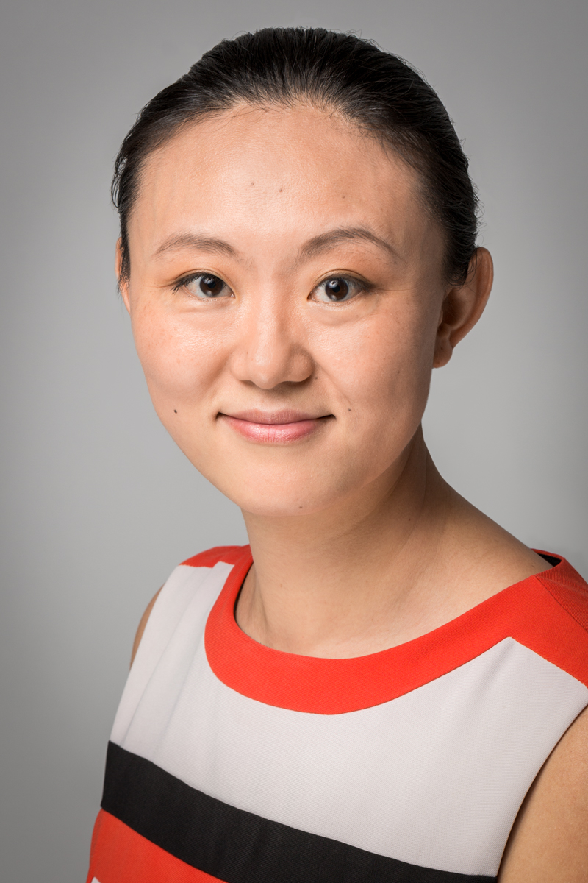
Birth :20 Novembre 1980
Eximium Asia, CEO

Adress:
9 Place Jules Nadi
26100 Romans-sur-Isère
Email: jliu@eximium.fr

Since 2016, Juan LIU DONG has acted as general director of the ASIA branch of the EXIMIUM group, where she has diligently handled international Mergers and Acquisitions as well as investments and counseling. She is:
1/A Self-entrepreneur: She has created and managed two companies in 2009 based in Valence in which she has handled the strategic viability of new projects, negotiations and commercial networking, textile and cosmetics import and export, and the drafting of long term and executive contracts.
2/A valued and experienced executive: In 2016, she has been put in charge by DALKIA EDF of the direction of purchases in the Centre-Est region, which involved conducting negotiations, and drafting executive contracts. She played an instrumental part in Le Grand Lyon ELM (Energie Lyon Metropole) by handling public bids, financial analysis, litigation issues and sourcing.
She is general director of the Asia division of the EXIMIUM group today, where she handles international Mergers and Acquisitions, as well as international investments and counseling.
3/An international alumnus, with a unique curriculum:
In 2016, she has obtained a Masters 2 specialized in Functions, Purchases and Supply Chain management from the IDRAC Business School, Lyon, France. Her thesis was nominated first of her class.
In 2008, she has followed a research degree in marketing studies in the IAE Université de Bourgogne, Dijon, France.
In 2003, she graduated from a Masters program in corporate administration in Renmin University, Beijing, China.
She has a clear international background and handles three languages fluently, namely English, French, and Mandarin Chinese.
4/A determined over-achiever, hungry for new challenges.
Being in finance and management doesn't stop her from actively participating in sustainable development associations like WSIS.
She sees this not only as a personal challenge, but as a worthy cause and her responsibility as an entrepreneur.

Short abstract:
Infinite growth in a finite world is not possible.
We have long since reached the " limits of growth " of the Meadows report.
The process of purchasing, selling and short-term gains/profits based on financial " comparative advantages " on theories of the last 200 years has led to the premature depletion of all kinds of resources, and to major global socio-economic imbalances.
Rethinking purchasing, the supply chain, long-term added value, in " total cost of ownership (TCO)", through the 17 SDGs paradigm, absolutely changes the company's management methods.
Renewable, sustainable and equitable growth in a finite world is, necessarily, possible.
We are moving from a linear world with finite resources to a renewable, sustainable circular world. And this circular economy requires another philosophical approach, other types of skills, other modes of risk analysis integrating sustainability, the balance between needs and production, between shared benefits in a buyer/supplier/customer ecosystem.
In a real-time connected world, with access to knowledge and available information, competitiveness no longer comes from the " lowest bider": it comes from the " best offer ", the most adapted offer in terms of services and Total Cost of Ownership.
These new ways of thinking and acting can only be achieved by rethinking education for greater adaptability, resilience and humanity.
In our presentation, we will try to show the limitations of the cost-reduction model at any price with an example, as well as some ideas on what we think are the new preconditions for a circular and sustainable economy.
Some sides :
www.ict-21.ch/com-ict/IMG/pptx/3JMpresentation.pdf
Questions and/or suggested item(s) for the discussion in plenary:
- Which know-how-to-be for which know-how in a world where technological breakthroughs are changing the relationships of global business?
- For the common good, what common values between different countries of culture?
- Are humanism and business compatible? As entrepreneurs, how can scientists help us reconcile these goals?

Andrea Bassi
Short CV
Dr. Andrea M. Bassi is the founder and CEO of KnowlEdge Srl, a consulting company exploring socio-economic and environmental complexity to inform decision making for sustainability. Dr. Bassi is also an Extraordinary Professor of System Dynamics at Stellenbosch University in South Africa. In his work Dr. Bassi is a project leader and researcher with over 15 years of experience supporting more than 40 governments and several international organizations primarily on (1) energy and climate policy, (2) natural resource utilization, (3) disaster resilience planning and response strategies and (4) sustainable development national -and regional- plans. Dr. Bassi's strengths lie primarily in the use of modeling and research techniques that focus on systems analysis, acquired through studies and several years working with Systems Thinking and System Dynamics. Over the years Dr. Bassi has authored several publications, including the book Tackling Complexity, proposing a systemic approach to support decision making in the public and private sector. Dr. Bassi was a Director at Millennium Institute, visiting researcher at the Danish National Environmental Research Institute and GRA at the Los Alamos National Laboratory. Dr. Bassi holds a Ph.D. and M.Phil. in System Dynamics at the University of Bergen, Norway, a M.Sc. in Business and Economics at LIUC, Italy, and completed a postgraduate course in modeling the environment at the Universitad Politecnica de Catalunia in Spain. Full profile available at: www.ke-srl.com and LinkedIn.

Short abstract:
This presentation highlights the role that systemic approaches can play in solving current and future sustainability challenges. It provides information on the conceptual mistakes we are prone to making in every step of the decision making process, and how with the use of Systems Thinking we can design intervention options (e.g. policies and investment) that generate benefits, without causing side effects.
Some sides :
http://www.ict-21.ch/com-ict/IMG/pptx/5 - AB WSIS.pptx
Questions and/or suggested item(s) for the discussion in plenary:
The role and legacy of our education system, and how our understanding of reality (becoming more and more complex) is improving at a faster pace than the tools available to us (by tools I refer to knowledge, education).
The challenge at hand, accelerating change for sustainability, requires information to be shared, accessed and analyzed objectively, for the greater good. How can this take place, given the diverse interests of the powers at play?

Organizers :

Philippe Koenig
Short CV
Philip Koenig, from Geneva, Switzerland, got a degree in Physics from ETHZ, while being present 5 years in Davos with WEF. This is his foundation for an international professional business and societal career, in favor of the intertwined Global Goals, a 21st century sustainable Greater Good, via exemplary impulses of the local and international Greater Geneva actors.

10 years International marketing career in Latin America with Nestlé, Philip learnt in complex organizations to co-create value from complementary roles & responsibilities, via Brands; manage business in vuca contexts, in particular Venezuelan, Argentinian crisis in ‘90s.

12 years with Caterpillar Philip went deeper into complexity and systemic approaches, via living labs, design thinking, to cocreate value, with purpose to improve 1. the sales & marketing approach via integration of products & services - EAME impact; 2. business models via lifecycle management, circular economy principles; 3. societal accounting for a common greater good, generating more profits than the sum of the parts, incl. employee engagement and education. With global impact, incl. DJIS, Dow Jones Index of Sustainability.

Since 2012, Philip applies systemic logics to society and federal organizations. He works with pioneers, forward thinking scientists, wise businessmen and politicians, to find ways to transcend human, cultural and organisational obstacles to creative leadership and the spirit of the creative process. Philip’s societal engagement: www.philipkoenig.org

With regards to the UN Sustainability glocal project, timing is perfect to cocreate G4, in February 2017, a civil society movement in order to participate at the Swiss Global Compact relaunch in Bern, with DFAE, SECO, Nestlé, etc ...; in March, the UN instigated G3iD event, and WSIS FORUM 2017 in May, both based in Geneva. see details G4-ll.net and G4 positioning

Mohamed Balghouthi
Short CV
Birth : 3 Novembre 1970
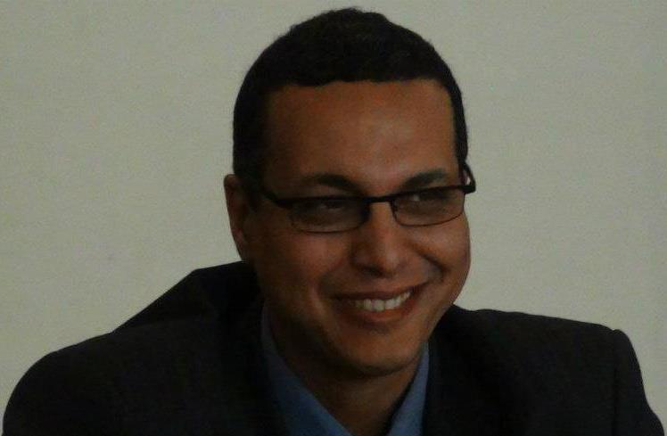
Expert Industrial Purchasing & Economic Intelligence
Adresse : Grenoble - FRANCE
Tel : +33 618 622 053

Since 2010, Mohamed Balghouthi has been the Director of MB Consulting, a consultancy in Industrial Purchasing & Business Intelligence for several companies, institutions and universities.

3 periods, 3 commitment.

1/Arts & Commerce: Electrical Engineering and Bachelor of Sciences in Mathematics & Physics, Mohamed worked for 10 years in Artistic Management and Commerce.
2/Industry & Systemic Approach : in 2004 he resumed his studies at the National Polytechnic Institute of Grenoble (Grenoble INP), then at the Management School of Grenoble (Grenoble EM) where he obtained a diploma in Technical Management in Industrial Engineering.
He was quickly hired by a multinational company (Schneider-Electric) as a cross-functional project manager for the reorganization of production purchasing in the global purchasing department.
Breaking down the entire value chain and the Industry/Purchase/Suppliers ecosystem, he develops an innovative industrial, financial, mathematical and humane methodology offering new, highly efficient tools enabling Schneider-Electric to achieve economies of scale of more than 20% in terms of operating results.
Long-term purchasing strategies, a resilient ecosystem between buyer and supplier, sustainable gains for the company, far from short-term cost-killing methodologies.
3/Teaching & Civil Society :
* Teaching: since 2014, he has been teaching at the Master of Economic Intelligence (Université Jean Moulin Lyon3) and Master of Purchasing & Supply Chain Management (IDRAC Business School). He has supervised more than 40 students for their professional thesis. Modules taught: Purchasing Cost-Models, Sustainable Sourcing, Sustainable Purchasing. With his students, he created a procurement audit tool that measures the performance and compliance of companies with the 17 SDGs.
* Tunisia & Africa : Since the Tunisian revolution (January 14,2011), he has developed an in-depth knowledge on the issue of mining, natural resources and economic intelligence for Tunisia in general.
In 2013, he was elected " Personality of Civil Society in Tunisia " and received the " Open Gov " prize for his fight on financial transparency and his contribution to article 13 of the New Tunisian Constitution.
He has given several conferences in Tunisia and with the UMA (Union du Maghreb Arabe) and the African Union on Debt, Natural Resources and industrial and socio-economic stakes induced by the 4th Industrial Revolution.
* Genève : Founding member of the think-tank G4 Living Lab with Raymond Morel & Philip Koenig.

Bob Bishop
Short CV
Bob Bishop spent 40 years in the technical, engineering and scientific computing business, and was responsible for building and operating the international aspects of Silicon Graphics Inc., Apollo Computer Inc., and Digital Equipment Corporation. To accomplish this task, he lived with his family in five countries: USA, Australia, Japan, Germany and Switzerland. He was Chairman and CEO of SGI from 1999 to 2005.

Bishop has been involved in a wide range of global initiatives including the advisory boards for EU's Human Brain Project, National ICT Australia (NICTA), Multimedia Super Corridor of Malaysia, University Tenaga Nasional (Uniten), and UCLA's Laboratory for Neural Imaging (LONI). He is a Fellow of the Australian Davos Connection and an elected member of the Swiss Academy of Engineering Sciences.
Bishop earned a B.S. (First Class Honors) in mathematical physics from the University of Adelaide, Australia, an M.S. from the Courant Institute of Mathematical Sciences at New York University, and received his D.S. honoris causa from the University of Queensland.
In 2006, Dr. Bishop was awarded the NASA Distinguished Public Service Medal for his role in building simulation facilities that helped NASA’s space shuttle fleet return-to-flight after the 2003 Columbia disaster. http://www.icesfoundation.org/Pages/PersonProfile.aspx?id=3

Bishop is Chairman & Founder of BBWORLD Consulting Services Sàrl and President & Founder of The ICES Foundation (International Centre for Earth Simulation), both Geneva-based organizations.

Peter Major
Short CV
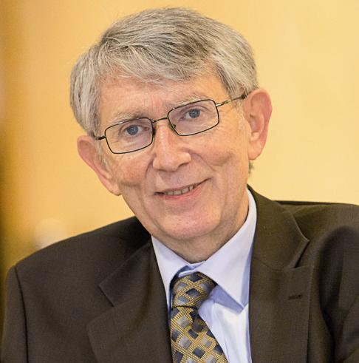
Peter Major is the vice chair of the UN Commission on Science and Technology for Development (CSTD). He chaired the CSTD Working Group on the improvements to the UN Internet Governance Forum and the CSTD Working Group on Enhanced Cooperation. He is vice-chair of the Radiocommunication Advisory Group at the International Telecommunication Union (ITU). He represents Hungary at the Governmental Advisory Committee of ICANN. He was working at the ITU for 23 years. He is a faculty member of the European Summer School on Internet Governance, Meissen and visiting professor at the Higher School of Economics of National Research University, Moscow.
Key strategic infos on CSTD :
http://www.ict-21.ch/com-ict/IMG/docx/pmajor-WSIS%20Forum_2018%20CSTD.docx

Raymond Morel
Short CV
Raymond Morel est actuellement actif comme: my full cv

- Membre individuel de la SATW (the Swiss Academy of engineering sciences)
- Représentant suisse à l’IFIP General Assembly Président du SIC (Swiss IFIP Committee)
- Représentant suisse au IFIP TC3 (Technical committee 3 on ICT and Education)
- Expert - Consultant au IFIP TC3 (Technical committee 3 on ICT and Education)
- Membre du IFIP ILC (IFIP International Liaison Committee)
- Délégué IFIP au WSIS (2003 and 2005) and WSIS Forum since 2006 (Sommet Mondial de la Sociéété de l’Information)
- Membre du Comité exécutif de la SI (Schweizer Informatik Gesellschaft)
- Membre du Comité exécutif de la SISR (Section Romande de la Société Suisse d'Informatique)
- Membre de SIRA (Swiss Informatics Research Association) since its foundation in 2012
- Membre de la SKIB (Schweizerischen Koordinationskonferenz ICT und Bildung) 2004-2012
- Membre du Board du IFIP MSA (Member Societies Assembly) dès sa fondation au début octobre 2015
- Membre du Board de IFIP IP3 (certification pour IT-Professionalism) depuis début octobre 2015
- Membre du Comité exécutif de la SSAB (Schweizerische Stiftung für audiovisuelle Bildungsangebote)
- Membre fondateur, président du CA de la cooperative of research Social-IN3
- Membre fondateur du G4 – Global Goal for Greater Good, projet de la cooperative of research Social-IN3
- Consultant au IITE et à l’UNESCO rm/21032018

