Wednesday morning 30th of November 2016
Sessions for IFIP Presidents and Australia 3.0 NSW Government Ministerial Forum

IFIP Presidents and Australia 3.0 NSW Government Ministerial Forum
Date: Wednesday 30th November 2016
Time: Registration 8:15am for 8:30am start to 12:00pm
Venue: Stateroom - Level 2
Hilton Hotel Sydney
488 George Street
Sydney NSW 2000
I am very excited to invite you to join us for the Ministerial forum with The Hon Victor Dominello NSW Minister for Innovation & Better Regulation.
This session will tackle innovation and disruption; driverless cars, AI, AR, VR, IoT – the commercial applications have come a long way in a short period of time, and we are seeing an explosion in technology innovation.
Why is it then that developed economies have yet to see any real GDP impact?
And with the rapid moves towards automation, and algorithm lead advice, what are the impacts for the modern day professional?
Some of our featured speakers include:

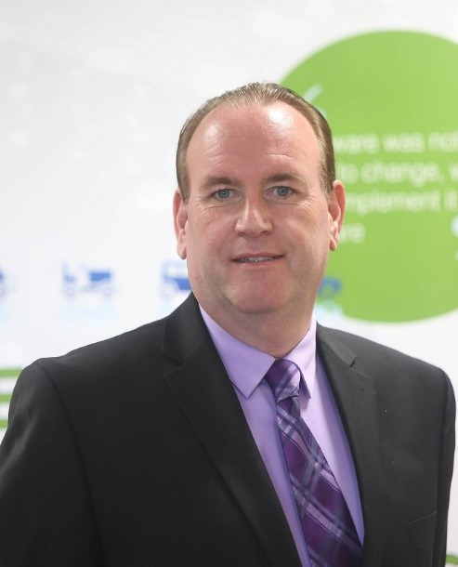 | Mike Hinchey is Director of Lero-the Irish Software Research Centre, a national research centre with a footprint in 8 institutions, and Professor of Software Engineering at University of Limerick, Ireland.  He is currently (2016-2019) President of IFIP (International Federation for Information Processing), Vice President of the Irish Computer Society, and Vice Chair and Chair-Elect of IEEE UK & Ireland (the largest IEEE section outside Silicon Valley).  Hinchey received a BSc in Computer Systems from University of Limerick, an MSc in Computation (Mathematics) from University of Oxford, UK, and PhD in Computer Science from University of Cambridge, UK. He is a Fellow of British Computer Society, Irish Computer Society, Engineers Ireland, IET, Institute of Mathematics and Its Applications, and Engineers Australia. He is the author/editor of 15 books (2 more forthcoming in 2017) and almost 200 papers, and holds 26 patents. He is Editor-in-Chief of Innovations in Systems and Software Engineering: a NASA Journal (Springer) and Journal of the Brazilian Computer Society (Springer). Prior to joining Lero, Hinchey was Director of the NASA Software Engineering Laboratory, and continues to work with NASA. He has previously held positions as Professor or Visiting Professor in Australia, UK, Germany, Sweden, Brazil, and Japan.
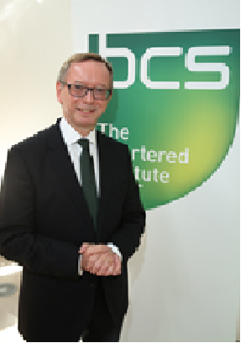 | Ray Long joined the UK Senior Civil Service when moving to the Department of Health in 1997, before his appointment as IT Director at the Department of the Environment, Transport and the Regions in 1999. He became CEO of the Northern Ireland Business Development Service in 2004 before serving as Programme Director for the National Health Service's 'Choose and Book' electronic booking service and Major Projects Director in the Cabinet Office. He joined Her Majesty's Revenue and Customs as Director of Business Tax Change in 2011, before becoming Director of Corporate Services Change in 2013. In 2014 he joined the Department for Work and Pensions, initially with responsibility for that Department's Infrastructure Modernisation Programme, more recently as Director of Technology Platforms, and now as CEO of Benefits and Pensions Digital Technology Services Ltd, the Government-owned company established to insource IT applications development, maintenance and support services. Ray has also been an Associate Lecturer with The Open University since 1993, delivering programmes on leadership and strategy in the UK and internationally. A Chartered Director, Engineer and IT Professional, he is also a Freeman of the City of London and a graduate of the UK Government's Major Projects Leadership Academy. He is the President of BCS, The Chartered Institute for IT, for 2016-17.
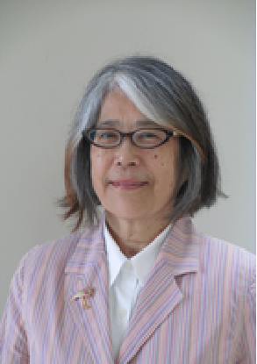 | Yuko Murayama is a Professor in the Department of Computer Science at Tsuda College, Japan. Her research interests include internet, network security, security, trust, anshin, and disaster information processing.  She had a B.Sc. in Mathematics from Tsuda College, Japan in 1973 and had been in industry in Japan. She had M.Sc. and Ph.D. both from University of London (attended University College London) in 1984 and 1992 respectively. She had been a visiting lecturer from 1992 to 1994 at Keio University, and a lecturer at Hiroshima City University from 1994 to 1998. She has been with Iwate Prefectural University since April 1998.  She is the Japanese Representative to IFIP GA and serves IFIP as a Vice President and Chair fo Domain Committee on IT in Disaster Risk Reduction. She is a secretary for IPSJ Special Interest Group on security psychology and trust (SIG on SPT). She is a senior life member of IEEE, as well as a member of ACM, IPSJ and IEICE.

AGENDA

0815 Arrivals Tea/coffee and registration
0830 Introductions

Mr Anthony Wong, President Australian Computer Society
Mr Wayne Fitzsimmons, Chairman Pearcey Foundation

IFIP Presidents Sessions

0840 IP3 Panel discussion: Does the Internet of Things, Algorithms and Artificial Intelligence of Everything promise Utopia?
Introduced by Brenda Aynsley OAM, FACS CP Chairman of the International Professional Practice Partnership, IFIP

Discussion moderated by Professor Michael Fraser AO, FAICD
•How do we achieve utopia and avoid disaster?
•How do we assure utopia?
•Are we there yet?
•What needs to be done to mature the ICT profession?
•What are the roles of the actors?

If we are to succeed in making sure society is not led astray by the technology we seek to use, then we must begin and continue the conversation which identifies the problems, seeks acceptable solutions and provides for the eco-system and infrastructure to deliver on them. Panelists include:
•Mr Mike Hinchey, President IFIP
•Mr Ray Long, President British Computer Society
•Ms Ulandi Exner, President, Institute of IT Professionals South Africa
•Prof. Liz Bacon, Past President British Computer Society
•Adrian Schofield, Vice Chairman Standards and Accreditation/Chief Assessor IP3

0930 Panel: Government as an influencer of innovation, technology adoption & economic growth
•Minister The Hon Victor Dominello NSW Minister for Innovation & Better Regulation
•Mr Ray Long, President British Computer Society
•Ms Ulandi Exner, President, Institute of IT Professionals South Africa
•Professor Yuko Murayama, IFIP Vice President & Information Processing Society of Japan

Australia 3.0 Sessions

1010 Australia 3.0 2016 Wicked Policy Challenges NSW Government Open Innovation
Introduced by Dr Ian Oppermann, CEO & Chief Data Scientist, NSW Data Analytics Centre
There is an emerging need for industry and government to work together to accelerate development of collaborative engagement models that lead to significantly better outcomes (lower cost, improved services, greater citizen satisfaction) through business innovation enabled by ICT. This session will present the winning solutions from two ‘Wicked Policy’ Hackathons which ran from August to October 2016 in Sydney with the NSW Department of Finance, Services and Innovation (NSW-DFSI).

1015 ICT Procurement Challenge
What solutions can help increase the agility, innovation of government ICT procurement?
•Ms Shae Howard, Director, IT and Digital Government, NSW-DFSI
•Ms Lesley Cooper, Team representative
•Mr Darren Whalen, ICT Procurement Framework Lead, NSW-DFSI

1030 Open Data Challenge
What solutions can help to increase the usability of Open Data from the NSW Government?
•Ms Sonya Sherman, Principal Policy Officer (Information), NSW-DFSI
•Mr Mat Darcy, Team representative

1045 Morning tea

1115 Australia3.0 Open Innovation Lessons Learned Panel
•Panel representatives from NSW-DFSI and teams
•Ms Kelly Hutchinson, Australia 3.0 Program Manager
•Dr Ian Oppermann, CEO & Chief Data Scientist, NSW Data Analytics Centre
1200 Close

