SICT
Dear Board members, Gilbert and Christian,

Kindly be reminded that the Marketing Workshop will be held as scheduled as follows :

Date: 21 April 2022 (before the Board meeting)
Time: 11:00 -16:00
Location: Glue Software, Schwarztorstrasse 31, 3007, Bern

Please see attached a tentative programme suggested by Mrs. Krippendorf. Sandwichs and water will be provided for lunch.

Tel +41 (0)32 512 23 33
office@swissinformatics.org
swissinformatics.org

SI Digital Magazine
https://magazine.swissinformatics.org/

https://files.ifi.uzh.ch/rerg/SI/SITC_2022_Photos/index4.html

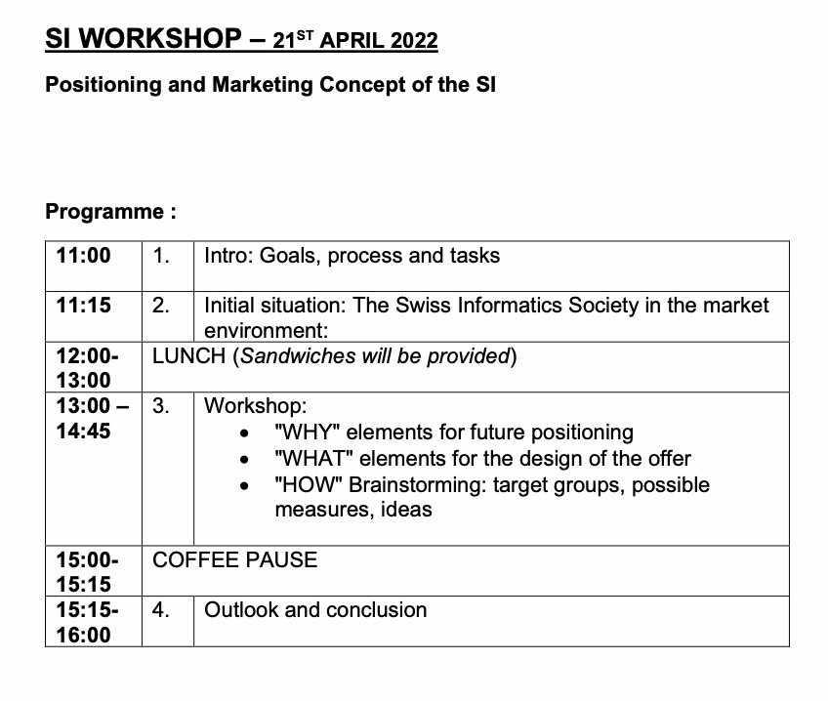

https://magazine.swissinformatics.org/en/

