IFIP Insights
News from IFIP members, technical committees and ICT sector around the world - Wednesday, Feb. 28, 2018

IFIP to Play Leadership Role at Upcoming WSIS Forum - IFIP News
www.ifipnews.org - Shared by IFIP
IFIP Leaders to Run Two Workshops, Present Keynote and Facilitate High-Level Policy Session IFIP will play a leadership role at the annual WSIS Forum in Geneva next month, showing how greater profess…

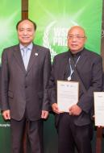

New Data Breach Laws for Australia - IFIP News
www.ifipnews.org - Shared by IFIP

New data breach laws came into effect in Australia last week, making it mandatory for companies to report significant breaches. Under the Privacy Amendment (Notifiable Data Breaches) Act 2017, eligib…

Open Conference of IFIP WG 8.3 on Decision Support Systems - IFIP News
www.ifipnews.org - Shared by IFIP

IFIP Working Group 8.3 invites interested professionals to Ljubljana, Slovenia, for the 2018 Open Conference of the IFIP WG 8.3 on Decision Support Systems from 13-15 June 2018. The theme of the conf…

Videos
Successful Launch of “Slow Tech and ICT” in Milan - IFIP News
www.ifipnews.org - Shared by IFIP
earlier this month for the official launch of “Slow Tech and ICT: A Responsible, Sustainable and Ethical Approach”, the new book by IFIP stalwarts, Diane Whitehouse and Norberto Patrignani. Ms Whiteh…

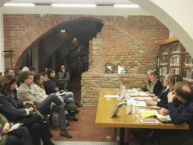

SEARCC Executive Council meeting April 2018 - IFIP News
www.ifipnews.org - Shared by IFIP

The South East Asian Regional Computer Confederation (SEARRC) will hold its first Executive Council meeting of 2018 in Tokyo, Japan on the 6th of April. The meeting will be hosted by SEARCC in partne…

Don't miss out. Subscribe to the email newsletter.

Email address

Do we want to live in a world where our ‘best friends' are AI chatbots?
theconversation.com - Shared by IFIP

Before the internet, before smart phones, teenagers and young people would seek out quizzes in comics, read problem pages in girls magazines and watch television for advice on how to be themselves. Y…

8 digital skills we must teach our children
www.weforum.org - Shared by IFIP
The social and economic impact of technology is widespread and accelerating. The speed and volume of information have increased exponentially. Experts are predicting that 90% of the entire population…

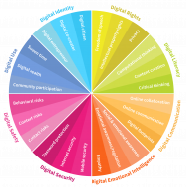

AI for Good Global Summit 2018, May 15 - 17, Geneva - IFIP News
www.ifipnews.org - Shared by IFIP

The AI for Good Global Summit will identify practical applications of AI and supporting strategies to improve the quality and sustainability of life on our planet. The summit, which is the leading Un…

Photos
- 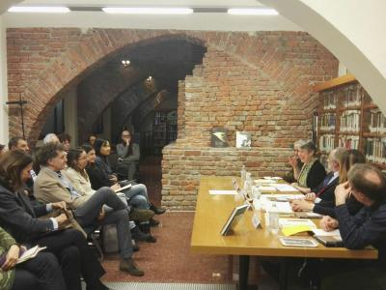
- 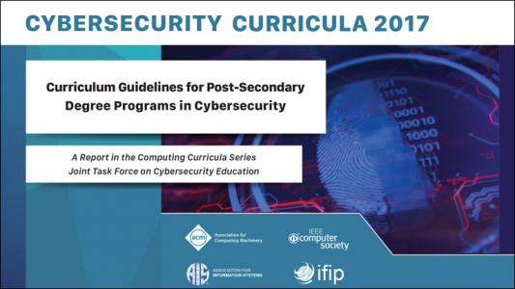
ACM Europe and Informatics Europe Release Education Strategy - IFIP News
www.ifipnews.org - Shared by IFIP

ACM Europe and Informatics Europe have collaborated on a report that builds on an earlier document, Informatics Education in Europe: Are We All in the Same Boat?. The new report, Informatics for All:…
ACM and IEEE-CS Release First-Ever Global Cybersecurity Curricula Recommendations - IFIP Newswww.ifipnews.org - Shared by IFIP

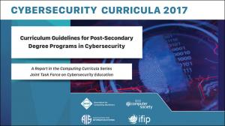

After an extensive two-year process, a joint task force led by ACM and the IEEE Computer Society (IEEE-CS) has released a first-ever set of global curricular recommendations in cybersecurity educatio…

Watch Videos of Sessions from ACM India Annual Event 2018 - IFIP News
www.ifipnews.org - Shared by IFIP

ACM India’s annual flagship event was held in Nagpur 15-17 February 2018. Leading computer science experts met to discuss trends in science and technology, and to celebrate ACM’s spirit and India’s a…

Inside the Panoptic Studio, the Dome That Could Give Robots Super-Senses
www.wired.com - Shared by WIRED

In a chilly basement room at Carnegie Mellon University sits a giant dome that looks like part physics experiment, part that chamber Darth Vader kicks back in. Wires and electronic boxes stud the wal…

These countries have the highest quality of life
www.weforum.org - Shared by World Economic Forum
What makes for a good life? Good health, education, money, or something else? The OECD attempts to answer this question by looking at a range of indicators across 41 countries in its latest study on …

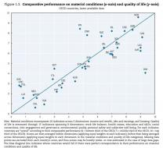

This country works the longest hours in Europe
www.weforum.org - Shared by World Economic Forum

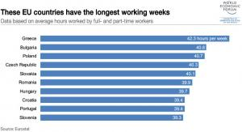

In Greece, people work longer days than anywhere else in the European Union, clocking up on average 42.3 hours per week, according to Eurostat. According to this EU data, which combines full and part…
- Share
The Adorable Microbots That Swarm to Build Structures
www.wired.com - Shared by WIRED

The beauty of evolution is that it’s so nonjudgmental. What began as the first organism billions of years ago has diversified into species that fly and hop and run, whatever best suits them in their …

These robotic arms could give you superhuman strength
futurism.com - Shared by World Economic Forum

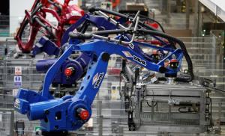

Have you ever lifted half a ton? With the Guardian GT, a set of robotic arms, you could do so with as little as two kilogram (five pounds) of force, allowing you to have superhuman strength. Elon Mus…

IFIP publishes a great selection of
curated content
Don't miss out! Subscribe to the newsletter!

