We use cookies to personalize content and ads, provide social media sharing, and to analyze our traffic to improve our Service. Visit our Privacy Policy if you wish to opt out of any non-required cookies. By continuing to use our site, you agree to our use of cookies.

IFIP Insights
News from IFIP members, Technical Committees and the ICT sector around the world
- By IFIP

Tuesday, Jul. 31, 2018 - Archives -

-
AI4KM Explores AI and Time - IFIP News
www.ifipnews.org - Shared by IFIP
The 6th AI4KM (AI for Knowledge Management) workshop took place at Stockholm during IJCAI-18, bringing together the members of IFIP Working Group 12.6 and those interest in their endeavours. The invi…
- Share

Participate in a Global Survey of Scientists - IFIP News
www.ifipnews.org - Shared by IFIP

The 2018 Global Survey of Mathematical, Computing, and Natural Scientists needs people in mathematical, computing and natural sciences, including students, to share their career and educational exper…
- Share
Open Living Lab Days - Geneva - IFIP News
www.ifipnews.org - Shared by IFIP

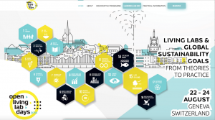

The 2018 Open Living Lab Days (OLLD) are just weeks away. Participants will gather in Geneva from 22-24 August 2018 to explore and debate the role of citizens, open innovation and the potential of Li…
- Share
Photos
- 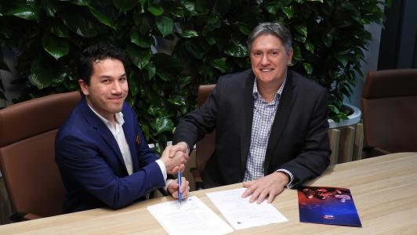
ACM Updates Code of Ethics - IFIP News
www.ifipnews.org - Shared by IFIP

ACM has updated its Code of Ethics and Professional Conduct. The revised Code of Ethics addresses the significant advances in computing technology since the 1992 version, as well as the growing perva…
- Share
ACM President Cherri Pancake Highlights Importance of Diversity in ICT - IFIP News
www.ifipnews.org - Shared by IFIP

Newly-elected ACM President, Cherri Pancake, has called for greater diversity of thinking across the ICT sector. In a recent interview with UK news magazine, The Verdict, Pancake said diversity is mo…
- Share
SIGKDD Conference in London Next Month - IFIP News
www.ifipnews.org - Shared by IFIP

Next month’s SIGKDD Conference on Knowledge Discovery and Data Mining brings together researchers and practitioners from data science, data mining, knowledge discovery, large-scale data analytics, an…
- Share
SIGCOMM 2018, 20 to 24 August, Budapest, Hungary - IFIP News
www.ifipnews.org - Shared by IFIP

The flagship annual conference of the ACM Special Interest Group on Data Communication will take place in Budapest from 20-24 August 2018. SIGCOMM 20188 will focus on the applications, technologies, …
- Share
OCCE2018 Shines in Austria - IFIP News
www.ifipnews.org - Shared by IFIP
The challenges and opportunities emerging with the societal impact of digital technologies was the topic addressed during the last TC3 Open Conference on Computers in Education hosted by the Austrian…
- Share

NITC Scheduled for October in Colombo - IFIP News
www.ifipnews.org - Shared by IFIP
Sri Lanka’s President, Maithripala Sirisena, will be the chief guest at this year’s National Information Technology Conference (NITC), which will take place from 2-4 October 2018 in Colombo. Organise…
- Share

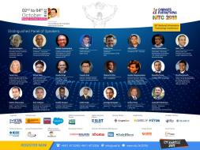

Life 3.0 Worth a Read - IFIP News
www.ifipnews.org - Shared by IFIP
Interested in the potential for AI to change the planet? Then take a look at “Life 3.0 – Being human in the age of Artificial Intelligence” by MIT Physics Professor Max Tegmark. According to a review…
- Share
ACS Launches Trust Mark Accreditation Scheme for SMEs - IFIP News
www.ifipnews.org - Shared by IFIP

ACS (Australian Computer Society) has unveiled a new accreditation scheme designed to give Australians greater confidence when using the ICT services of small and medium-sized enterprises (SMEs). The…
- Share
ACS moves into eSports - IFIP News
www.ifipnews.org - Shared by IFIP

ACS (Australian Computer Society) has ventured into new territory, signing as a foundation partner of the Australian Esports League (AEL). The two organisations plan to work together to promote eSpor…
- Share
CSSL Degree Accreditation Recognised at Global Level - IFIP News
www.ifipnews.org - Shared by IFIP

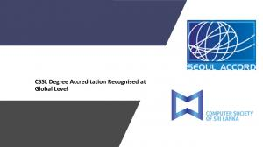

The Computer Society of Sri Lanka (CSSL) has been inducted as a Provisional Member of the Seoul Accord at its recent meeting in Cambridge, UK. CSSL President, Yasas Abeywickrama called the recognitio…
- Share
Sampling molecular conformations and dynamics in a multiuser virtual reality framework
advances.sciencemag.org - Shared by news.google.com/news
We describe a framework for interactive molecular dynamics in a multiuser virtual reality (VR) environment, combining rigorous cloud-mounted atomistic physics simulations with commodity VR hardware, …
- Share
Open plan offices could be limiting our social skills, study says
theconversation.com - Shared by World Economic Forum
Open-plan offices have taken off because of a desire to increase interaction and collaboration among workers. But an innovative new study has found that employees in open-plan offices spend 73% less …
- Share

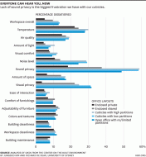

​The data center is dead: Here's what comes next | ZDNet
www.zdnet.com - Shared by ZDNet
The traditional enterprise data center is heading for the history books, overtaken by cloud computing, the internet of things and new requirements to get applications closer to the customers using th…
- Share

Our future electronics could be printed like newspaper sheets | ZDNet
www.zdnet.com - Shared by ZDNet
Researchers have developed a new technique which may one day be used to print our electronics in the same way as newspapers. Scientists from Purdue University, West Lafayette, Indiana, say the manufa…
- Share

This is how rising temperatures will change our lives and our planet
news.trust.org - Shared by World Economic Forum
The effects of climate change mean the world can expect higher temperatures and more frequent heat waves, climate experts have warned, with poor communities likely to be worst affected. Heat is negle…
- Share

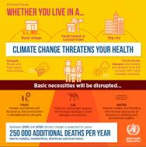

- About Paper.li
- Blog
- Help
- Stop mentions
- Terms
- Privacy

- EN
- DE
- FR
- ES
- PT
- 日本語
© Finity SA 2018
AddThis Sharing Sidebar
Share to FacebookShare to TwitterShare to LinkedInShare to Google+Share to EmailShare to Buffer

