E-Commerce Week 2018:
Development Dimension of Digital Platforms
16 - 20 April 2018
Palais des Nations
Geneva, Switzerland
- Key Issues
- Documents
- Programme
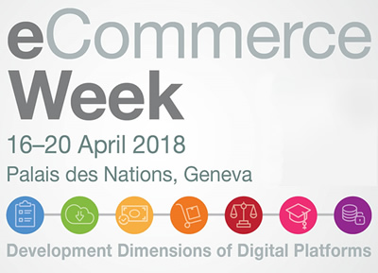

E-commerce continues to grow in the global economy. According to UNCTAD's 2017 Information Economy Report, the value of global e-commerce increased to an estimated $25 trillion in 2015, up from $16 trillion in 2013. The report stresses that the world is on the cusp of a 'new' digital economy, which will have transformational impacts on the world economy, creating both opportunities and challenges for government, business and people alike.
In the evolving landscape for e-commerce and the digital economy, various forms of digital platforms play a central role, facilitating e-commerce, payments, labour opportunities and cloud work as well as social interaction.
The UNCTAD's fourth E-Commerce Week will place particular emphasis on the Development Dimension of Digital Platforms.
Often accessed through mobile apps, digital platforms bring together and aggregate demand and supply in ways that were not possible before, including in geographical areas/service sectors traditionally neglected. They present new opportunities for international trade and efficient economic activities, including for small businesses. However, the extent to which people and enterprises engage and benefit from such platforms varies considerably. There are indeed concerns that they will disrupt economies, with potential negative consequences for employment and working conditions.
This year edition of the E-Commerce Week will offer a venue for different stakeholders to discuss key challenges and opportunities arising from such platforms, and put forth concrete actions to harness maximum benefits for developing countries. Highlights will include a High-level dialogue on the Development Dimension of Digital Platforms and two Ministerial round tables. The week will also feature meetings organized by and with eTrade for all partners covering a wide spectrum of topics, a full Business Day, and the second session of the Intergovernmental Group of Experts on E-commerce and the Digital Economy on 18-20 April (details from the 2017 IGE can be found here).
The 2017 E-Commerce Week was attended by 1,000 representatives, from governments, international organizations, the private sector and civil society from 99 countries, with 170 speakers and moderators. More than 30 sessions addressing policy-relevant topics were organized in collaboration between UNCTAD and another 30 partners.
This page will updated on a regular basis, and we therefore invite you to come back to stay informed about all the events organized throughout the entire Week.

More Infos :
http://unctad.org/en/conferences/e-week2018/Pages/default.aspx
Summary and Key Highlights of e-Commerce Week 2018
http://unctad.org/meetings/en/SessionalDocuments/dtl_eWeek2018_summary_en.pdf

