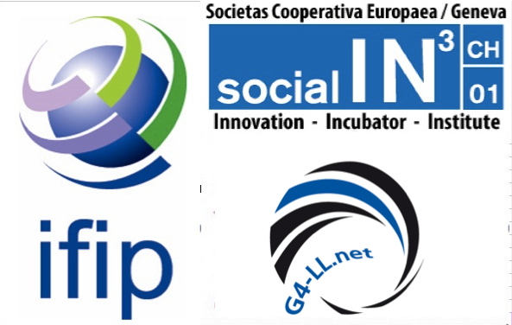 | Geneva, 15th of June 2017  IFIP – Social-IN3 – G4  HDRR: Human Digital Rights  & Responsibilities  Document version 2  Outcome after WSIS Forum 2017  In the Thematic Workshop :  From Sustainable Development Goals (SDGs), to Unleashing  21st Century Global Goals Potentials

Table of content:

Abstract

0. Preliminary
1. Introduction
2. Food for Thought
3. Deeper Dive into some roots of the “ HDRR tree “
4. Speakers’ Contributions to the WSIS Workshop
5. Recommendations
6. Next Steps
Our inclusive humanizing recommendation for WSIS and CSTD, before going to the UN GA:

“In a time when the human species’ survival is at stake, it is critical that we make better faster wiser decisions in favor of SDGs - including COP21 UNFCCC Paris, UNISDR Sendai, Habitat III Quito - in balanced and renewed partnerships between all societal stakeholders.
This is best achieved by a wise use of sciences, future ICT, wisdom of first nations and great traditions.”

Our recommendation is to empower the civil societies and ensure wise ways to use technology. Our aim is to move towards a world wide humanized and inclusive society.

To succeed we will leverage the agreed SDGs - Sustainable Development Goals - and signed NDCs - Nationally Determined Contributions. For further information, Cf. Chapter 5

The highest and most urgent priority is the survival of humanity

The complete document
http://www.ict-21.ch/com-ict/IMG/docx/Version-2.docx
Abstract:

This document has 6 parts which allow us to build up HDRR - Human Digital Rights & Responsibilities - from the foundations laid in the past, which clearly start at least in the 1970's, if not the1940's with the first robots and computers, all the way to a recommendation to WSIS Forum 2017 organizers, with the kind request to hand it over to UN's CSDT

Closer to us we want to refer in particular to the 2016 IFIP conference in Costa Rica, which lead to a draft proposal to engage in HDRR via IFIP.

To paraphrase the quote of Georges Clemenceau "War is too important to leave to the military", some might be tempted to apply it also to the Digital, ICT and AI worlds, in the context of the 16 SDGs in order to give us the means to rethink and reinvent a regenerative society, based on 21st century governance - global goal 17 - , at all levels from global to local, within a decent, dignifying, and humanizing HDRR framework.

We have been developing the HDRR proposal since then, via collaboration and collective intelligence between IFIP and G4, including civil society via hackatons and living labs organized in Geneva, inviting key societal stakeholders, like UNIGE, the state of Geneva via GeneveLab, EPFL, ICES foundation, TEST trust and other key strategic partners who participate in our WSIS workshop as speakers.

To summarize the actual context, critical topics to transform:

- possible risks to turn into opportunities:
- lack of security coming from technology
- AI without an HDRR framework is accelerating insecurity
- education "kills" the required human potentials, creativity, complex problem solving capabilities

- possible obstacles to overcome and brakes to release:
- current laws and the legal silos
- current silo organisations and cultures
- military power with no rules; industrial competitive culture
- governance in silos
- individuals and pubic/private organisations not yet aware or consciously contributing

- threats to be slowed down
- industry is a competitive race, too "dynamic and inventive"
- give power to robots, GAFAs and algorithms - specially in the military and financial arena
- army's global race for superiority, raw materials, most profitable industries
- all weapons and drones are AI based today
- high frequency trading is AI applied to gain money or to support the management

- possibilities to explore
- a UN organisation representing civil society, linked to SDGs, complementary to member states and
business efforts
- accelerate SDGs globally from a top down meta position, with operation
“Best practice with SDGs” by city / regions on operationalized transformations
- financing of integration and replication of best practices
- share experiences, data & amplify successes and breakthroughs
operational steps to gain rapidly the required capacity and capability
- find systemic and altruistic capable people
- create living labs and a network of labs of labs
- populate living labs with systemic altruistic capable people
- define living labs missions
- align operational organisations on SDGs
- define circular business models
- renew the organisational Societal Roles & Responsbilities
- World citizens, individuals and organisation need to feel involved, engaged, intrinsically motivated,
and proud to contribute consciously to SDGs. This is best done via a transdisciplinary approach
across all human sciences.

- SDGs need to
- be known, understood and integrated by all
- become a framework to rethink ourselves, project ourselves into a renewed and regenerative
society
- become a transcendental converging force of common Greater Good, supported and implemented
by convinced and conscious world citizens, leaders that need to have "air cover" from the top and globally, nationally and locally
- be put under renewed media spotlights when transformations are exemplary of the new desired
behaviors, decision and success criteria
- become a design thinking and incitative transformational framework for emergence and integration
- be the space to cultivate diversities and complementarities, in experiences, skills, believes,
worldviews, cultures, functions
- foster deep partnerships across humanity, to create harmony within humanity.

Therefore we recommend to work also closely with the 17 countries that are not at war and the UN's 5 Small States.

A Proposal

G4 is a Living Lab to foster Greater Good for Global Goals.

At an international level we will convene 20 to 30 city / regions representing
all continents and with their diversities to create a positive constructive
emerging societal movement in adequation with SDGs and their concrete
implementation with their potential transformation based on right people, right
organization and right missions.

This will be achieved by partnering with member states via UN SDG LAB, business via UN Global Compact, civil societies with an adequate network of living labs.

Internationally G4 will leverage all international organizations like the various UN bodies, WEF, WBCSD, etc.

G4 could also leverage the current existing trend where all UN bodies in Geneva put in place a Living Lab to accelerate their alignment and positive contribution to the SDGs as well as support consciously in SMART ways the global achievement of the NDCs.
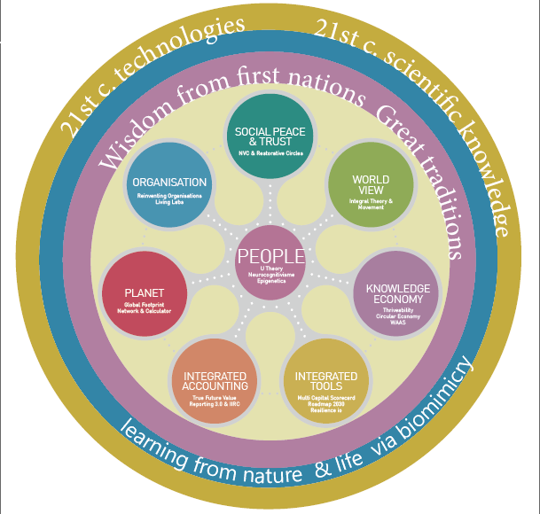

https://issuu.com/theacornhub/docs/lighthouse (page 7)

To get a deeper feeling for this humanizing G4 360 degrees proposal, where we propose to unleash
latent human, organisational and societal potentials in favor of the SDGs and NDCs, pls have a look
at all the links on the various "petals" of the grafic, on page 7 of our 1st newsletter LIGHTHOUSE.

For Geneva G4 is a Living Lab to foster Greater Geneva for Global Goals
and make the region an exemplary lighthouse for and with the world.
Locally G4 will co-create a network of living labs, connecting and aligning public and private sectors, academia, civil societies, banks and investors.

A prerequisite for a successful implementation of SDGs is to bring together systemic thinkers and actors, from all societal actors. These people are capable of acting transversally in transdisciplinary complex contexts in favor of the common greater good of the whole and the parts. This is the big critical challenge to find the right people.

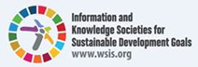
0. Preliminary
Note to members of the IFIP General Assembly
San Jose (Costa Rica) - 16th and 17th of September 2016
and members of the IFIP MSA on the 15th of September 2016

Proposal for the development through IFIP of a draft entitled:
Human Digital Rights
and Responsibilities (HDRR)
The architecture of this draft could have the following scheme:
1. Rationale and importance of this document to be created. The context of the Internet of Things and big data, such as the existence and development of fulgurant networks include pillars of this section 1.
We find in the 14 references cited in this document much food for inspiration (for brevity only reference 1 was explained by citations to increase understanding of the urgency of such an effort; other references could be explained by the same way). Other references could also be added naturally in a collaborative and interactive work for the several months to come (see section 3).
In the field of the immaterial in the society, it is today near the jungle and the desert for codes of conduct.

2. The purpose of such a draft is not to aim / denounce any of the leading companies (eg GAFAM) or behavior of certain States. This is to raise awareness to a maximum of decision makers of the need for meta-rules to save, if this is even possible, mankind face to networks of controllers and their chaotic jobs, unbridled and irresponsible. The digital responsibility in life is not a process to be left to a small caste or even the robots themselves.
The systematic use of many connected and increasingly sophisticated robots is not a testing ground to invest without rules of conduct and leaving tomorrow or the future generations the task of finding parades against perverse effects.
This is to define a type of meta charter as is the case for Human Rights or the Rights of Children. Incidentally, I think the IFIP must be proactive in this area and be the “International Body” that can bring some reason, conscience and lucidity. In terms of visibility, the opportunity is certainly unique, especially as it comes to producing a permanent and sustainable charter vis-a-vis fulgurant developments in technology and science.

3. Roadmap (this is a suggestion)
How to proceed? How to produce the successive drafts?
First, it would be contra-productive to try to hold on to a first text and illusory to
believe that we succeed only in making a similar document to the "Human Rights". …. For more infos
1. Introduction (English / Français)

A group of men and women, considering technological development without prejudging its merits, share their reflections in a text called "Human Rights and Responsibilities HDRR" so that technology remains one of the tools to help humanity to keep its role.

This text offers a universal reflection on the responsibility of the uses of any technological evolution, we must have with regard to the preservation of the human species in coherence / alignment with the SDG.

This text may seem to some ridiculous, others will see it as a danger; our wish is that it becomes an evidence for the preservation of humanity.

One cannot continue to envision a future in which the permanent disruption between the linear human and the exponential technological evolutions. It is therefore URGENT to systematically accompany the reflections on the consequences in coherence / alignment with the SDGs. It is clear that technologies will continue to accompany human evolution.
_____________________________________________________________________

La survie de l’espèce humaine, priorité pour l’humanité.

Un groupe d’hommes et de femmes, considérant les évolutions technologiques sans préjuger de leur bien-fondé, partagent leur réflexion dans un texte baptisé « Human Digital Rights and Responsibilities HDRR » pour que la technologie demeure un des outils du maintien de l’humanité.

Ce texte offre une réflexion universelle sur la responsabilité des usages que toute évolution technologique doit avoir au regard de la préservation de l’espèce humaine en cohérence / alignement aux SDG.

Ce texte peut paraître à certains ridicule, d’autres le verront comme un danger; notre souhait est qu’il devienne une évidence pour la préservation de l'humanité.

On ne peut pas continuer d’envisager un avenir dans lequel la disruption permanente entre les démarches humaines (linéaires) et l’évolution technologique exponentielle. Il est donc URGENT d’accompagner systématiquement les réflexions sur les conséquences en cohérence / alignement avec les SDGs. Il est évident que les technologies continueront à accompagner l’évolution de l’humain.

Open Geneva Hackathons Human Digital Rights & Responsibilities - Droits et Responsabilités Humains dans le monde Numérique
Open Geneva Hackathons : Education-21 - L’évolution nécessaire des systèmes éducatifs pour intégrer les mondes numériques, Education 21 - Necessary evolution of the education systems to integrate the digital worlds

