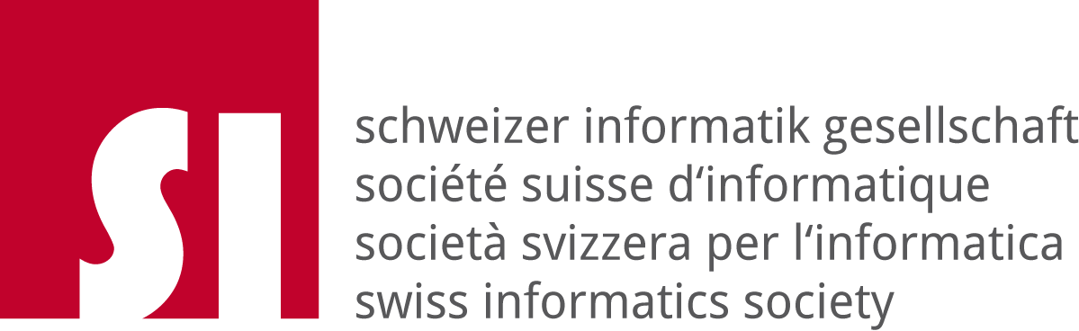

Swiss Informatics Society
Code of Ethics

Version 1.0

Approved at the General Assembly of the Swiss Informatics Society November 25th 2005

￼Preamble

The Swiss Informatics Society code of ethics follows a long tradition of professional principles of conduct and is bound by this tradition. The objective of this code of ethics is to provide a standard for responsible conduct for all informatics professionals.
For over thirty years ethics standards for computer professionals have been discussed and drawn up in many countries. It has become apparent that there cannot be a globally standardized code of ethics owing to cultural differences and local situations. The basic precepts of the Swiss Informatics society (SI) are modelled on the Code of Ethics and Professional Conduct of the Association for Computing Machinery) (ACM) approved in 1992. We have expanded on them taking into account the Swiss point of view. They now define the ethical commitments to be made by each member of the SI in the form of 26 personal pledges. Special attention has been given to the following subjects:

- fair competition
- trust between the customer and the service provider
- ecological and social sustainability in informatics
- avoidance of unnecessary and uncontrolled complexity.

This code of ethics will be in effect as of 1/1/2006 and is binding for all members of SI.1

1. General Moral Imperatives

As a member of the Swiss Informatics Society I shall..
.
1.1 contribute to the general welfare of society;

1.2 respect the privacy and rights of others;

1.3 act in an honest and trustworthy manner;

1.4 respect material and immaterial property rights.

2. Professional Responsibility

As a member of the Swiss Informatics Society, whilst exercising my profession I shall...

2.1 only perform jobs that I can justify both ethically and professionally;

2.2 guarantee the highest degree of quality and effectiveness;

2.3. acquire and maintain professional competence;

2.4 include the subject of social responsibility when imparting professional knowledge;

2.5 oppose inappropriate expectations of systems of Information and Communication Technologies (ICT);

2.6 observe and apply existing rules and regulations;

2.7 access ICT resources only when authorized to do so;

2.8 honor contracts and agreements;

2.9 accept and provide appropriate professional reviews;

2.10 give comprehensive and thorough evaluations of ICT systems and their impacts, including analysis of possible defects and risks;

2.11 avoid unnecessary and uncontrollable complexity;

2.12 protect material and immaterial resources and not burden future generations unnecessarily.

3. Additional Responsibilities of Management

As a member of the Swiss Informatics Society in the execution of my managerial duties I shall...
3.1 articulate social responsibilities of members of an organizational unit and encourage full acceptance of those responsibilities;

3.2 strive to manage personnel and resources to enhance the quality of working life;

3.3 procure and use ICT systems in such a way that the dignity and rights of users and those who will be affected by a system are protected;

3.4 ensure that users and those who will be affected by a system have their needs clearly articulated during the assessment and design of requirements; later the system must be validated to meet requirements;

3.5 create opportunities for those who will be affected to learn the ICT systems’ principles and limitations;

3.6 ensure that ICT resources in my area of responsibility are used legally and appropriately;

3.7 ensure that ICT systems in my area of responsibility are used in manageable and transparent ways.

4. Application of the Code of Ethics

As a member of the Swiss Informatics Society I shall…

4.1 observe the principles of this code of ethics;

4.2 support the promotion and dissemination of this code;

4.3 use opportunities to make this code a component of employment agreements and similar contracts;

4.4 ensure that my staff observe the present code and help them to do so when necessary.

5. Role of the Swiss Informatics Society

The Swiss Informatics Society declares the recognition and observance of this code as an inte- gral component of its conditions for membership.

Furthermore the Swiss Informatics Society will…

5.1 make this code known to a broad public and promote its use as a component of agreements governing employment, products and services;

5.2 gather cases of violation against this code and publish them regularly in an appropriate way. This will heighten awareness and support adherence;

5.3 process selected cases and make them available for the purposes of ethical training and further education in informatics;

5.4 elect an ethics delegate who can be consulted confidentially in connection with ethical issues involved with the application of ICT;

5.5 ensure that this code of ethics is re-examined regularly and adapted where appropriate.

_______________

NoteL The statutes of the SI are being amended per 1.1.2006 as follows: “Endorsement of the Code of Ethics as a personal commitment to responsible behavior is a prerequisite for membership in the Swiss Informatics Society” (Article 3, Para. 2, new). This amendment places the responsibility for enforcing the Code of Ethics with the Executive Committee of the SI. Based on the statutes valid today the Committee may, in extreme cases, expel a member from SI: “If a member fails to discharge his/her statutory duties or harms the society, the Committee may decide to expel him/her” (Article 3, Para. 4).

