SUSTAINABLE ICT, EDUCATION and LEARNING

A transversal language and understanding to support the activities including pedagogy and technologies at large:

Towards MITIC: Media and ICT (Information - Communication Technologies) in Education

Section 1 Around the author of this input, Raymond Morel
In 1964, it was my first contacts with computers and programming as assistant at Geneva Observatory. In addition with the dry astronomy in its Institute in Geneva (theory, books, workshops with students, with experts, etc) a large part of my time was dedicated to stars observations, mesuring them in ST-Michel de Provence Observatory ( a cluster of 17 telescopes_/coupoles), in Gornergrat Observatory _(in the Swiss Alps in Wallis for the quality of the sky) and in Jungfraujoch Observatory (same reasons in Berner Alps) for a big project: to move from 3 filters photometry system to a 7 filters photometry (age, characteristics of the stars, distances, chemical elements, etc.).
To do the job we need to have a menu for each night (mix of already observed standard stars and new ones to enlarge the catalog. Plenty of problematics were emerging and have to be mastered ( to point and fellow with the telescopes on the right stars, to be sure of our shoots to measure, to input the new data in the database independently of the location and to judge and certify the coherence with other data already collected, etc). All these operations have to be achieved with the technologies of that time and ICT methods, hardware interfaces, software interfaces and with specific applications or use of generic old software to assure the information and the the computing of astronomical datas.
End of the sixties (60’), with my academic degrees (mathematics, numerical analysis, statistical methods, informatics) + teacher education to be able to teach, I can now teach some years at the level end of high secondary education (matura).
At that time with very active colleagues in different disciplines and our best students, we achieved a lot of new style pedagogical projects. We all notice that something new was missing: a resource center to support the actors (users, teachers in schools, developers of integrating ICT ( at that time TV, video were completely disconnected with ICT !!!), helping the headmasters to promote the right projects/innovations/classes usages with this emerging technologies. (cf.2)
As you will certainly notice the fact that I was early since a long time member of SATW (Swiss Academy of Technical Sciences) and conduct during more of 10 years the SATW COM ICT (ICT Commitee) facilitate any projects link with ICT.
The same observation with my involvement since 40 years in IFIP which conduct in 2020 to receive the IFIP Fellow distinction. International Federation for Information Processing - https://ifip.org/

Section 2

Towards MITIC: Media and Information - Communication Technologies in Education

To develop a resources center as suggest above, it’s take time; it is necessary to put together and in action various innovative and collaborative demands; it’s also necessary to convaince decision makers and to have some major helps in the educational system if possible human people conscious of the needs of innovation for a school more a less static, but with many competent individuals . Take care not to be too much impatient and to obtain from the start the final solution. Chronologically we can summarize the different steps as:

Already end of 60’ies, beginning of 70’ies we were convainced that communication, network, sharing data were among key issues to have success along the time with quick evolution of technologies. To anticipate at that time (more 50 years ago by the way sorry for some links not anymore active - they were suppressed by inconscious jung people looking for more space and not understanding these prehistorical discussion) with continuous reflections around prospective news on technology, very soon this list was enlarged with security, code of conduct and social aspects.
To be concrete we propose experiments and test on real pedagogical projects with DTSS (Dartmouth Time Sharing System). We rented some accounts for students and teachers on Mark I in Zurich for Europe and Mark III in Boston 8 to have worldwide covering). When on site you read Lilliam Hurst experiment for example

22-08-1991-Liliam Hurst-Ping-pong par ordinateur, des éléves participent à un débat mondial

http://www.ict-21.ch/l4d/pg/file/read/924041/22081991liliam-hurstpingpong-par-ordinateur-des-eleves-participent-a-un-debat-mondial
It was already true some decades ago and fullfil the 6 main issues just above !!!
Pedagogical experiments and tests on Mark I and III were excellent and belong to success of this period. But they was a big bemol: they were NOT possible to generalize and to much to much costly. From there we find THE solution : to bye a complete time-sharing system to install in our resource center (we condemned half a classroom). This solution was some tens less expensive and so efficient that Honneywell-Bull fixed these system could be sell only for educational institutions, otherwise they are killing the competition for business applications.
We keep this HB1642 during 10 years (dividing the educational price by 120 and by the number of users till 64 was magic). We do the same for the next decade with Pr1me
The TSS offer fruitfull perspectives to real innovative pedagogical projects.

After 10 years of HB-1640, the change to Pr1me systems and afterwards the networks of microcomputers in the central resource center, in the schools and at home give the start key issues (cf. above) at disposition of all users and a stability during more than 4 decades. That conduct all the projects locally, as well at national and international levels.

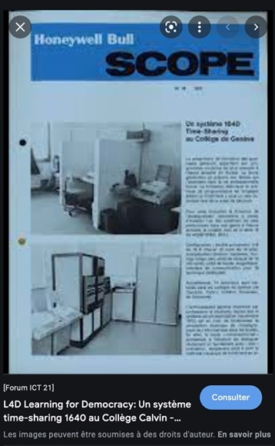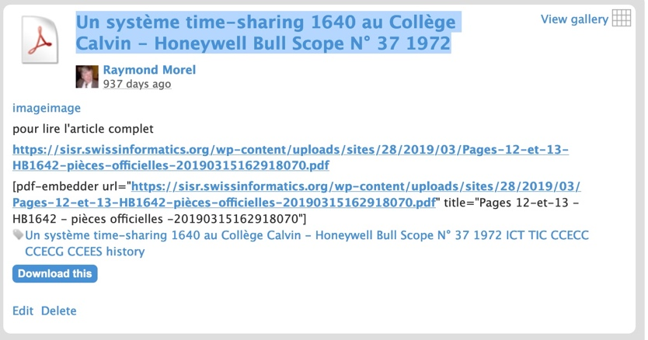

Since 1972 (about half a centuary) THE priority was the teacher training and the education. Even you have very serious newspaper recognize it. LT-07sept-2001-Pour mieux intégrer les nouvelles technologies à l'école, la Suisse doit former 30 000 enseignants – C. Dubouloz http://www.ict-21.ch/l4d/pg/file/read/925305/lt07sept2001pour-mieux-integrer-les-nouvelles-technologies-a-lecole-la-suisse-doit-former-30-000-enseignants-c-dubouloz

As a resource center we accomplished hundreds of courses mainly LLL (lifelong learning) for teachers of teachers, teachers, headmasters and decision makers, teaching aids and of course also for accompagniment, support and diffusion. We offered and continue to offer very successful projects and existing material (i.e Cabri Geometre http://www.ict-21.ch/l4d/pg/file/read/923444/avril1994cabrigeometre), new packages developed by team of taechers on specific topics (i.e NEURODULES http://svtolog.free.fr/article.php3?id_article=229
or EVOLUT https://sisr.swissinformatics.org/1989-evolut-mecanismes-de-levolution-franc%CC%A7ois-lombard/ in biology), new applied methodologies (i.e KDMK https://kdmk.social-in3.coop/retour-sur-making-gouter/ (kid he make): ICT for very young children) or new concept (i.e e-inclusion).

Of course during these decades the name of our resource center changes, the target enlarged and the services adjust to the evolution of the reality. From CCECC (Computer Center College Calvin), we move to CCECG (Computer Center College de Geneva – 8 gymnasien – matura schools before University), to have a stage with CCEES (a period with all the schools and institutions of the secondary education), then the name was Centre EAO (teaching and learning with computers). It was during this time that took place the first European projects

1989-1991-START-UP-OTE-CPTIC-CIP-CEAO-EU-Project-Pedagogy-organisation-industry
http://www.ict-21.ch/l4d/pg/file/read/922869/19891991startupotecpticcipceaoeuprojectpedagogyorganisationindustry

1989-FNRS-Start-UP-demande de subvention

1988-DF-Ostini-DELTA START-UP

1989-Conférence de presse du 7 juin - La Suisse dans un projet européen, START-UP EU-projects

1991-ofes boder rapport final Start-up

1989-1991-START-UP-Education et nouvelles technologies, un réseau européen

1990-START-UP-Christine Gardiol - Start-up , quoi et pourquoi ?
For other international projects after 1991 see below

Then 1991 (30 years ago !!) was a new important change of name with an extension from the DIP (Education minister) to CIP (Center for Pedagogical Informatics). It’s mean all levels of education and special institutions in charge of targeted actions (i.e. handicapped population of students, etc.)

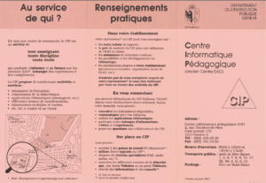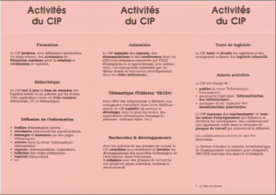

https://sisr.swissinformatics.org/wp-content/uploads/sites/28/2020/09/Binder11991-dépliant-CIP-.pdf

It’s from that very active period that began to emerge the necessity of A transversal language and understanding to support the activities including pedagogy and technologics at large: Towards MITIC

To illustrate the level of activities (teacher training, pedagogical projects, events, etc.) have a look on a document from François Lombard, one of the collaborators shared between CIP and University of Geneva (TECFA), as examples

Formation continue des maîtres du secondaire à la biologie de l'information BIST

La biologie a changé : Comment enrichir mes cours?
http://tecfa.unige.ch/perso/lombardf/bist/
Page pour les élèves de biologie
http://tecfa.unige.ch/perso/lombardf/calvin/index.php

1991, it’s also a nice usage of ICT with the system Kalimera – home made - (Kalimera = “Welcome” in Greek language). As we are at that time in the period of videotex (Minitel in France) not the top in comparaison with 2021, but you can already achieve some interesting pedagogical projects according with our earlier 6 basic key issues / prerequisites / priorities.

Dec-1992-Trop lourd, trop cher, le Videotex n'a plus que deux ans pour réussir

oct-1991-serveur videotex-Kalimera-X25-CIP-CEAO

1997-La-classe branchée-Enseigner à l'ère des technologies-Judith Haymore Sandholtz, C. Ringstaff, D. Dwyer
In 1998 le CIP was changing its name and integrates the ICTs for the global institution DIP ; its become the CPTIC (Centre pédagogique des technologies de l’information et de la communication)

After the reflections to conduct to the concept of MITIC (cf. above) and the settings of the CPTIC, the resource center change its name and become the SEM – Service Ecoles-Medias (2006)
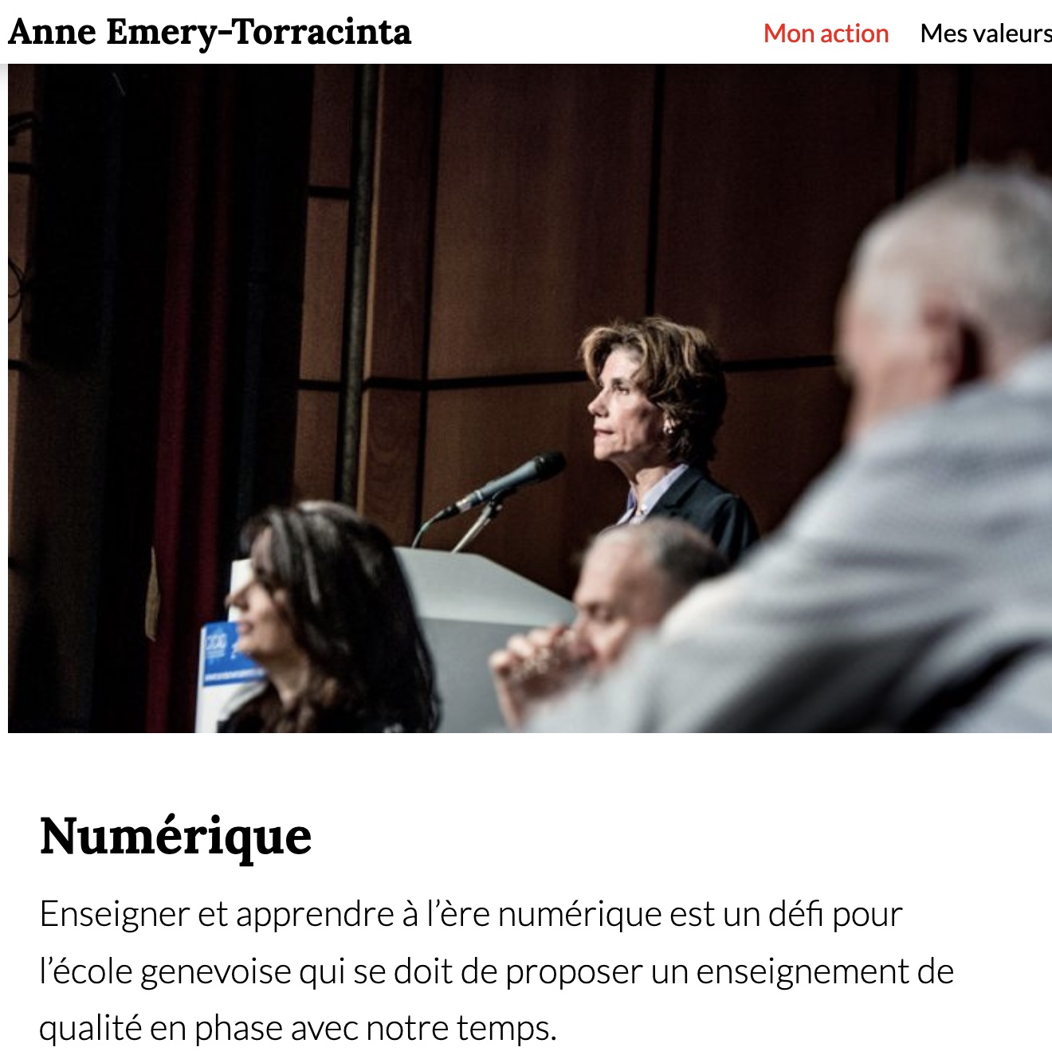

https://www.emery-torracinta.ch/mon-action/formation/numerique/

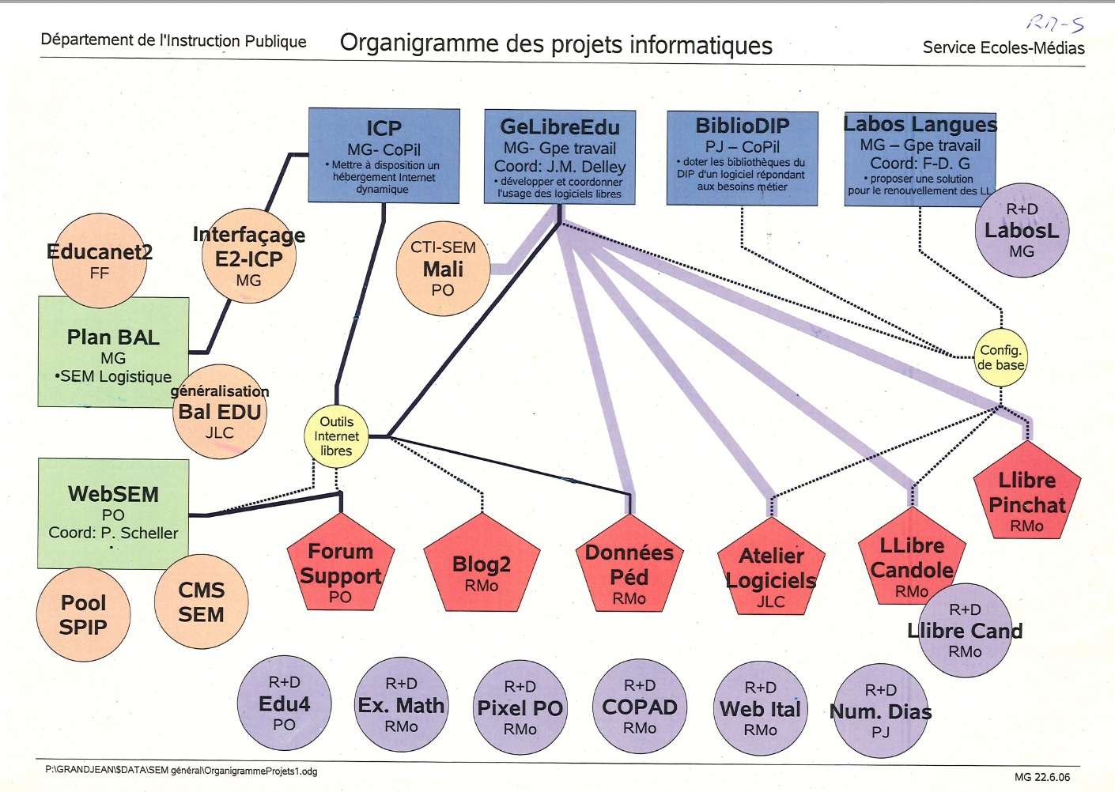
Towards the F3-MITIC Certification in Switzerland 4th and 5th of May 2003
The even rash new, generous ideas (taking charge of the training of teachers and of their teachers) which are translated in four years (the equivalent of a legislature) by a national regulation of competence recognition with an European standard (ECTS), while having been the object of a prototyping, an experiment, then an unanimous action plan of the CDIP-CH before being in the heart of a federal law, are not legions.

This F3-MITIC project 2 aims at implementing a learning process for teachers of teachers (F3) in media, image and ICT (MITIC) for all levels of education (from the primary to the secondary education including the professional training) for the initial training as well as the continued education of all teachers. The priority target of using MITIC in the processes of education and learning is in reference to the plans of studies, the current modernization efforts in the educational systems and the institutional priorities.

The roots of this process can already be found in a certain number of European projects with Swiss participation (TREND3 , FETICHE4 , etc.) at the end of last century. The click occurred during two national seminars at the end of this millennium within the framework of the project EKC (European Knowledge Centre) – KCTR (Knowledge Centre for Teachers and Researchers). F3-MITIC was already, indeed, in the plan of actions.

Towards the F3-MITIC Certification in Switzerland -

F3-MITIC, mai 2003 - Short Information about the ICT 21 process
https://www.yumpu.com/fr/document/view/22481606/na-3-f3-mitic-mai-2003-short-information-about-the-ict-21-process

NaTechInfo-No 31-Dec 2021-Plus de femmes dans les MINT : Ce que fait à la ville de Zurich

http://www.ict-21.ch/l4d/pg/file/read/925520/natechinfono-31dec-2021plus-de-femmes-dans-les-mint-ce-que-fait-la-ville-de-zurich

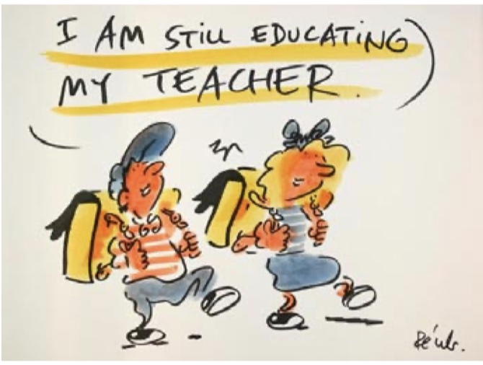

Reconnaissance des qualifications complémentaires dans la profession enseignante : mise en consultation by the General Secretary of CDIP (Conference of all directions of cantonal Ministers of Education)

Formation continue des enseignantes et enseignants, reconnaissance nationale des qualifications complémentaires, organisation de la carrière professionnelle : la CDIP lance une double consultation sur toutes ces questions.

Le Comité de la Conférence suisse des directeurs cantonaux de l’instruction publique (CDIP) a mis en consultation deux projets : les Recommandations relatives à la formation continue des enseignantes et des enseignants et le Règlement concernant la reconnaissance des qualifications complémentaires dans la profession enseignante. La procédure de consultation s’est terminée le 15 mars 2004.

CDIP = EDK = CDPE = CDEP top power of all Cantons Minister of Education in CH

To move from an Information Society to a Knowledge Society
Raymond Morel, Président de la Commission ICT de la SATW
Cf. the full text on demand

Section 3

Reminding actions to achieve for improving the process

Any reader of this description around MITIC should have notice that I use “services” of a cartoonist because I believe pictures (cartoons) help to understand better/deaper even serious contents / concepts. The deal is the following: we discuss and bring many documents on a subject, then Pécub (a cartoonist) who draw very, very, very rapidely. My organism byes series of drawing and then the copyrights are fully belonging to us. We leave each gallery at the disposal of our users free of copyright if the quote from which document the extract was drawn and that they engage themselves to don’t make money of them.

This discussion around the different facets of MITIC was a big success because now all actors can understand the same thing and the nuances. Nevertheless the MITIC have difficulties to impose themselves because the education system which is “silo oriented “. People (students and teachers) are not trained to share and/or think outside their domain.

When some decision makers propose to “give” 2 hours inside the table of the week (timetable) to introduce MITIC, they continue to refuse the globality of learning and favorize without being conscious the hashed-time during the week (only my discipline is top important, not a gadget oriented – they don’t facilitate the task of students with such a “tartare of topics and time-slices of the week”).

To overcome this situation, we should promote systematically interdisciplinary projects, but it’s very difficult to start such a process with people who are first specialist of a discipline and dedicated concepts in their field. May bee we should begin slowly with only one project (of course you can have different subjects for the totality of groups in one class). We don’t forget that to allow the meetings and concrete activities we can may be decide for a section to have a frozen half a day – don’t forget to offer the teachers implied in one project to share the discussion from the beginning of details of follow each project (modalities of the projects, evaluation, presentation and diffusion of the results, etc.)

https://svia-ssie-ssii.ch/fr/

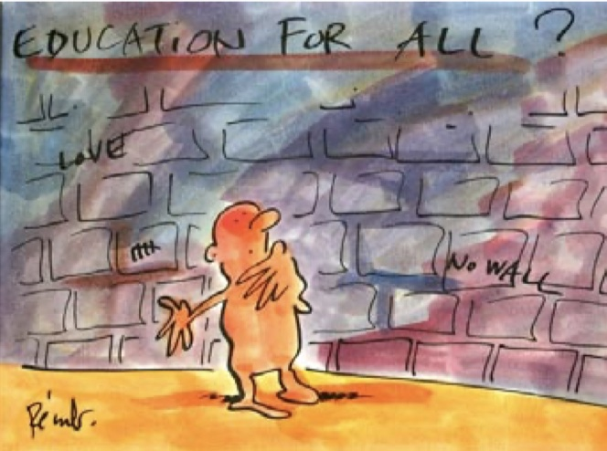

If I have to choose over the time among half a centuary of activites i.e some hundreds of descriptions the four actions that I love the best it would be :

A The Success Stories operations (1990-1995) because the collaborative work in action

https://tecfa.unige.ch/edu-comp/success-stories/

B The Zanzibar Declaration (2019-2022) the whole process, because the collaborative work in action (actually in full action)
How to suggest positionS in the Zanzibar Matrix ?

C some KDMK activities for very young children (beginning of the primary education – (….-….) the whole process, because the collaborative work in action (only an extract)

KIDIMAKE au Salon du Livre 2018

KIDIMAKE 31-32 -La magie du mouvement - Retours sur les activités de février 2020 (du 1er février et du 22 février)

Follow-up of "AI for Good" (29-30-31 of May 2019) à Genève

Kidimake 17 mars 2018 | 23ième Making Goûter @Flux Laboratory Genève - Bidouille made in Asia

Kidimake 17 mars 2018 | 23ième Making Goûter @Flux Laboratory Genève - Bidouille made in Asia

KDMK - Kidimake N° 20 et 21 - Après-midi de bidouille en famille - (4 et 25 novembre 2017)

KDMK : Kidimake N° 19 - Les machines à dessiner (Après la séance de novembre 2016)

https://geneve.reseauvacances.projuventute.ch/activity/alice-au-pays-du-codage Passeport Vacances été 2021

D FOAD sapeurs pompiers (Formation ouverte et à distance Sapeur-Pompier Volontaire)
FOAD : Formation ouverte et à distance SPV : Sapeur-Pompier Volontaire
FGSP : Fédération Genevoise des Sapeurs-Pompiers
CSSP : Coordination suisse des sapeurs-pompiers
Point d’accès sur l’ensemble des FOAD (1) SPV(2) • https://jsilab.ch/cspv/foad/
I apologize again for some non active links due to non cultural jung technos to “save/erase space” ! (RMO)

http://www.ict-21.ch/l4d/pg/file/read/920592/april-2527-2019sustainable-ict-education-and-learning-ifip-wg-34-international-conference-suza-2019-zanzibar-tanzania-sustainable-ict-education-and-learning https://ifip.org/ 2 Engineering the Knowledge Society (EKS), Geneva Dec. 2003 - Information technology supporting human development - http://www.ict-21.ch/l4d/pg/file/read/925612/engineering-the-knowledge-society-eks-geneva-dec-2003-information-technology-supporting-human-development

