8 digital life skills all children need – and a plan for teaching them

To become well-rounded individuals, children must learn these eight digital life skills
Image: REUTERS/Alexandre Meneghini
06 Sep 2016
- Yuhyun Park Chair, infollutionZERO Foundation
Latest Articles

Chart of the Day: These cities are busiest for business travellers
Charlotte Beale 11 Dec 2017

Facebook is rolling out a messaging app just for kids
Hanna Kozlowska · Quartz 11 Dec 2017

Explore context
Workforce and Employment
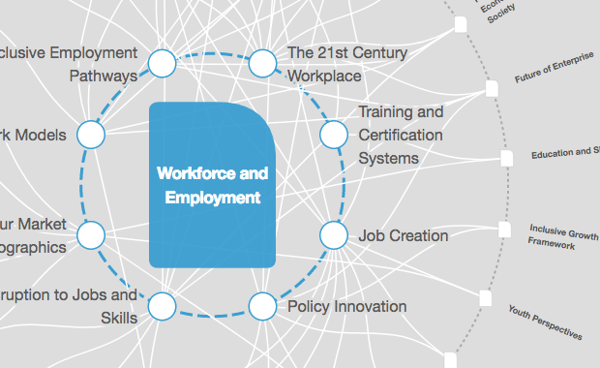
Explore the latest strategic trends, research and analysis
A generation ago, IT and digital media were niche skills. Today, they are a core competency necessary to succeed in most careers.
That’s why digital skills are an essential part of a comprehensive education framework. Without a national digital education programme, command of and access to technology will be distributed unevenly, exacerbating inequality and hindering socio-economic mobility.

What’s your DQ?
The challenge for educators is to move beyond thinking of IT as a tool, or “IT-enabled education platforms”. Instead, they need to think about how to nurture students’ ability and confidence to excel both online and offline in a world where digital media is ubiquitous.
Like IQ or EQ – which we use to measure someone’s general and emotional intelligence – an individual’s facility and command of digital media is a competence that can be measured. We call it DQ: digital intelligence. And the good news is that DQ is an intelligence that is highly adaptive.
DQ can broadly be broken down into three levels:
Level 1: Digital citizenship
The ability to use digital technology and media in safe, responsible and effective ways
Level 2: Digital creativity
The ability to become a part of the digital ecosystem by co-creating new content and turning ideas into reality by using digital tools
Level 3: Digital entrepreneurship
The ability to use digital media and technologies to solve global challenges or to create new opportunities

Why are we neglecting digital citizenship?
Of the three, digital creativity is the least neglected, as more and more schools attempt to provide children with some exposure to media literacy, coding and even robotics, all of which are seen as directly related to future employability and job creation. Likewise, there are major education initiatives – from America’s code.org to Africa’s IamTheCode.org – that promote access to coding education.
Digital entrepreneurship has also been actively encouraged, particularly in tertiary education. Many top universities have adopted and developed new courses or initiatives such as technopreneurship and entrepreneurship hackathons to encourage a culture of innovation. We’re even starting to see global movements that nurture social entrepreneurship among children through mentoring programmes – such as the Mara Foundation – and school programmes, like with the Ashoka Changemaker School.
But digital citizenship has often been overlooked by educators and leaders. This is in spite of the fact it is fundamental to a person’s ability to use technology and live in the digital world, a need which arises from a very young age. A child should start learning digital citizenship as early as possible, ideally when one starts actively using games, social media or any digital device.

The digital skills our children should learn
Educators tend to think children will pick up these skills by themselves or that these skills should be nurtured at home. However, due to the digital generation gap, with generation Z being the first to truly grow up in the era of smartphones and social media, neither parents nor teachers know how to adequately equip children with these skills.
Young children are all too often exposed to cyber risks such as technology addiction, cyberbullying and grooming. They can also absorb toxic behavioural norms that affect their ability to interact with others. And while most children encounter such challenges, the problematic exposure is amplified for vulnerable children, including those with special needs, minorities and the economically disadvantaged. They tend to not only be more frequently exposed to risk, but also face more severe outcomes.
So what skills should we be teaching our children as part of their digital citizenship? In the research we’ve done on this matter, we’ve identified eight in particular.
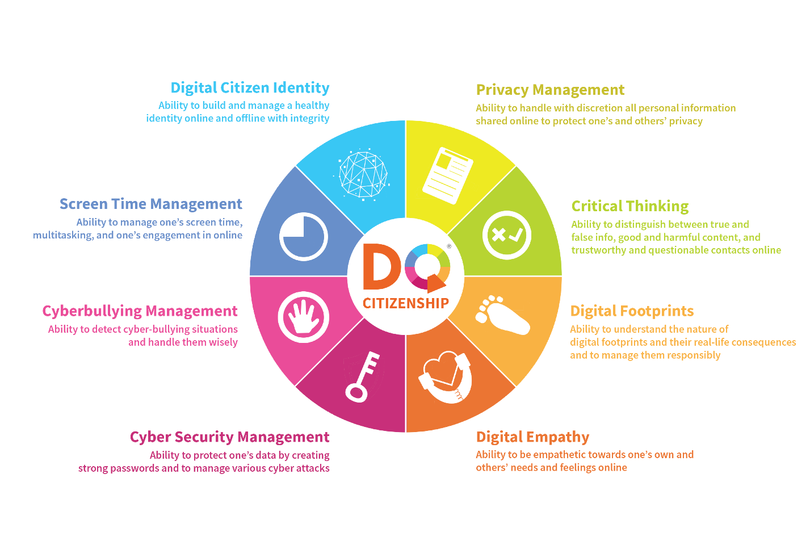
Digital citizen identity: the ability to build and manage a healthy identity online and offline with integrity
Screen time management: the ability to manage one’s screen time, multitasking, and one’s engagement in online games and social media with self-control
Cyberbullying management: the ability to detect situations of cyberbullying and handle them wisely
Cybersecurity management: the ability to protect one’s data by creating strong passwords and to manage various cyberattacks
Privacy management: the ability to handle with discretion all personal information shared online to protect one’s and others’ privacy
Critical thinking: the ability to distinguish between true and false information, good and harmful content, and trustworthy and questionable contacts online
Digital footprints: The ability to understand the nature of digital footprints and their real-life consequences and to manage them responsibly
Digital empathy: the ability to show empathy towards one’s own and others’ needs and feelings online

What a quality digital education looks like
A quality digital citizenship education must include opportunities for assessment and feedback. The assessment tools should be comprehensive as well as adaptive in order to evaluate not only hard but also soft DQ skills. Ultimately, such assessments should serve as a means of providing feedback that gives children a better understanding of their own strengths and weaknesses, so that they may find their own paths to success.
Ultimately, national leaders need to understand the importance of digital citizenship as the foundation of digital intelligence. National education leaders should make it a priority to implement digital citizenship programmes as part of an overall DQ education framework.
Most importantly, individuals should initiate digital citizenship education in their own sphere of influence: parents in their homes, teachers in their classes, and leaders in their communities.
There is no need to wait. In fact, there is no time to wait. Children are already immersed in the digital world and are influencing what that world will look like tomorrow. It is up to us to ensure that they are equipped with the skills and support to make it a place where they can thrive.
This post is a follow up to the 8 digital skills we must teach our children

