|  |  |
| --- | --- |
| **Capture d’écran 2012-04-17 à 10** | Colombo, 12th of September 2017  **IFIP General Assembly**  **National Report**  **September 2016 - August 2017** Country: SWITZERLAND Representative **: Raymond MOREL (CH)**  **Swiss Reps at IFIP GA and member of ILC,**  **MSA and board of IP3**  [Raymond.Morel@unige.ch](mailto:Raymond.Morel@unige.ch) |

**Table of content**

# 1. The SI (Swiss Informatics Society), the Swiss IFIP Member

# 2. The Swiss IFIP Committee (SIC)

# 3. Feedbacks IFIP during 2016 - 2017 in Switzerland – LEVEL SWITZERLAND

# 4. Feedbacks IFIP during 2016 - 2017 from Switzerland – LEVEL INTERNATIONAL

5. State of the art for the proposal GA’2016 on : HDRR Human Digital Rights and Responsaibilities **-------🡪 and the follow-up**

# AOB – References



**IFIP FULL MEMBER SOCIETY REPORT 2016-2017  
to the General Assembly, Colombo (Sri Lanka)**

# 1. The SI (Swiss Informatics Society), the Swiss IFIP Member

**The Swiss IFIP Committee** is (since September 2011) one of the Working Groups of the SI (Swiss Informatics Society)which is as of now the new Swiss Member of IFIP.

**SIC members** are the Swiss delegates to the IFIP General Assembly and to the IFIP Technical Committees.

They meet once a year to discuss the annual reports of the TC rep's, the past and future activities, the participation in Swiss associations and events, and also issues with IFIP and its TC's, etc..

This chapter describes briefly the IFIP Federation recent activities and its various bodies, various aspects of the Swiss participation and contributions to IFIP, the associated amount of efforts and also tries to emphasize the value for Switzerland of this participation.

Very active in IFIP since its creation in 1960 and although not part of the European Community, **Switzerland** has not only been a founder of IFIP but has continued to contribute towards its objectives and activities without interruption through the personal involvement of its representatives:

* active presence in the Executive Board and the Council and 3 Presidents covering a period of 12 years.
* R.Morel, Swiss representative to the IFIP GA since 1999, has been Board Member and Councillor from 2004 to 2010, actually member of the IFIP ILC (International Liaison Committee), of IP3 Board and of the new MSA (Member Societies Assembly),
* Strong and active Swiss presence in the Technical Committees and Working Groups dealing with matters of interest to Switzerland.
* Swiss Honorary Members of IFIP : Kurt Bauknecht, [Pierre-André Bobillier](mailto:pa.bobillier@gmail.com)

Today, **82 specialists** from Swiss Academia and industry are participating in **11 TC's** and **39 WG's.**, with 2 reps who are also special consultants.

The TC representatives are appointed by SI Board, the Swiss Member of IFIP since 2011. P.-A Bobillier, past IFIP President is in charge for preparing election and renewal of these delegates.

The WG members are individual specialists accepted by the WG's for their expertise (there is no country limitation on their number).

The personal involvement and the efforts of these specialists contribute, through their international contacts with leading experts, to acquiring and bringing to Switzerland knowledge on new technology developments and strategies discussed within IFIP Working Groups. They are the ambassadors of Switzerland to the TC's and WG's

and contribute to the maintenance and improvement of the Swiss international image.

This is especially true in areas such as Education, Communications (infrastructure, access, etc..), Security, Software, Human aspects, etc.. which present important potential for Switzerland.

Support for these international activities is therefore very important to allow the continuation of an active Swiss participation in the international IFIP activities in all areas of ICT.

The Swiss Committee for IFIP is thankful to the employers of the IFIP delegates; without such support they could not pursue their mission. We have tried hereunder to evaluate the overall effort represented by the activities of the delegates to IFIP functions.

**The Swiss delegates** are appointed for a period of 4 years renewable by periods of 2 years. The names of the Swiss TC and Working Groups representatives are published on the SIC Web site <http://www.ict-21.ch/SIC>

The main functions of a Swiss IFIP TC representative are :

* to assure the both ways communications between Switzerland and his TC (information to the Technical Committee about latest developments and concerns in Switzerland and information to the interested parties in Switzerland about the TC activities),
* organise TC meetings and events in Switzerland when feasible, SI, etc...

**For more information** (cf. para 3) **:**

* **Tasks** : <http://www.ict-21.ch/SIC/IMG/docx/SIC-task.docx>
* **Rules** : <http://www.ict-21.ch/SIC/IMG/docx/SIC-rules.docx>

# 2. The Swiss IFIP Committee (SIC)

**The Swiss IFIP Committee** is (since September 2011) one of the Working Groups of the SI (Swiss Informatics Society)which is now the new Swiss Member of IFIP.

**SIC members** are the Swiss delegates to the IFIP General Assembly and to the IFIP Technical Committees.

It meets once a year to discuss the annual reports of the TC rep's, past and future activities, participation in Swiss associations and events, issues with IFIP and its TC's, etc..

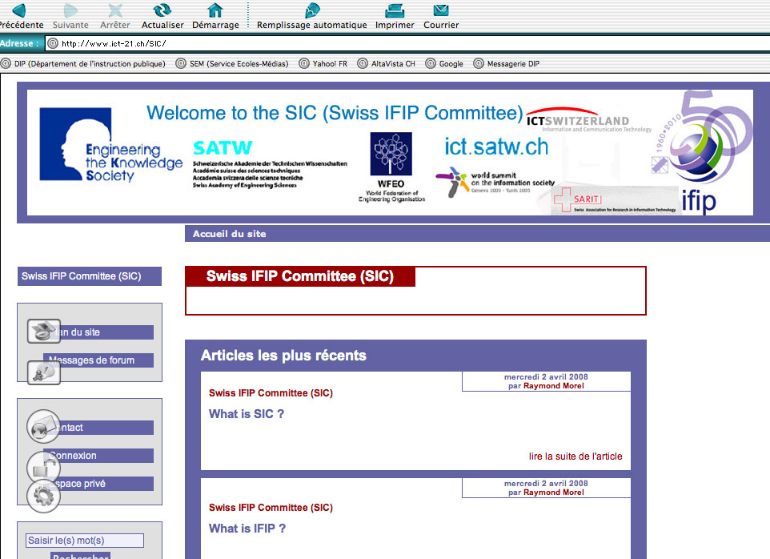

[**http://www.ict-21.ch/SIC/spip.php?rubrique2**](http://www.ict-21.ch/SIC/spip.php?rubrique2)

**Yearly spendings of Swiss IFIP delegates :**

 in order to get an evaluation of the importance of resources spent by IFIP delegates to TC's and WG's a survey is repeated on a regular basis. The delegates are asked how much they spend annually in:

- Person days (meeting attendance, home work, reports, meeting preparation, etc..) and

- Travel expenses (airline/train tickets, hotel and meals, registration fees or receptions for invitees, etc..)

The numbers vary significantly; for example, the time spent varies from 5 to 50 days/year. The maximum happens when the TC rep has several IFIP functions (for example Council Member, TC Officer, etc..) or when in charge of organising an IFIP event in Switzerland. The last detailed evaluation was done for the **year 2010**.

**Total expenses per TC/WG representative were** **16.3 kfr/person/year**

As of December 2013 82 specialists from Swiss Academia and industry were participating in 10 TC's and 39 WG's.

This represents a total Swiss effort of approximately **1'336’600 fr/year** of which 140 kfr for airline tickets.

These activities would obviously be impossible without the IFIP delegates employers. They however tend to restrict allowing "free time" to their employees for obvious reasons. They are of course encouraged when at least the travel tickets for the TC delegates (although a small part of the total) are covered. The "old" scheme was: support by SATW (20 kFr. via ICTswitzerland) and SARIT (5 kFr.).

Various ways were investigated to find the new support and this critical situation has been partially resolved starting 2014: **SI and ECDL-SI contribute 25 kFr. towards SIC International activities.**

ICTswitzerland stopped interest for international and scientific / research aspects and SATW having broken the support contract in force for years, it was necessary to reorganise the IT scene. The IFIP Swiss membership with SIC finances were transfered to SI (Swiss Informatics Society).

Following organisation charts were established, thanks to C.-A. Zehnder, regarding all associations: ICTswitzerland, SIRA, SI, SATW, etc.. which achieved the whole transition process.

They reflect well the complexity of the current environment.

InfkVerbCH2012-b

InfkBildgCH2012

**To summarize :**

The financial issue was actively studied inside SI and **since 2014 a long range solution was found for the continuation of the active presence of Switzerland in IFIP.**

It must be remembered that no support is provided to the members of Working Groups. Their expenses have therefore to be totally covered by their employer.

The current status (travel tickets paid for the TC delegates) allows some freedom in the nomination of TC rep's. The reduction of such support would mean to restrict the selection of new TC rep's to persons fully supported by their employers (a questionable solution!) or to drop the Swiss representation to some Technical Committees.

The support by employers to their employees international activities is a very important contribution for the whole Switzerland: they contribute to the Swiss reputation and image, to fruitful international experience exchange and to allow valuable information to be brought back to Switzerland, etc..

They therefore deserve our most sincere thanks for their valuable contributions.

# 3. Feedbacks IFIP during 2016 - 2017 in Switzerland – LEVEL SWITZERLAND

[**After the event : 10. Zürcher Konferenz und Netzwerktreffen : Technologieoutlook und Megatrends: Digitale Gesellschaft in der Zukunft on 30th of September 2016 in Zürich organised by Future Network**](http://www.ict-21.ch/l4d/mod/file/download.php?file_guid=892904)

[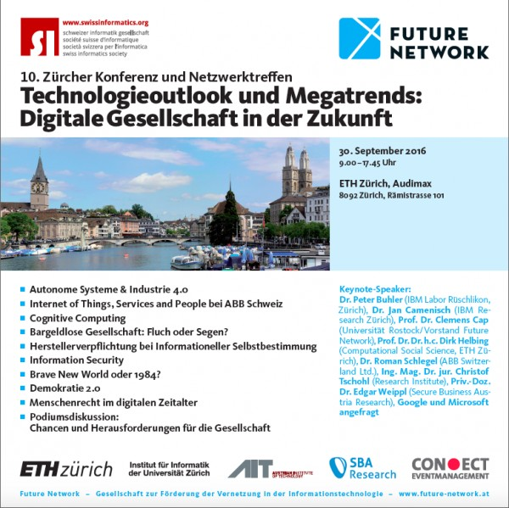](http://www.ict-21.ch/l4d/mod/file/download.php?file_guid=892911)

## [From LIN : rencontre LinForum du 1er octobre 2016](http://www.ict-21.ch/l4d/mod/file/download.php?file_guid=893243)

[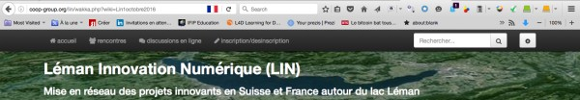](http://www.ict-21.ch/l4d/mod/file/download.php?file_guid=893241)

# Un Samedi pour se rencontrer tous, et se raconter/montrer tous nos projets, partager des idées

* **Date**: Samedi 1er Octobre 2016
* **Durée**: 10h-17h
* **Lieu**: sur Genève: à BATTELLE (lieu et réservation confirmée [UnigeCUI](http://coop-group.org/lin/wakka.php?wiki=UnigeCUI) ;)
  + 1 demi-table par (groupe de) participant (pas par visiteur), devant un poster mural (à fournir, optionnel).
* **Inscription**: via ce meetup STP: <http://meetu.ps/e/BNNz0/mDBRd/f> (mieux adapté que sur un Wiki ;)
* **Venir avec**:
  + 1 poster (ou plusieurs) avec vos idées/projets: flyers et cartes de visites...
  + 1 laptop avec vos 20 slides (ou plus), video et autres, en boucle... (optionnel)
  + Un peu à boire et à manger: à partager ? Brunch canadien ?
  + 1 clef USB avec 20 slides de 20 secondes, (de 6mn40), ou simplement 20 photos (JPG), pour ceux qui présentent
    - EN FAIT NON: comme backup, bonne idée, mais fournir 1 URL qui tourne ce slideware avec tempo de 20 secondes: utilisez [Slides.com](http://Slides.com) au besoin
    - Nous sélectionnerons les présentations et elles seront disponibles ici-même, en ligne, avant l'event... (je sais, cela casse l'effet surprise, mais cela éveille intérêt et questions...)
  + et 1 clef backup...
  + vos équipements informatiques et mobiles seront tolérés,
  + appareils photos et partages encouragés
* #LINFORUM2016 (Twitter, Facebook, ...) #[Net2LIN](http://coop-group.org/lin/wakka.php?wiki=Net2LIN) #LIN42 #[Tech4GoodLIN](http://coop-group.org/lin/wakka.php?wiki=Tech4GoodLIN/edit&theme=bootstrap3&squelette=1col-navbar-alt.tpl.html&style=bootstrap.min.css&bgimg=&newpage=1)
* Questions: [PascalKotte](http://coop-group.org/lin/wakka.php?wiki=PascalKotte) <http://callme.kotte.net>

# Programme

Merci d'ajouter votre envie de participation, vos idées, suggestions ici dessous, que ce soit sur le déroulement, ou bien sur le contenu.  
**Rappel Thème de LIN**: Transition ou Innovation Numérique, de préférence durable et/ou responsable.  
Le [LinForum](http://coop-group.org/lin/wakka.php?wiki=LinForum), sera ce que vous en ferez. [**PechaKucha**](http://coop-group.org/lin/wakka.php?wiki=PechaKucha) **et 2 [BarCamp](http://coop-group.org/lin/wakka.php?wiki=BarCamp)**.  
Le déroulement sera ajusté en fonction des demandes: nous devrions pouvoir tenir **20 présentations**

# In October 2016, after the SI VIsionDay on the 21st, New issue of the SI News, SIRA and SI @ CeBIT 2016 – Swiss Pavillon

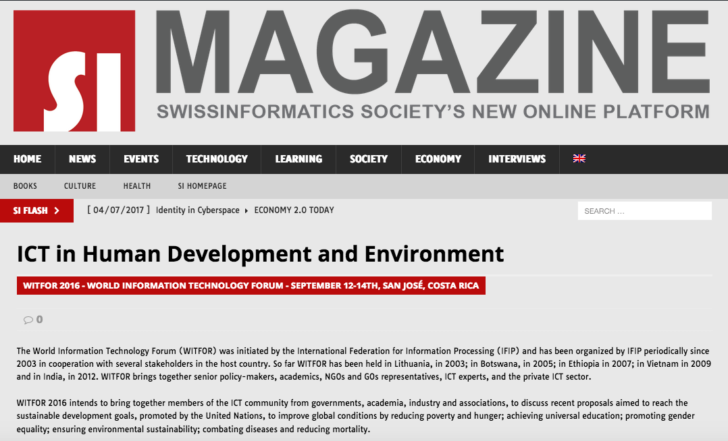

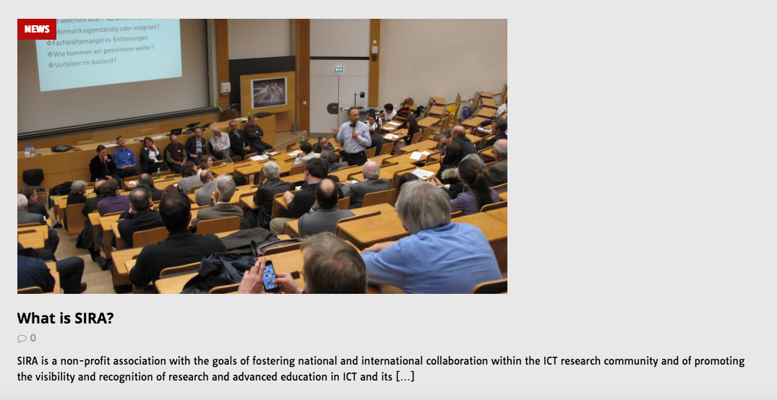

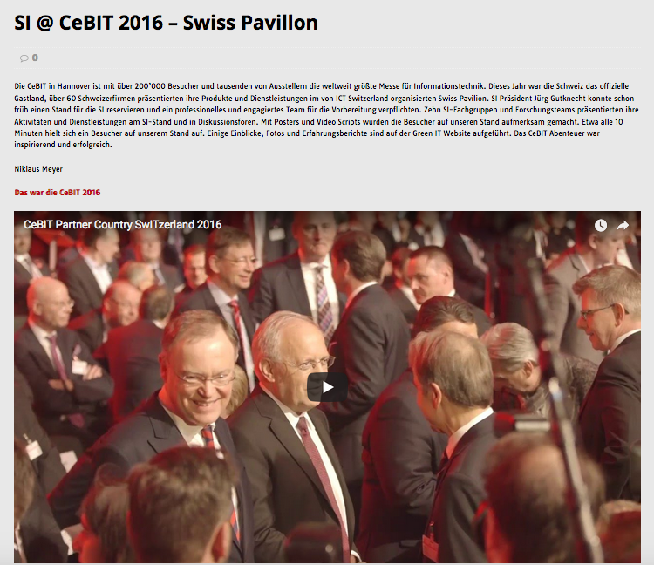

## [KDMK : Kidimake N° 19 - Les machines à dessiner (Après la séance de novembre 2016)](http://www.ict-21.ch/l4d/mod/file/download.php?file_guid=893655)

[[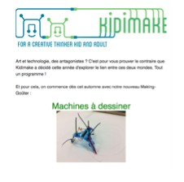](http://www.ict-21.ch/l4d/mod/file/download.php?file_guid=893653)](http://www.ict-21.ch/l4d/mod/file/download.php?file_guid=893653)

## [Après le colloque CTIE du 9 novembre 2016 09.00–12.30, BERNEXPO, Berne](http://www.ict-21.ch/l4d/mod/file/download.php?file_guid=894051)

# L'identité numérique, l'école et ses acteurs

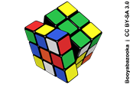

**Colloque TIC et formation du CTIE (Swiss Center for ICT in Education)**  
**Mercredi 9 novembre 2016, 09.00–12.30, BERNEXPO, Berne**

La numérisation entraîne un accroissement rapide de la quantité de contenus éducatifs et modifie dans le même temps les conditions pour la création de nouveaux contenus. À cela s'ajoute un nombre croissant d'appareils et d'objets, connectés à Internet.

[cf. l'annonce](https://commons.wikimedia.org/wiki/File:Rubik%27s_cube.svg" \t "_blank) <http://www.ict-21.ch/l4d/pg/file/read/893322/sfibfachtagung-ict-und-bildung-2016-digitale-identitt-schule-und-ihre-akteure-colloque-tic-et-formation-du-ctie-2016-lidentit-numrique-lcole-et-ses-acteurs-09112016-swiss-education-days-bernexpo>

Compte tenu de ces réalités techniques, des services en ligne et des plateformes Internet sont utilisés pour s'informer, communiquer et interagir. Les utilisateurs et utilisatrices sont d'un côté formellement tenus à cela et d'un autre côté ils souhaitent utiliser de manière responsable les offres disponibles en raison d'une accessibilité facile et de la – prétendue – gratuité.

**Comment l'école gère-t-elle l'identité numérique de ses acteurs?**  
Lors du colloque TIC et formation des experts se sont exprimés et ont discuté avec les participantes et participants:

[Introduction à la thématique](http://www.educa.ch/fr/manifestations/lidentite-numerique-lecole-acteurs/lidentite-numerique-lecole-acteurs), Toni Ritz  
[Education 4.0: la formation dans l’ère numérique](http://www.educa.ch/fr/manifestations/lidentite-numerique-lecole-acteurs/education-40-formation-l-ere-numerique), Prof. Dr. Dirk Helbing  
[Facteurs de succès pour la numérisation de l’école](http://www.educa.ch/fr/manifestations/lidentite-numerique-lecole-acteurs/facteurs-de-succes-numerisation-de-l-ecole), Peter Ganten  
[Identité Numérique, fédéralisme, subsidiarité et politique publique numérique](http://www.educa.ch/fr/manifestations/lidentite-numerique-lecole-acteurs/identite-numerique-federalisme-subsidiarite), Prof. Jean-Henry Morin [Débat spécialisé](http://www.educa.ch/fr/manifestations/lidentite-numerique-lecole-acteurs/debat-specialise), Modérateur: Phlippe Wampfler

## After the Creation of the G4 (Global Goals 4 Greater Geneva or 4 Greater Goods 4 Global Goals)

## HDRR : Human Digital Rights & Responsibilities

## From end of Fall 2016 to 12th of June 2017 beginning of WSIS Forum 2017, numerous meetings (working parties) to elaborate, test and present different versions of theabove document HDRR

**cf. Minutes GA 2016 – item 3.9.3**

## 

## More info :

[**http://www.ict-21.ch/com-ict/IMG/docx/Version-2.docx**](http://www.ict-21.ch/com-ict/IMG/docx/Version-2.docx)

[**http://G4-LL.net** **<===**](http://G4-LL.net)**G4-web-site**

## [to download the G4-Lighthouse newsletter N° 1](http://www.ict-21.ch/com-ict/IMG/pdf/lighthouse21042017.pdf)

## TechnoArk – Forum Business Valais-Wallis 2016

## 

## <http://www.technoark.ch/en/events/forum-business-valais-wallis-2016-8563>

[**IGF-CH in Bern on the 16th of December 2016**](http://www.ict-21.ch/l4d/mod/file/download.php?file_guid=894311)

## mage

## On 19th of January 2017 meeting of the SI Advisory Bord and

**Swiss IFIP Committee (SIC)**

**2016 SIC Annual Meeting, Bern, January 19, 2017, 13h45 to 16h00**

**1. Note for all members who haven’t yet sent their required informations**

**Request for information for each SIC member (it’s a kind reminder) :**

* **Your 2016 Annual report**
* **Your budget requests for 2017 and 2018** (cf. previous e-mails as attachment)
* **Your reporting of the time spent on IFIP activities during 2016** (idem)

**2) Please read, before our next meeting, the Minutes of the last IFIP General Assembly Meeting, Sept. 16-17, 2016,  San Jose (Costa Rica), which contain valuable information**

**3) P.-A. Bobillier will provide you before our meeting the document to review the list of Swiss TC and WG members attached to your TC for discussion in point 3 of the Agenda**

**MEETING AGENDA (draft)**

**\*\*\*\*\*\*\*\*\*\*\*\*\*\*\*\*\*\*\*\*\*\*\*\***

1. **Welcome**
2. **Agenda approval**

**2. Approval of Minutes of the last meeting: January 21st, 2016**

**Review of the Action List during the whole meeting**

**3. Activity Reports: All.**

Please concentrate on information especially relevant to Switzerland.

- TC itself

- WG membership: report on the current membership: active/inactive, need for actions, replacement, etc..

**4. General information**

* **From the chairman of the Swiss IFIP Committee**:

**- last GA meeting, WITFOR’16, etc**

**- Annual Follow up of the WSIS Forum 2016**

* **ICTSwitzerland, SI, => SIRA : R.Morel, and others**
* **SIC Rules and procedures: Elections, Travel Budget requests, travel reports, etc..**
* **From the other members of the IFIP Swiss Committee**

**5. Finances**

**6. Visibility of IFIP in Switzerland:** All

**7. Date of the next meeting**

**8. Miscellanous**

RM 31.12.2016

## [La Conférence TechnoArk revient le 27 janvier 2017 à Sierre pour une 12ème édition sur le thème : - Blockchain, au-delà du bitcoin -](http://www.ict-21.ch/l4d/mod/file/download.php?file_guid=894243)

## [mage](http://www.ict-21.ch/l4d/mod/file/download.php?file_guid=894225)

## Sierre, Suisse  ·  janvier 2017  ·  16 Talks

## [After the LIN Forum N°2 - Connectons projets, idées et entreprises numériques innovantes, 3 février 2017 à Lausanne (HES-SO)](http://www.ict-21.ch/l4d/mod/file/download.php?file_guid=895587)

## mage

## [Le congrès SSAB FSFA du 16 mars 2017 - Big Data and Learning Analytics](http://www.ict-21.ch/l4d/mod/file/download.php?file_guid=896117)

[**http://www.ssab-online.ch/mrz\_tag/mrz\_de\_2017.html**](http://www.ssab-online.ch/mrz_tag/mrz_de_2017.html)

[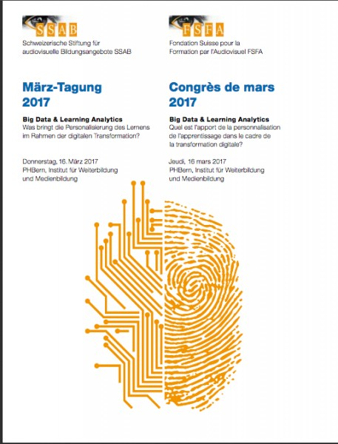](http://www.ict-21.ch/l4d/mod/file/download.php?file_guid=896124)

## From SATW (Académie des sciences techniques)

## Big data - ethical challenges for companies - «Big Data – enjeux éthiques» : Recommandations d‘action pour la politique et les entreprises - SATW special study (2017)

## 

## More info :

## <http://www.ict-21.ch/l4d/pg/file/read/895639/big-data-ethical-challenges-for-companies-big-data-enjeux-thiques-recommandations-daction-pour-la-politique-et-les-entreprises-satw-special-study-2017>

## [Geneva Global Goals Innovation Day (24th of March 2017)](http://www.ict-21.ch/l4d/mod/file/download.php?file_guid=895841)

[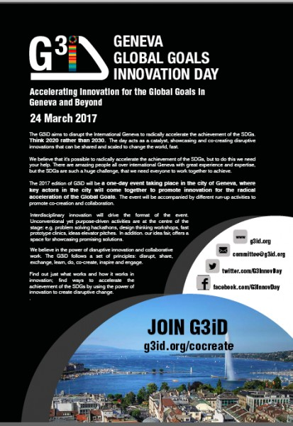](http://www.ict-21.ch/l4d/mod/file/download.php?file_guid=895848)

## During the 1st semester 2017 many meetings, working parties for SI, G4, SISR, Social-IN3, LIN for progressing….

## After the Creation of the G4 (Global Goals 4 Greater Geneva)

## [Talk from Philip Koenig, cofoundor of G4 BNS (Swiss National Bank) General Assembly on 27th of April 2017 à in Berne](http://www.ict-21.ch/l4d/pg/file/read/897081/discours-de-philip-koenig-cofondateur-du-g4-lors-de-lassemble-gnrale-de-la-bns-du-27-avril-2017-berne)

## More info :

## <http://www.ict-21.ch/com-ict/IMG/pdf/BNS.pdf>

## <http://www.ict-21.ch/l4d/pg/file/read/895834/creation-of-the-g4-global-goals-4-greater-geneva-after-a-2days-deep-workshop-2223-of-march-2014>

## [Open Geneva Hackathons : Education-21 - L’évolution nécessaire des systèmes éducatifs pour intégrer les mondes numériques, Education 21 - Necessary evolution of the education systems to integrate the digital worlds](http://www.ict-21.ch/l4d/mod/file/download.php?file_guid=897760)

[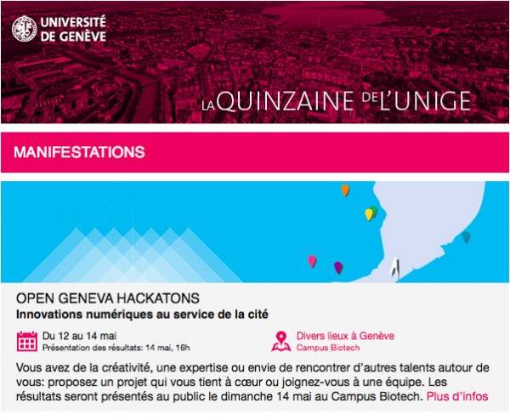](http://www.ict-21.ch/l4d/mod/file/download.php?file_guid=897735)

# ****[Open Geneva](http://opengenevahackathons.org/index.html)**** [****Hackathons****](http://opengenevahackathons.org/index.html)

**Education-21 - L’évolution nécessaire des systèmes éducatifs pour intégrer les mondes numériques,**

**Education  21 - Necessary evolution of the education systems to integrate the digital worlds**

# IP3-ch – Certification - Profesionnalism – CPD (Continuing Professional Development) Work in progress

# Program, SI-Workshop May 24th, 2017 (Version 1, RR)

12.15 Meet & Greet

12.30 Welcome by the President (JG)

12.40 Introduction by the Moderator (Reinhard Riedl, RR)

**12. 45 – 14.00 Information Session (only questions for understanding allowed):  
presentations without questions each 10 – 15 minutes (not more!)**

12.45 Results so far (Simon Moser, SM)

13.00 Perspective SI President (JG)

13.15 Perspective of Swiss ICT (Thomas Flatt, TF)

13.30 Input by Skype

**14.00 – 15.00** **First Round: Positive Value Proposition** (individual and group work, only positive values are admitted in this round)

15.00 – 15.20 Coffee Break

**15.20 – 16.40 Second Round: Identification of Risks – Reasons for Failure and Uncertainties and of Risk Mitigation Options** (individual and group work, only true risks are admitted in this round, only risk mitigation measures creating minor costs are admitted)

16.40 – 17.00 Coffee Break

**17.00 – 18.15 Third Round: Identification of Various Implementation Options including Cost Estimates** (group work; side condition: first version must be implementable within one year; options: a.) nearly free of costs, b.) costs for full version lower than 100’000, first version implementable for 30’000, c.) costs for full version unlimited, costs for first version lower than 100’000)

18.15 Feedback by Participants

18.25 Summary by the Moderator (RR)

18.30 End of Workshop

## 

## KB (Swiss Education Committee) of ICT Switzerland – Meeting on 30th of May 2017

## 

## [Swisstainability Forum 29 and 30 June 2017 in Lausanne](http://www.ict-21.ch/l4d/mod/file/download.php?file_guid=898648)

[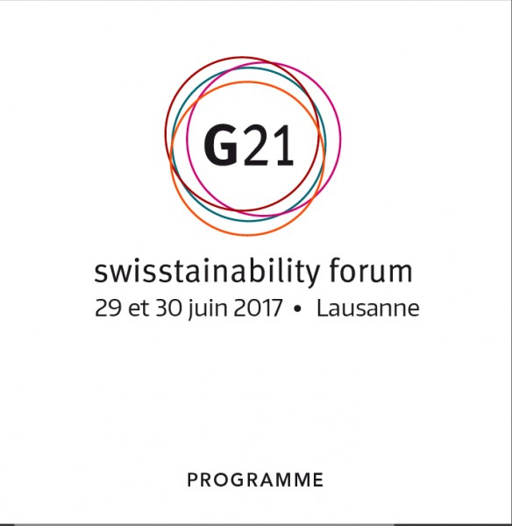](http://www.ict-21.ch/l4d/mod/file/download.php?file_guid=898632)

# 4. Feedbacks IFIP during 2016 - 2017 from Switzerland – LEVEL INTERNATIONAL

## [ICT for Promoting Human Development and Protecting the Environment - 6th IFIP WITFOR 2016 - San José, Costa Rica, September 12-14,2016 - Proceedings](http://www.ict-21.ch/l4d/mod/file/download.php?file_guid=895014)

[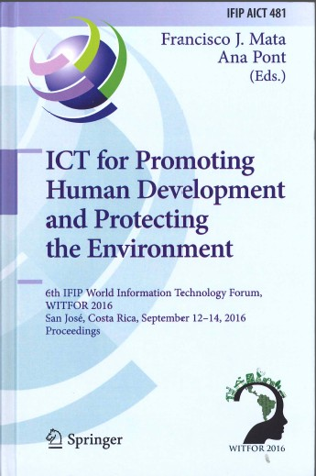](http://www.ict-21.ch/l4d/mod/file/download.php?file_guid=894992)

## After IFIP GA 2016

## From end of Fall 2016 to 12th of June 2017 beginning of WSIS Forum 2017, numerous meetings (working parties) to elaborate, test and present different versions of theabove document HDRR

## HDRR : Human Digital Rights & Responsibilities

[**http://www.ict-21.ch/l4d/pg/file/read/897692/open-geneva-hackathons-human-digital-rights-amp-responsibilities-droits-et-responsabilits-humains-dans-le-monde-numrique**](http://www.ict-21.ch/l4d/pg/file/read/897692/open-geneva-hackathons-human-digital-rights-amp-responsibilities-droits-et-responsabilits-humains-dans-le-monde-numrique)

**cf. Minutes GA 2016 – item 3.9.3**

[**Swiss IT Professional : A certification project by the Swiss Informatics Society communicated to the IP3 Board at the Sydney IT professional meetings (end of Nov 2016)**](http://www.ict-21.ch/l4d/mod/file/download.php?file_guid=894019)

[](http://www.ict-21.ch/l4d/mod/file/download.php?file_guid=894026)

[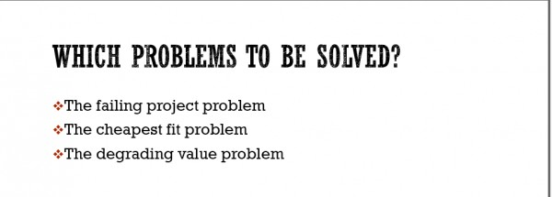](http://www.ict-21.ch/l4d/mod/file/download.php?file_guid=894028)

[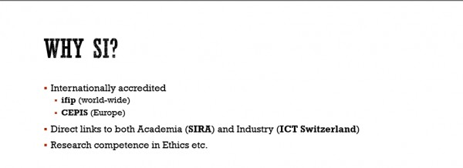](http://www.ict-21.ch/l4d/mod/file/download.php?file_guid=894030)

[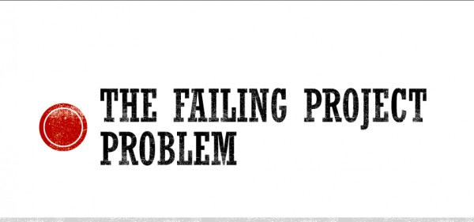](http://www.ict-21.ch/l4d/mod/file/download.php?file_guid=894032)

[**Swiss IT Professional : A certification project by the Swiss Informatics Society communicated to the IP3 Board at the Sydney IT professional meetings (end of Nov 2016)**](http://www.ict-21.ch/l4d/mod/file/download.php?file_guid=894019)

[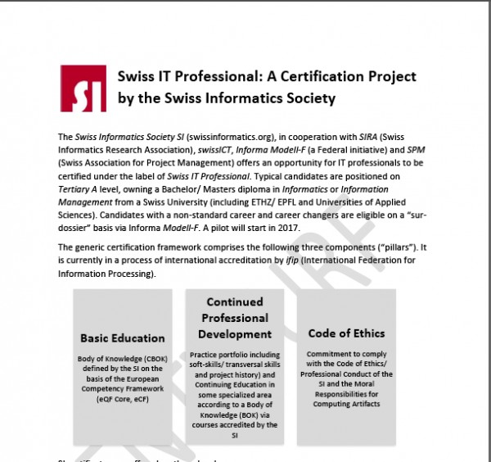](http://www.ict-21.ch/l4d/mod/file/download.php?file_guid=894015)

[**# REIMAGINATION'2016 - Australian Computer Society (ACS) - 1st of December 2016**](http://www.ict-21.ch/l4d/mod/file/download.php?file_guid=893619)

[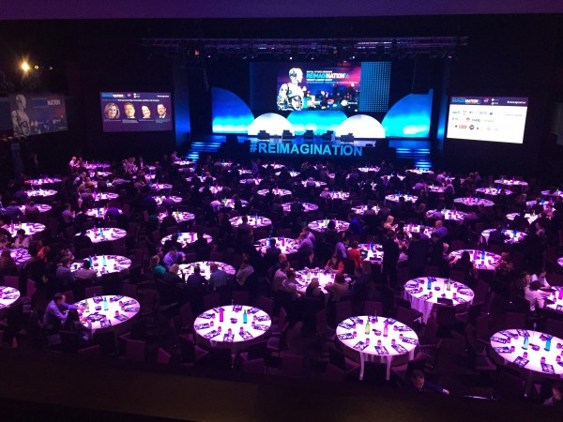](http://www.ict-21.ch/l4d/mod/file/download.php?file_guid=893624)

## [IFIP Presidents and Australia 3.0 NSW Government Ministerial Forum - Date: Wednesday 30th November 2016 Venue: Stateroom - Level 2 Hilton Hotel Sydney 488 George Street Sydney NSW 2000](http://www.ict-21.ch/l4d/mod/file/download.php?file_guid=893593)

   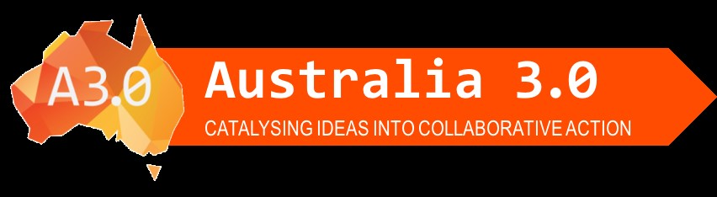

I am very excited to invite you to join us for the Ministerial forum with The Hon Victor Dominello NSW Minister for Innovation & Better Regulation.  
  
This session will tackle innovation and disruption; driverless cars, AI, AR, VR, IoT – the commercial applications have come a long way in a short period of time, and we are seeing an explosion in technology innovation.  
  
Why is it then that developed economies have yet to see any real GDP impact?   
  
And with the rapid moves towards automation, and algorithm lead advice, what are the impacts for the modern day professional?

**Some references**

[How far should AI replace human sense?](http://www.ict-21.ch/com-ict/IMG/pdf/How%20far%20should%20AI%20replace%20human%20sense_.pdf)

[The Thin Dividing Line Between Human Financial Advisers and ‘Robo-Advisers’](http://www.ict-21.ch/com-ict/IMG/pdf/AW%20on%20FinTech%20Professional%20Standards%20for%20The%20Oz%27.pdf)

[Ethics must travel as AI’s associate](http://www.ict-21.ch/com-ict/IMG/pdf/Ethics%20must%20travel%20as%20AI%E2%80%99s%20associate.pdf)

[Planning for Cyber Threats](http://www.ict-21.ch/com-ict/IMG/pdf/AW%20on%20Cyber%20Security%20for%20The%20Oz%20291116.pdf)

**Some of our featured speakers include:….**

## [UTS researchers visualising their data - UTS Data Arena at Sydney](http://www.ict-21.ch/l4d/mod/file/download.php?file_guid=893526)[mage](http://www.ict-21.ch/l4d/mod/file/download.php?file_guid=893533)

# Overview

* [News articles](http://www.uts.edu.au/partners-and-community/initiatives/data-arena/overview#news-articles)
* [UTS researchers visualising their data](http://www.uts.edu.au/partners-and-community/initiatives/data-arena/overview#uts-researchers-visualising-their-data)

The UTS Data Arena is a 360-degree interactive data visualisation facility set to change the way we view and interact with data.

## [After the event : Let’s make Global Goals Local Business Corporate Social Responsibility and Sustainable Development Goals A Factor of innovation for the Swiss economy ? 2nd of February 2017, Berne](http://www.ict-21.ch/l4d/mod/file/download.php?file_guid=895616)

[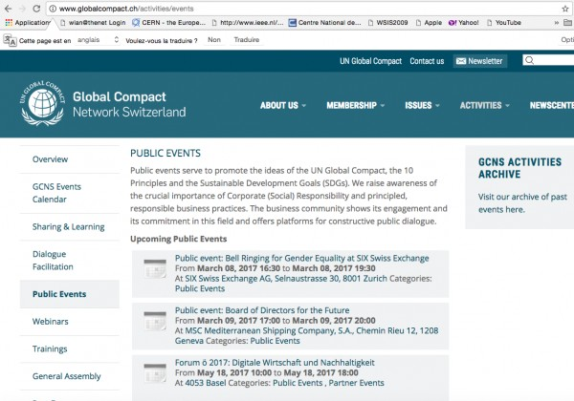](http://www.ict-21.ch/l4d/mod/file/download.php?file_guid=895612)

**G4 Resilience Living Lab, Geneva, 22-23.3.2017**

Centre Universitaire d'Informatique (CUI) Battelle - bâtiment A  7, route de Drize CH-1227 Carouge

[preparation for the Thematic Workshop inside of the next WSIS Forum 2017

## [From Sustainable Development Goals SDGs, to unleashing 21st century Global Goals potentials - a mindset shift, a human centric approach, - in favor of the common greater good](http://www.ict-21.ch/l4d/mod/file/download.php?file_guid=897245) |

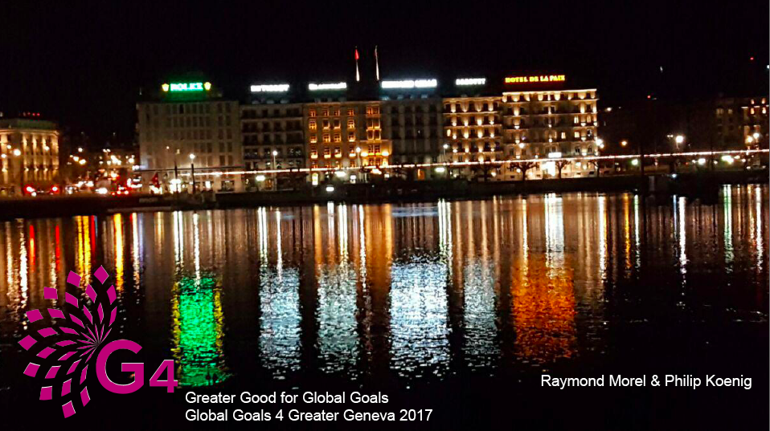

**Mercredi 22.3 – 10.00 – 17.00**

* Accueil et introduction de G4 Resilience Living Lab – Raymond Morel & Philip Koenig
* Présentation de l'outil resilience et du Roadmap 2030- Peter Head / Scott Williams / Bob Bishop
* Présentations envisagées de différents Labs
  + UNIGE Francois Grey
  + SIG Giorgio Pauletto , René Longet
  + ONU : SDGs lab , human lab, etc…
  + Etat de geneve : Patrick Genoud
  + Pangloslab : Paul Bristow
  + BFU : Mme Anschwander et Mr Aeschliman
  + UN Global Compact : Antonio Hautle
  + Firmenich
  + La Poste

**Jeudi 23.3 – 10.00 – 15.00**

* Accueil et introduction de G4 Resilience Living Lab – Raymond Morel & Philip Koenig
* Présentation de l'outil resilience et du Roadmap 2030- Peter Head / Scott Williams / Bob Bishop
* Suite de presentation des Labs
* Présentation envisagées de différents projets
  + EPFL : projet énergie avec Francois Marechal
  + Projet Bâtiments autonome de l’ONU
  + Project Neuroscience & education – G4 Team
    - Epigénétique avec Docteur Céline Guerin / [Conscience21.ch](http://Conscience21.ch)
    - SEVE avec Nuria Gonzales et Florence Coulin
    - Neurocognitivisme avec Françoise Peckstadt
    - HP et generati on y, z et alpha avec Olivier Revol

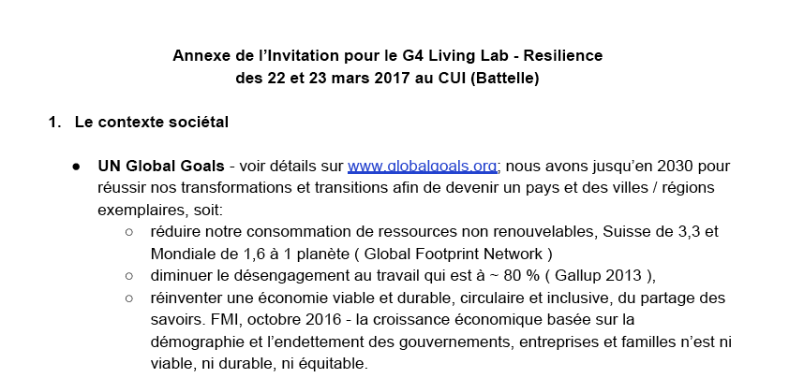

**26th and 27th of March – by skype – TC3 Executive meeting - Preparation WCCE (World Conference on Computers in Education) : Tomorrow’s Learning: Involving Everyone Printworks Conference Hall, Dublin Castle - 3-6 July 2017, Doctoral Consortium, ICS Offices, Ballsbridge - 2 July 2017**

## 

## More info :

## <http://www.ict-21.ch/l4d/pg/file/read/894882/tomorrows-learning-involving-everyone-printworks-conference-hall-dublin-castle-36-july-2017-doctoral-consortium-ics-offices-ballsbridge-2-july-2017>

## Preparation of wsis forum 2017 meetings

## [WSIS Forum 2017: Open Consultation Process 2nd Physical Meeting on the Thematic Aspects and Innovations on the Format](http://www.ict-21.ch/l4d/mod/file/download.php?file_guid=895164)

[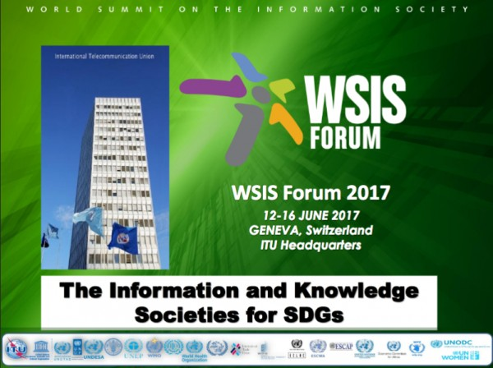](http://www.ict-21.ch/l4d/mod/file/download.php?file_guid=895152)

After 14 years of discussions we can read **KNOWLEDGE**  ..... and Societie**S.**

**What a progress !!**

## [Draft Agenda WSIS Forum 2017 (12th to 16th of June) - version du 28.3.2017 - From Sustainable Development Goals SDGs, to unleashing 21st century Global Goals potentials​ - a mindset shift, a human centric approach, - in favor of the common greater good](http://www.ict-21.ch/l4d/mod/file/download.php?file_guid=896134)

[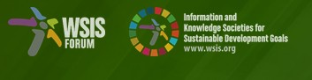](http://www.ict-21.ch/l4d/mod/file/download.php?file_guid=897099)

[http://www.ict-21.ch/l4d/mod/file/download.php?file\_guid=897101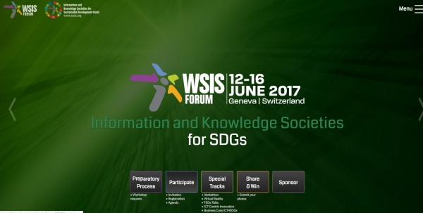](http://www.ict-21.ch/l4d/mod/file/download.php?file_guid=897101)

## [Open Geneva Hackathons Human Digital Rights & Responsibilities Droits et Responsabilités Humains dans le monde Numérique](http://www.ict-21.ch/l4d/mod/file/download.php?file_guid=897692) (May 2017)

## mage

**After "AI for Good Global Summit" ITU - 7-9 June 2017**

**In Geneva, Switzerland**

## 

## More info :

## <http://www.ict-21.ch/l4d/pg/file/read/898623/79-june-ai-for-good-global-summit-itu-geneva-switzerland>

## From WSIS (World Summit of the Information Society)

**WSIS Forum 12-16 of June 2017 - Geneva Switzerland - Information and Knowledge Societies for SDGs Programme Brochure - June 2017**

**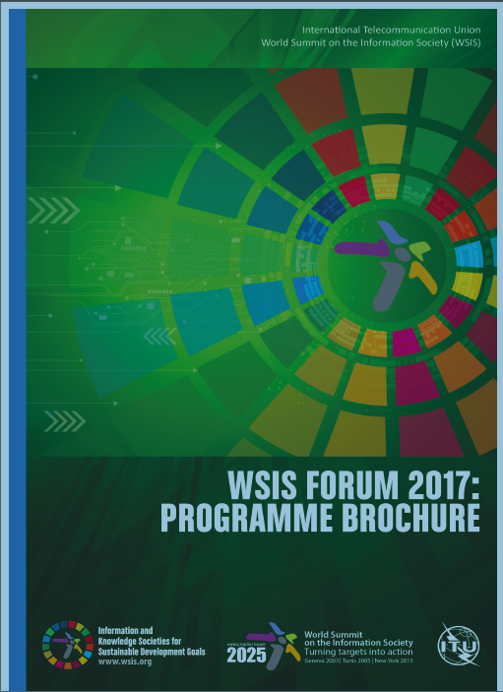**

## More info :

[**http://www.ict-21.ch/l4d/pg/file/read/898226/wsis-forum-1216-of-june-2017-geneva-switzerland-information-and-knowledge-societies-for-sdgs-programme-brochure-june-2017**](http://www.ict-21.ch/l4d/pg/file/read/898226/wsis-forum-1216-of-june-2017-geneva-switzerland-information-and-knowledge-societies-for-sdgs-programme-brochure-june-2017)

## [WSIS Forum 12-16 of June 2017 - Geneva Switzerland - Information and Knowledge Societies for SDGs Programme Brochure - June 2017](http://www.ict-21.ch/l4d/mod/file/download.php?file_guid=898744) Outcomes

## [Unesco : WSIS Forum 2017 successfully held](http://www.ict-21.ch/l4d/mod/file/download.php?file_guid=898838)

## [WSIS FORUM 2017 : IFIP sides (HLS, HDRR, IP3)](http://www.ict-21.ch/l4d/mod/file/download.php?file_guid=898857)

## [Some feedbacks after WSIS Forum 2017](http://www.ict-21.ch/l4d/mod/file/download.php?file_guid=899452)

## HDRR : Human Digital Rights & Responsibilities : A Thematic Workshop organised by IFIP, Social-IN3 and G4

Cf. just above or

[**http://www.ict-21.ch/com-ict/IMG/docx/Version-2.docx**](http://www.ict-21.ch/com-ict/IMG/docx/Version-2.docx)

**Action Line C7 (e-Learning) - Ensuring Inclusive and Equitable Quality Education and Promoting Lifelong Learning Opportunities for All United Nations Organization for Education, Science and Culture (UNESCO)**

## 

## More info :

## <http://www.ict-21.ch/l4d/pg/file/read/898659/action-line-c7-elearning-ensuring-inclusive-and-equitable-quality-education-and-promoting-lifelong-learning-opportunities-for-all-united-nations-organization-for-education-science-and-culture-unesco>

## [WCCE-2017 : Tomorrows Learning involving Everyone printworks Conference Hall Dublin Castle-3 to 6 July 2017 Doctoral consortium ICS offices ballsbridge 2 July 2017](http://www.ict-21.ch/l4d/mod/file/download.php?file_guid=898753)

## mage

## [During WCCE-2017 : Symposium: From Curriculum Visions to Computer Science and Computational Thinking in the Curriculum in Practice Presenters](http://www.ict-21.ch/l4d/mod/file/download.php?file_guid=898788)

## mage

# 5. State of the art for the proposal GA’2016 on HDRR Human Digital Rights and Responsaibilities

**----- and the follow-up**

## HDRR : Human Digital Rights & Responsibilities : A Thematic Workshop organised by IFIP, Social-IN3 and G4

Cf. just above or

[**http://www.ict-21.ch/com-ict/IMG/docx/Version-2.docx**](http://www.ict-21.ch/com-ict/IMG/docx/Version-2.docx)

# 6. References - AOB

**Future competencies at the digital age - reshuffle the cards - Les compétences du futur - une manière de rebattre les cartes**

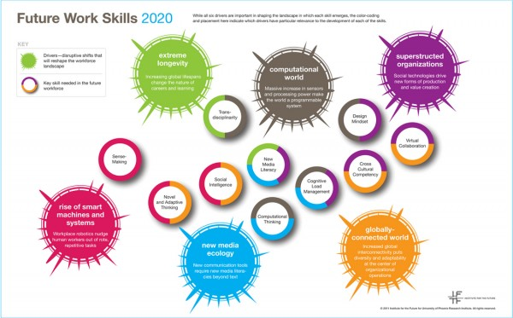

## More info :

[**http://www.ict-21.ch/l4d/pg/file/read/898017/future-competencies-at-the-digital-age-reshuffle-the-cards-les-competences-du-futur-une-maniere-de-rebattre-les-cartes**](http://www.ict-21.ch/l4d/pg/file/read/898017/future-competencies-at-the-digital-age-reshuffle-the-cards-les-competences-du-futur-une-maniere-de-rebattre-les-cartes)

## [The Age of Thrivability - Vital perspectives and practices for A Better World - Michelle Holliday](http://www.ict-21.ch/l4d/mod/file/download.php?file_guid=898480)

## [TEDxConcordia - Michelle Holliday - The Pattern of Living Systems](http://www.ict-21.ch/l4d/mod/file/download.php?file_guid=898950)

[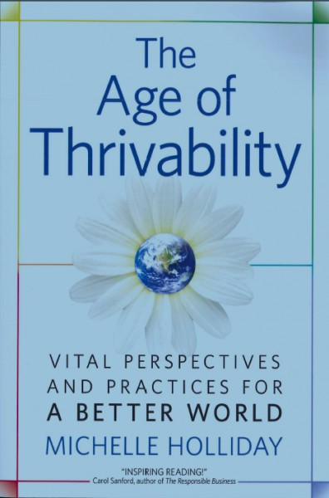](http://www.ict-21.ch/l4d/mod/file/download.php?file_guid=898493)

**AOB**

* Various **articles** in CH newspapers
* Hundreds of messages with e-mail
* Reviewing for some conferences
* **Active participation for diffusion of all informations for forthcoming IFIP events** (usual tasks : call for papers, preliminary program, reviewing, organisation of the national contribution, then post-conference feed-back)
* Meetings with the **SI Committee** (Swiss Informatics Society) and **KB** (special interest group for Kommission ICT Bildung)**.** SI is the leader for **ECDLand for Education**
* Report 2016 (meeting in Bern) at the **Swiss Committee for IFIP** on the 19st of January 2017 🡪 see above

Raymond Morel Swiss GA Representative, Member of the IFIP ILC, IP3

and MSA in collaboration with P.-A Bobillier

Geneva, 3rd of September 2017